Job:

Hi Delta FlexGas® - Type WH

Dual-Fuel Water Heaters
Models 992CD-2342CD

Engineer:

Contractor:
Prepared By: Date:
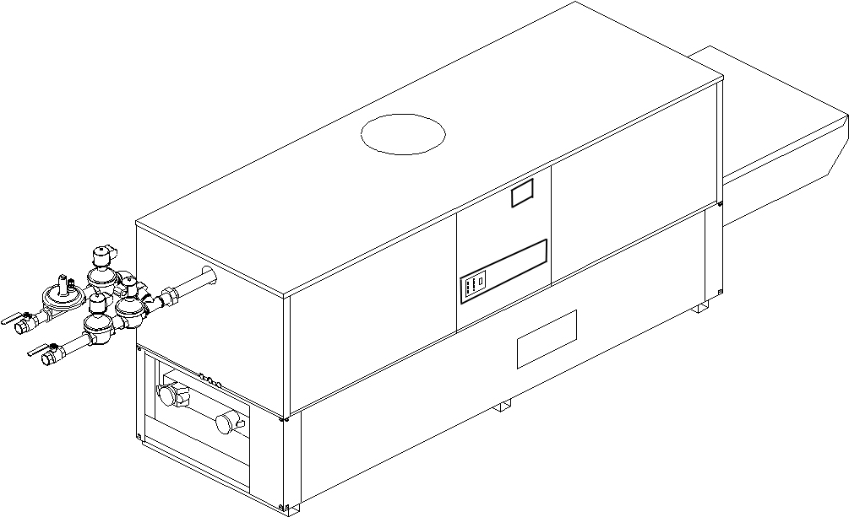
Model: Indoor/Outdoor: MBTUH Input:
- 100% Factory Fire Tested
- Thermal Efficiency: Up to 85%
- Versa IC® Controller with LCD Display
- Maximum Setpoint: 150°F
- Maximum Outlet Temperature: 200°F
- Minimum Non-Condensing Inlet Temperature: 105°F
- Thermal-Shock Proof Heat Exchanger
- Limited Twenty-Year Thermal Shock Warranty
- Limited Ten-Year Cupro-Nickel Heat Exchanger Warranty
- Limited Five-Year Copper Heat Exchanger Warranty
- Full Safety Diagnostics with Fault History
- PolyTuf Powder Coated Cabinet
Patent Nos. 6,904,873 & 7,044,124; other patents pending
- No Combustible Floor Shield Required
- Fan-Assisted
- Patented Burner Security Blanket
Proudly Assembled in the USA

- Ultra-Low NOx – SCAQMD 1146.2 Certified (992C – 1802C)
- Cascade up to 4 Heaters – No External Sequencer Required

Heat Exchanger
- Headers
Brass – Standard
A-2 Glass-Lined Cast Iron
- ASME Inspected and HLW Stamped
160 PSIG Working Pressure
- National Board Approved
- Fin Tubing
Copper (Std.) 85%
Cupro-Nickel 83.1%
- ASME Steel Tube Sheet
- Silicone High-Temp. O-Rings
- ASME Pressure Relief Valve
125 PSIG – Standard
PSIG – Optional
- Temperature and Pressure Gauge
- Water Connections
Left – Standard

A-6 Right Hand

Controls
- 120V, 60Hz, 1∅ Power Supply
- 120/24V 60Hz Transformer
- Versa IC® Integrated Control
- 100% Shut-Off/Lockout
- Hot Surface Ignition
- Ignition Module
3-Try – Standard
C-6 Single Try
- Remote Flame Sensor
- Fixed High Limit, Manual Reset 240°F
- On/Off Power Switch
- Flow Switch
- Blocked Vent Pressure Switch
- Combustion Air Proving Switch
- Programmable Pump Time Delays
- Heater
- Recirculation
- Enable/Disable

Controls – cont.
- LCD Display; Status, Fault and Diagnostics
- Cold Water Protection Function
Optional CWR Variable-Speed Pump
(See Cat. 5000.73)
- Modbus RTU BMS Port (Up to 115K Baud, See Cat. 5000.73)
B-85 – BMS Gateway – BACnet MS/TP, BACnet IP, N2 Metasys or Modbus TCP
B-86 – BMS Gateway - LonWorks

Gas Train
- Manual Gas Shut-Off Valve(s)
- Combo Valve(s)
- Firing Mode
3-Stage (WH8): Model 992C
4-Stage (WH9): Models 1262C – 2342C
- Natural/Propane Gas
- Design Certified - ANSI Z21.10.3/CSA 4.3

Construction
- Indoor/Outdoor Construction
- Enclosed Front Controls
- Powder Coat Finish
- CSA Low Lead Certified (≤ .25% Lead)

Venting
Vent Category I/III Cupro-Nickel
Vent Category II/IV Copper
- Vent Location
Top – Standard
D-14 Rear
- Vent Termination Cap
D-11 Outdoor
D-15 Indoor, Horizontal
Indoor, Vertical (by others)
- Combustion Air

D-17 In-Line Filter Kit (TruSeal only)
D-16 Air Intake Elbow

Venting – cont.
- Extractor – Optional
By others
Not required

Burner
Ultra-Low NOx: Less than 20 PPM

Options
D-21 TruSeal® Direct Vent
F-10 Low Water Cut-Off, Remote Probe
I-1 High Limit Control, Auto Reset
P- Pump: HP, 120V, 1∅, 60Hz
Bronze
Mounted Loose
Front Rear
S-1 Low Gas Pressure Switch, Manual
S-2 High Gas Pressure Switch, Manual
X-1 SureRack® Kit
X-2 SureRack Add-on

Additional Options or Accessories

Multi-Boiler Temperature Controllers
TempTracker Mod+ Hybrid
B-36, 2-4 Heaters
B-37, 5-10 Heaters
B-38, 11-16 Heaters
B-39 EMS 4-20mA Remote Setpoint Interface Module
B-62 BACnet MS/TP Interface

Hi Delta FlexGas – Type WH
Models 992CD-2342CD Model _ _____

Raypak, Inc. 2151 Eastman Avenue, Oxnard, CA 93030 (805) 278-5300 Fax (800) 872-9725 www.raypak.com
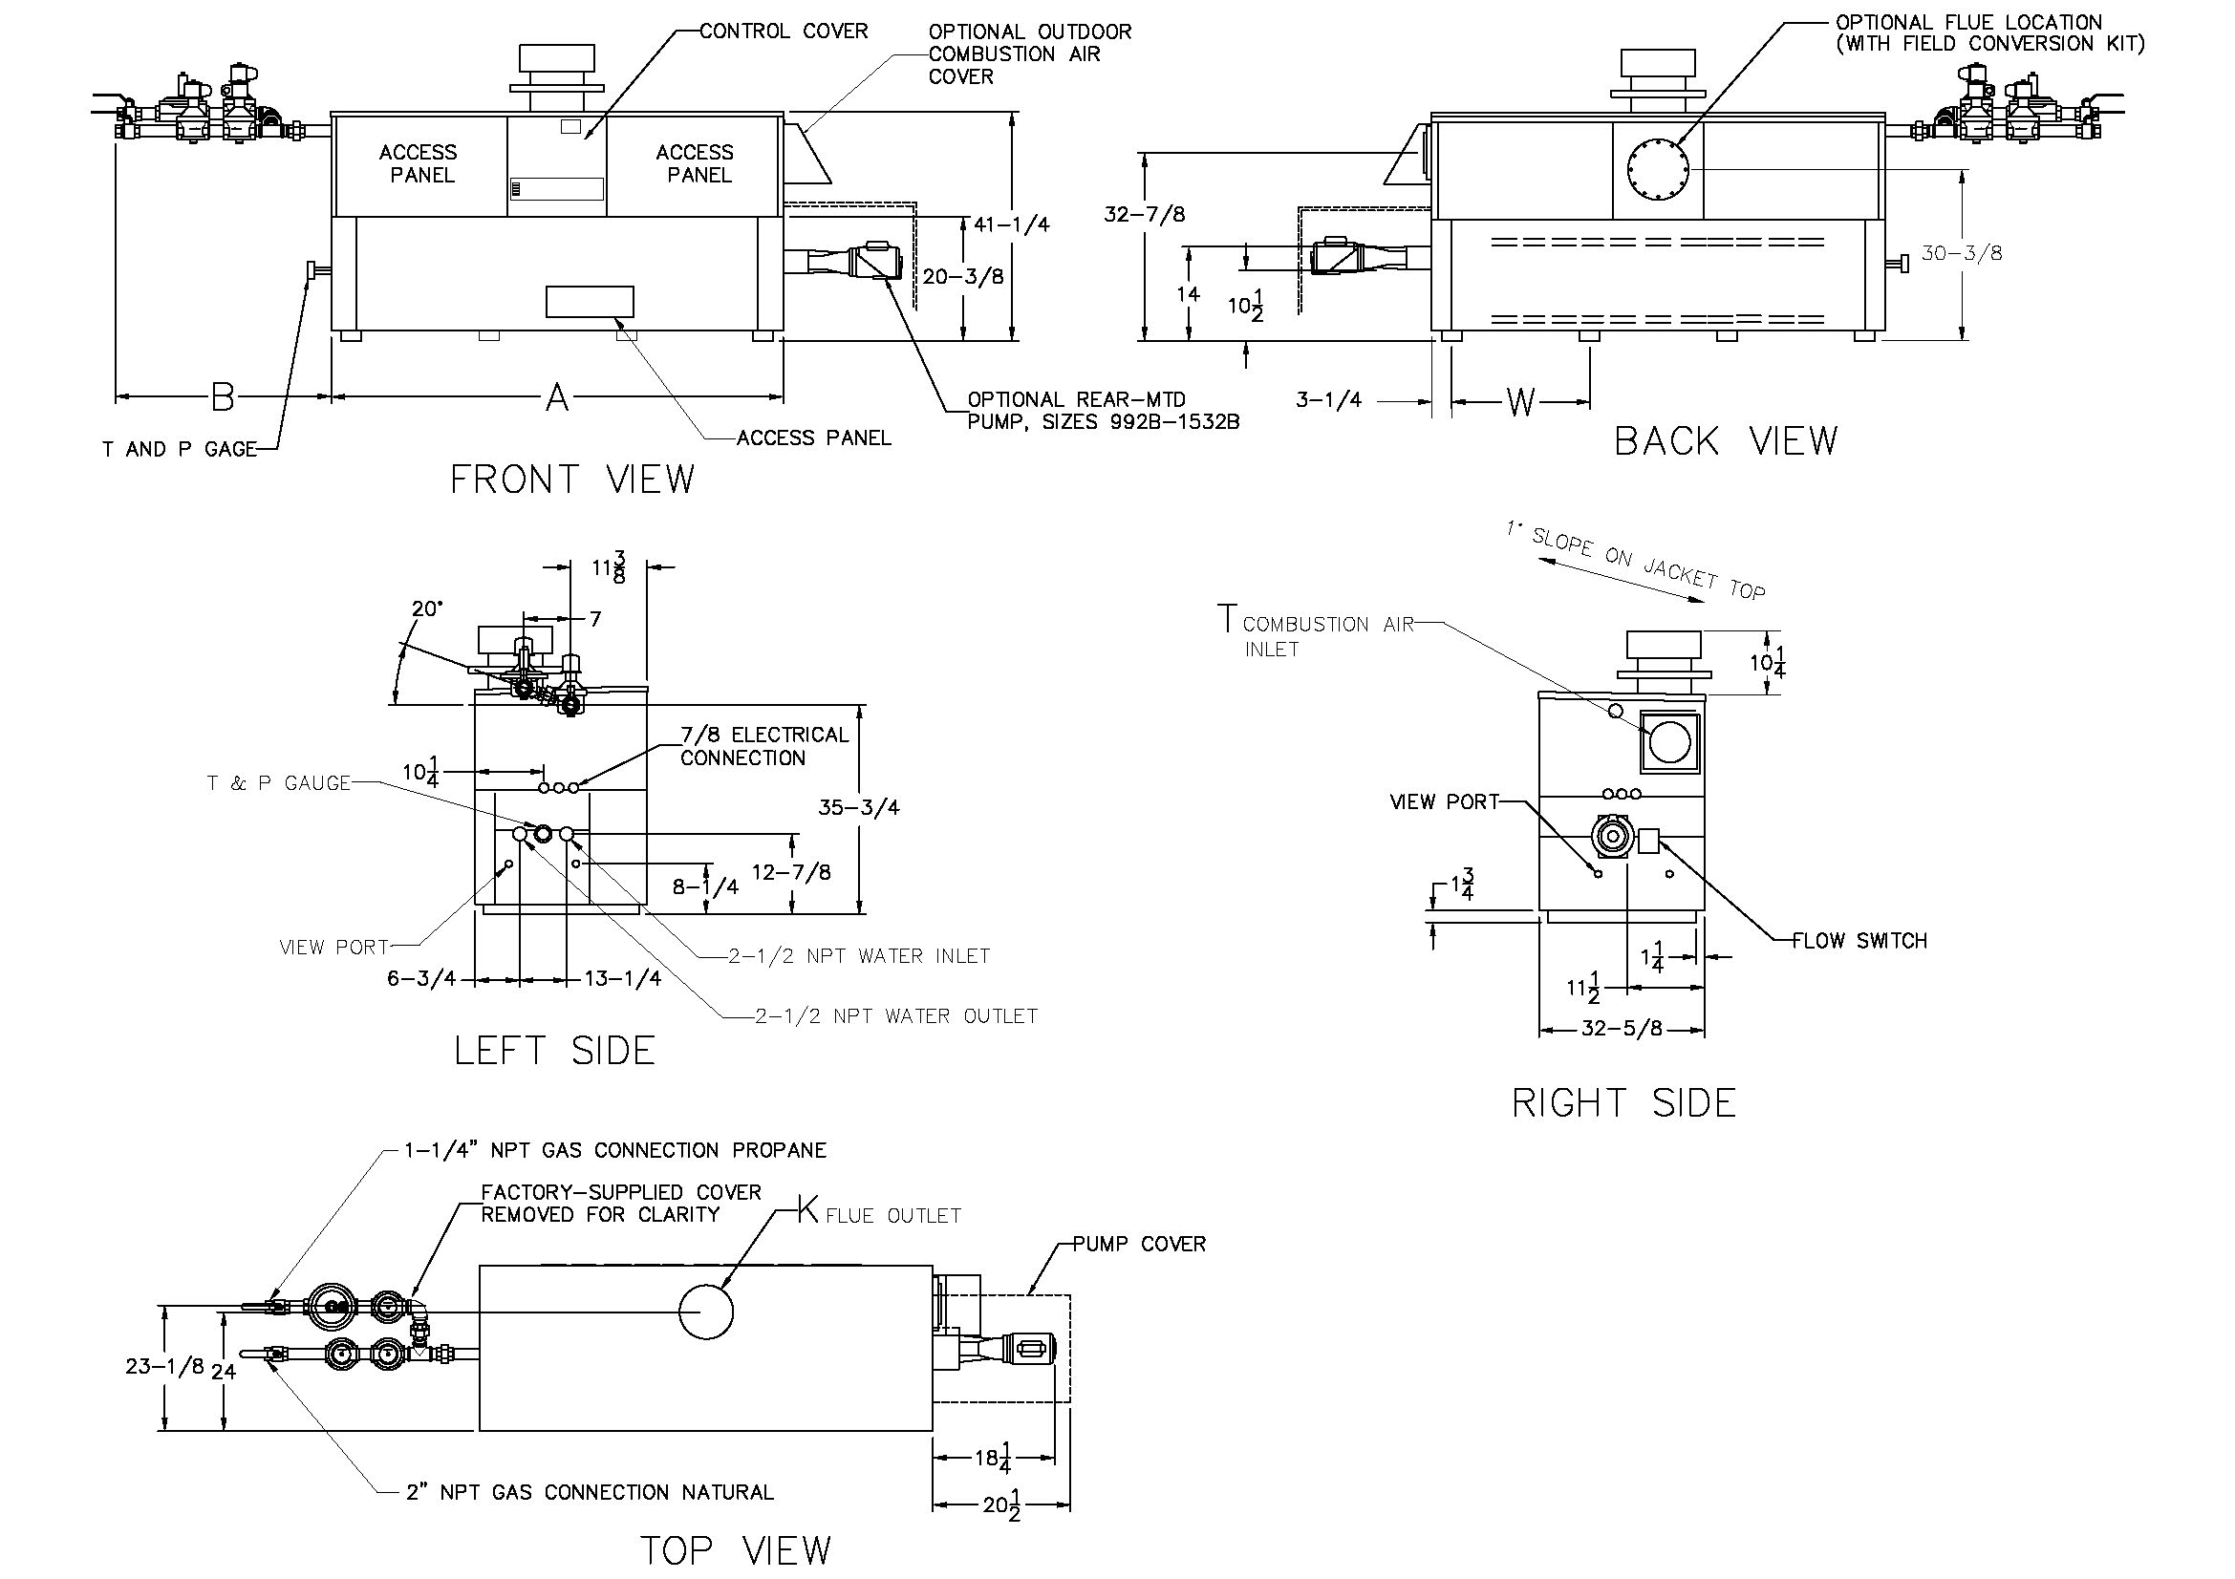
NOTE: Pump location varies based on model and application.

 | SPECIFICATIONS
Model | MBTUH |  |  | Firing  Stages | A  Width | K | T | W | Amp.  Draw* | Approx.  Shipping  Wt. (Lbs.)
 | Input | Output  85% | Output  83.1%
992CD | 990 | 842 | 823 | 3 | 57-1/8 | 10 | 10 | 16-13/16 | <12 | 900
1262CD | 1260 | 1071 | 1047 | 4 | 68-1/2 | 12 |  | 20-9/16 |  | 1010
1532CD | 1530 | 1301 | 1271 | 4 | 79-7/8 | 12 |  | 24-3/8 |  | 1225
1802CD | 1800 | 1530 | 1496 | 4 | 91-1/8 | 14 |  | 28-1/8 |  | 1350
2072CD | 2070 | 1760 | 1720 | 4 | 102-1/2 | 14 |  | 31-15/16 |  | 1450
2342CD | 2340 | 1989 | 1945 | 4 | 113-7/8 | 16 |  | 35-11/16 |  | 1520
*Without pump.

NOTES: 1. Dimensions are in inches.
2. Rates shown are for natural or propane gas, and elevations up to 4,500 feet. For installation above 4,500 feet, please contact manufacturer.
3. Required natural gas pressure is 7 – 10.5” WC. Required propane gas pressure is 11 - 13” WC.

Hi Delta FlexGas – Type WH
Models 992CD-2342CD Model

Model | 83.1% System Flow and Head Loss
 | 3-4 Grains Per Gallon |  |  |  |  | 5-15 Grains Per Gallon |  |  |  |  | 16-25** Grains Per Gallon
 | ΔT  (°F) | GPM | ΔP  (FT WC) | MTS  (IN) | SHL  (FT WC) | ΔT  (°F) | GPM | ΔP  (FT WC) | MTS  (IN) | SHL  (FT WC) | ΔT  (°F) | GPM | ΔP  (FT WC) | MTS  (IN) | SHL  (FT WC)
992CD | 28 | 60 | 2.7 | 2 1/2 | 5.2 | 17 | 98 | 7.3 | 2 1/2 | 13.3 | 13 | 132 | 13.1 | 2 1/2 | 23.6
1262CD | 28 | 75 | 4.8 | 2 1/2 | 8.5 | 18 | 115 | 11.3 | 2 1/2 | 19.4 | 16 | 132 | 14.8 | 2 1/2 | 25.3
1532CD | 30 | 86 | 7.1 | 2 1/2 | 11.9 | 21 | 120 | 13.7 | 2 1/2 | 22.5 | 19 | 132 | 16.5 | 2 1/2 | 27.0
1802CD | 30 | 102 | 10.9 | 2 1/2 | 17.4 | 25 | 120 | 15.1 | 2 1/2 | 23.9 | 23 | 132 | 18.3 | 2 1/2 | 28.7
2072CD | 30 | 117 | 15.1 | 2 1/2 | 23.4 | 26 | 132 | 19.0 | 2 1/2 | 29.5 | 26 | 132 | 19.0 | 2 1/2 | 29.5
2342CD | 30 | 132 | 21.4 | 2 1/2 | 31.8 | 30 | 132 | 21.4 | 2 1/2 | 31.8 | 30 | 132 | 21.4 | 2 1/2 | 31.8

Model | 85% System Flow and Head Loss
 | 3-4 Grains Per Gallon |  |  |  |  | 5-15 Grains Per Gallon |  |  |  |  | 16-25** Grains Per Gallon
 | ΔT  (°F) | GPM | ΔP  (FT WC) | MTS  (IN) | SHL  (FT WC) | ΔT  (°F) | GPM | ΔP  (FT WC) | MTS  (IN) | SHL  (FT WC) | ΔT  (°F) | GPM | ΔP  (FT WC) | MTS  (IN) | SHL  (FT WC)
992CD | 28 | 60 | 2.7 | 2 1/2 | 5.2 | 17 | 98 | 7.3 | 2 1/2 | 13.3 | 13 | 132 | 13.1 | 2 1/2 | 23.6
1262CD | 28 | 76 | 4.8 | 2 1/2 | 8.5 | 19 | 115 | 11.3 | 2 1/2 | 19.4 | 16 | 132 | 14.8 | 2 1/2 | 25.3
1532CD | 32 | 83 | 7.1 | 2 1/2 | 11.9 | 22 | 120 | 13.7 | 2 1/2 | 22.5 | 20 | 132 | 16.5 | 2 1/2 | 27.0
1802CD | 32 | 98 | 10.9 | 2 1/2 | 17.4 | 26 | 120 | 15.1 | 2 1/2 | 23.9 | 23 | 132 | 18.3 | 2 1/2 | 28.7
2072CD | 32 | 112 | 15.1 | 2 1/2 | 23.4 | 27 | 132 | 19.0 | 2 1/2 | 29.5 | 27 | 132 | 19.0 | 2 1/2 | 29.5
2342CD | 32 | 126 | 21.4 | 2 1/2 | 31.8 | 30 | 132 | 21.4 | 2 1/2 | 31.8 | 30 | 132 | 21.4 | 2 1/2 | 31.8
SHL includes 50 equivalent ft of tubing each way (100 total)
** Must use optional cupro-nickel tubes. For hardness exceeding 25 GPG, must use water softener
Basis for minimum flow is 55 GPM or 30°F ∆T, 132 GPM for maximum flow

Model | 83.1% RECOVERY RATES (GPH)
 | Temperature Rise (°F)
 | 20° | 30° | 40° | 50° | 60° | 70° | 80° | 90° | 100°
992CD | 4986 | 3324 | 2493 | 1994 | 1662 | 1425 | 1247 | 1108 | 997
1262CD | 6346 | 4231 | 3173 | 2538 | 2115 | 1813 | 1586 | 1410 | 1269
1532CD | 7706 | 5137 | 3853 | 3082 | 2569 | 2202 | 1926 | 1712 | 1541
1802CD | 9065 | 6044 | 4533 | 3626 | 3022 | 2590 | 2266 | 2015 | 1813
2072CD | 10425 | 6950 | 5213 | 4170 | 3475 | 2979 | 2606 | 2317 | 2085
2342CD | 11785 | 7857 | 5893 | 4714 | 3928 | 3367 | 2946 | 2619 | 2357
Model | 85% RECOVERY RATES (GPH)
 | Temperature Rise (°F)
 | 20° | 30° | 40° | 50° | 60° | 70° | 80° | 90° | 100°
992CD | 5100 | 3400 | 2550 | 2040 | 1700 | 1457 | 1275 | 1133 | 1020
1262CD | 6491 | 4327 | 3245 | 2596 | 2164 | 1855 | 1623 | 1442 | 1298
1532CD | 7882 | 5255 | 3941 | 3153 | 2627 | 2252 | 1970 | 1752 | 1576
1802CD | 9273 | 6182 | 4636 | 3709 | 3091 | 2649 | 2318 | 2061 | 1855
2072CD | 10664 | 7109 | 5332 | 4265 | 3555 | 3047 | 2666 | 2370 | 2133
2342CD | 12055 | 8036 | 6027 | 4822 | 4018 | 3444 | 3014 | 2679 | 2411
Raypak, Inc. 2151 Eastman Avenue, Oxnard, CA 93030 (805) 278-5300 Fax (800) 872-9725 www.raypak.com

