­­­Job:

# Professional Indirect Pool Heater

## Powered by XTherm®

## 1.0-1.5-2.0 MMBTUH Models

Engineer:

Contractor:

Prepared By:       Date:

Model:       Indoor/Outdoor:

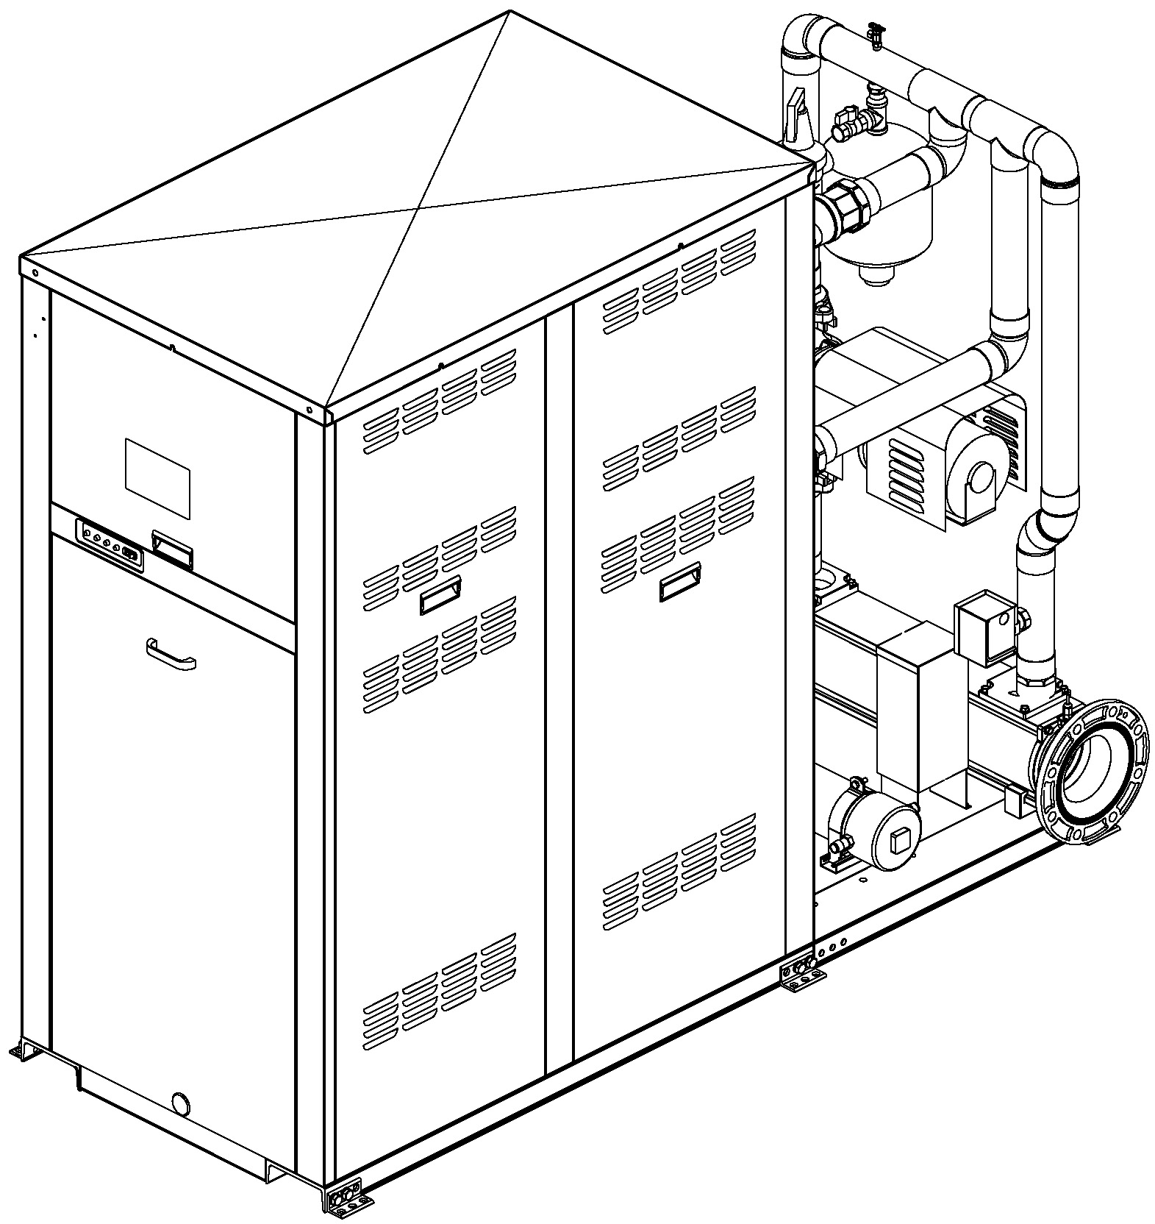

**96% Thermal Efficiency at Full Rate; Up to 99% at Part Load**

**VERSA IC® Modulating Controller**

**7 Inch HD Capacitive Color Touch Screen Display**

**Full Electronic Modulation, Constant Ratio 7:1 Turndown**

**Full Safety Diagnostics with History**

**PVC Venting**

**Modbus RTU BMS Port**

**Maximum Pool/Spa Water Temperature: 104°F**

**Limited Twenty-Five-Year Thermal Shock Warranty**

**Limited Ten-Year Primary Heat Exchanger Warranty**

Low NOx – Meets SCAQMD Rule 1146.2

**Limited Ten-Year Secondary Heat Exchanger Warranty**

Proudly Assembled in the USA

**Limited 3/5-Year Indirect Heat Exchanger Warranty**

#### Heat Exchanger

* Headers

Cast Iron

* ASME H Stamped; 160 PSIG MAWP
* National Board Listed
* Copper Fin Tubing
* ASME Powder-Coated Tube Sheet
* Silicone High-Temp O-Rings
* ASME Pressure Relief Valve

30 PSIG – Standard

* Air Vent, Manual
* T&P Gauge
* Stainless Steel Secondary Heat Exchanger
* Stainless Steel Evaporator Plate
* Indirect Heat Exchanger

Cupro-Nickel

Titanium

* Boiler Pump: 120V, 1∅, 60Hz
* Indirect Pump: 115/230V, 1Ø, 60Hz

#### Control

* 120V, 60Hz, 1Ø, Power Supply
* 120/24V 60Hz Transformer
* Versa IC® Integrated Control
* Ignition Module

3-Try – Standard

C-6 Single-Try

* Hot Surface Ignition (HSI)
* Remote Flame Sensor
* Adjustable Auto High Limit, 100-240°F
* Adjustable Manual High Limit, 200°F
* Low Water Cut-Off, Remote Probe
* Low Gas Pressure Switch, Manual Reset
* High Gas Pressure Switch, Manual Reset
* Low Water Pressure Switch
* On/Off Power Switch
* Flow Switch (2)
* Fixed Auto Limit – Pool Return
* Blocked Vent Pressure Switch
* Freeze Protection
* Alarm Dry Contact
* Programmable Pump Time Delays
* 7 Inch Color HD Touch Screen Display
* Water Temperature Sensors (4)
* Cold Water Protection – Built In
* Blocked Condensate Switch
* Modbus RTU BMS Port (Up to 115K Baud Rate, see Cat. No. 5000.73)
* B-85 BMS Gateway, Modbus RTU to Modbus TCP, N2 Metasys, BACnet IP, or BACnet MS/TP
* B-86 BMS Gateway, Modbus RTU to LonWorks

#### Burner

* Radially-Fired Knitted Burner

#### Gas Train

* Fuel

Natural Gas

Propane (HD-5)

* Dual-Seat Combination Valve
* Manual Shut-Off Firing Valve
* Electronic Modulation Firing Mode (H7-)

#### Construction

* Indoor/Outdoor Construction
* Enclosed Front Controls
* PolyTuf Powder Coat Finish
* PVC Vent Adapter (Includes Manual Vent Limit)
* Mounted Condensate Treatment Kit
* Rear Connections (Water, Gas, Vent, Electrical, Comb. Air, Cond. Drain)
* Internal Combustion Air Filter
* Front Connection Low Voltage Wiring
* Indirect Pool Heat Exchanger
* Expansion Tank
* Manual Air Bleed Valve

#### Venting

* Vent Termination, Cat IV

#### Options

E-15 Boiler Alarm Buzzer

F-14 System Flow Switch

M-1 Motorized Safety Valve

#### Additional Options and Accessories

Raypak-Rheem logo, submittals

# Professional Indirect Pool Heater

## Powered by XTherm®

## 1.0-1.5-2.0 MMBTUH Models Model:

**CLEARANCES (all models) (in.)**

|  |  |  |  |  |  |  |  |
| --- | --- | --- | --- | --- | --- | --- | --- |
|  | **Front** | **Rear** | **Right** | **Left** | **Top** | **Floor** | **Vent** |
| **Certified Minimum** | 24 | 12 | 1 | 1 | 0 | 0 | 1 |
| **Minimum Service** | 24 | 36 | 24 | 1 | 10 | N/A | N/A |

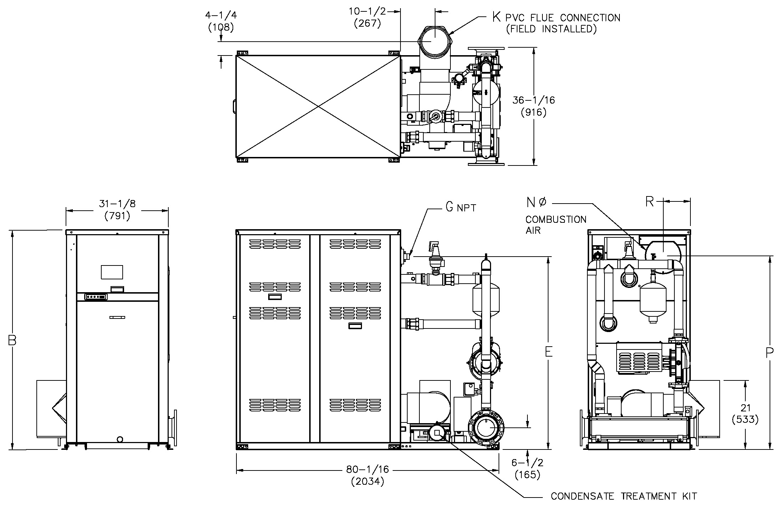

† Separate power connections are factory supplied and separate supply breakers must be field supplied.

** Current draw is for boiler only (Supply breaker must have delayed trip).

|  |  |  |  |
| --- | --- | --- | --- |
| Model | Amp Draw** (120V) | | |
| Boiler † | Boiler Pump † | Indirect Pump † |
| 1005A | 12** | 10 | > 7 |
| 1505A | 12** | 14 | 10.8 |

|  |  |  |  |  |  |  |  |  |  |  |
| --- | --- | --- | --- | --- | --- | --- | --- | --- | --- | --- |
| **Model**  **(H7-)** | **MBTUH** | | **Dimensions (in.)** | | | | | | | **Ship**  **Weight**  **(Lbs.)** |
| **In** | **Out** | **B**  **Height** | **E** | **G\***  **NPT** | **K Flue**  **Ø** | **N C/A**  **Ø** | **P** | **R** |
| 1005A | 999  (292.7) | 969  (283.9) | 55-1/4  (1403) | 47  (1194) | 1-1/4 | 6 | 6 | 47-1/8  (1197) | 8-5/16  (211) | 1343  (609) |
| 1505A | 1500  (439.6) | 1455  (426.4) | 67-1/8  (1705) | 59  (1499) | 1-1/4 | 8 | 8 | 59-1/8  (1502) | 8-3/16  (208) | 1448  (657) |

**\*** For Propane Gas, all models are 1” NPT.

Note: Ratings are shown for elevations up to 4,500 feet. For installations at elevations

Above 4,500 feet, please consult the factory for additional instructions.

# Professional Indirect Pool Heater

## Powered by XTherm®

## 1.0-1.5-2.0 MMBTUH Models Model:

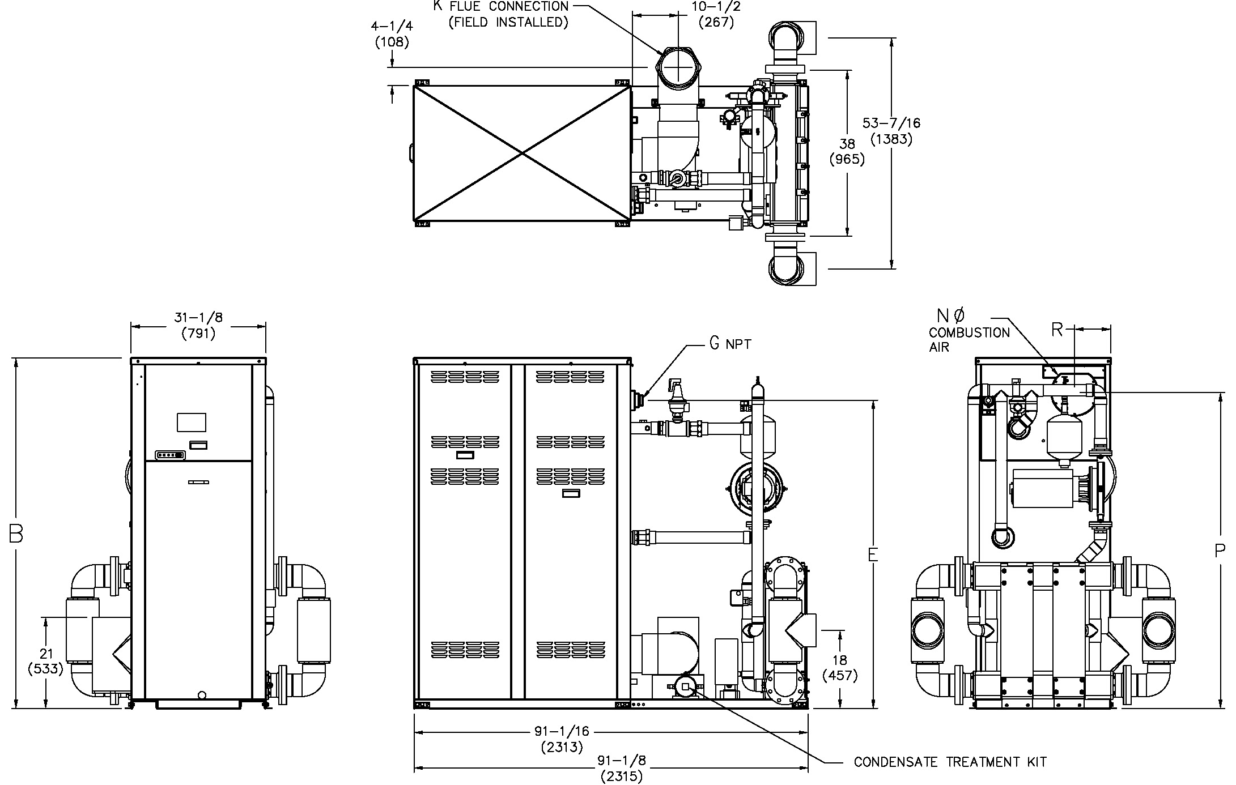

|  |  |  |  |
| --- | --- | --- | --- |
| Model | Amp Draw** (120V) | | |
| Boiler † | Boiler Pump † | Indirect Pump † |
| 2005A | 12** | 10 | > 15 |

† Separate power connections are factory supplied and separate supply breakers must be field supplied.

** Current draw is for boiler only (Supply breaker must have delayed trip).

|  |  |  |  |  |  |  |  |  |  |  |
| --- | --- | --- | --- | --- | --- | --- | --- | --- | --- | --- |
| **Model**  **(H7-)** | **MBTUH** | | **Dimensions (in.)** | | | | | | | **Ship**  **Weight**  **(Lbs.)** |
| **In** | **Out** | **B**  **Height** | **E** | **G\***  **NPT** | **K Flue**  **Ø** | **N C/A**  **Ø** | **P** | **R** |
| 2005A | 1999  (585.5) | 1939  (568.2) | 81-1/8  (2061) | 72  (1829) | 2 | 8 | 8 | 73-1/8  (1857) | 8-3/16  (208) | 1930  (875) |

**\*** For Propane Gas, all models are 1” NPT.

Note: Ratings are shown for elevations up to 4,500 feet. For installations at elevations

Above 4,500 feet, please consult the factory for additional instructions.

# Professional Indirect Pool Heater

## Powered by XTherm®

## 1.0-1.5-2.0 MMBTUH Models Model:

**Anchoring Details**

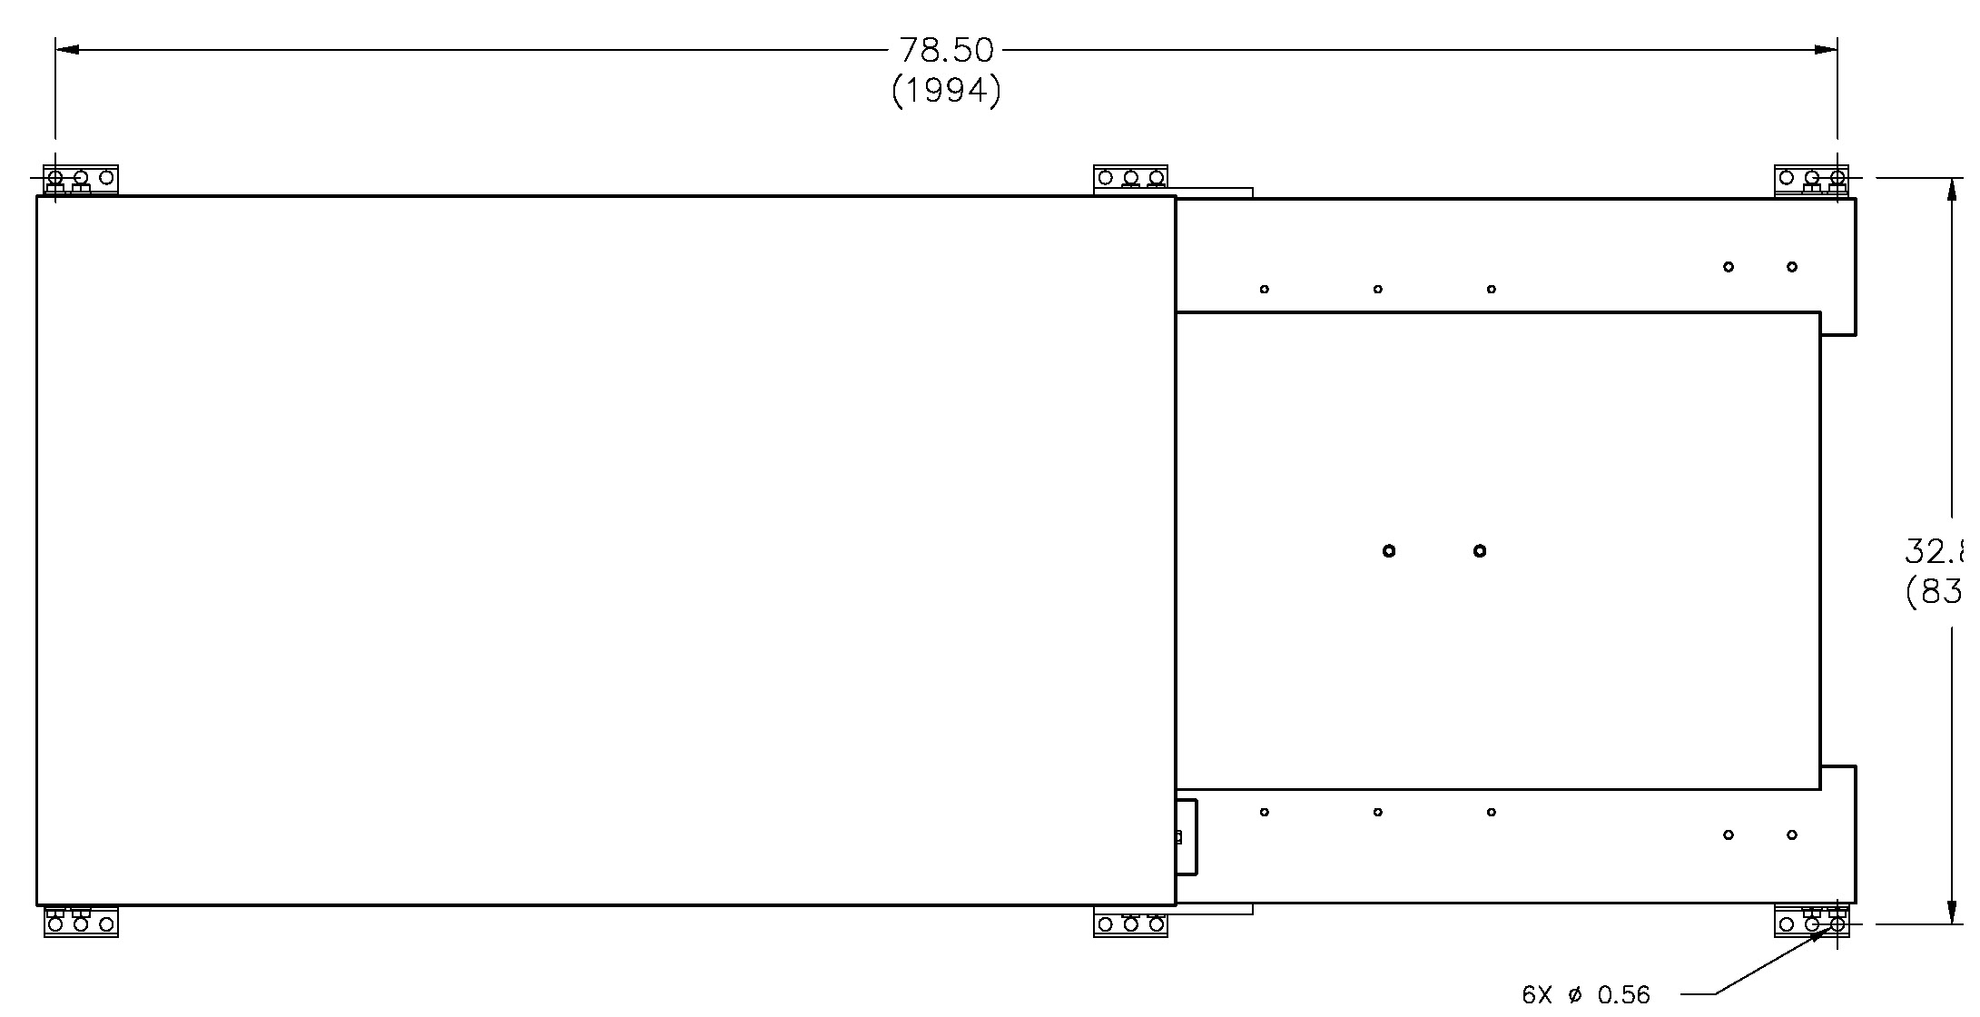

Models 1005A – 1505A

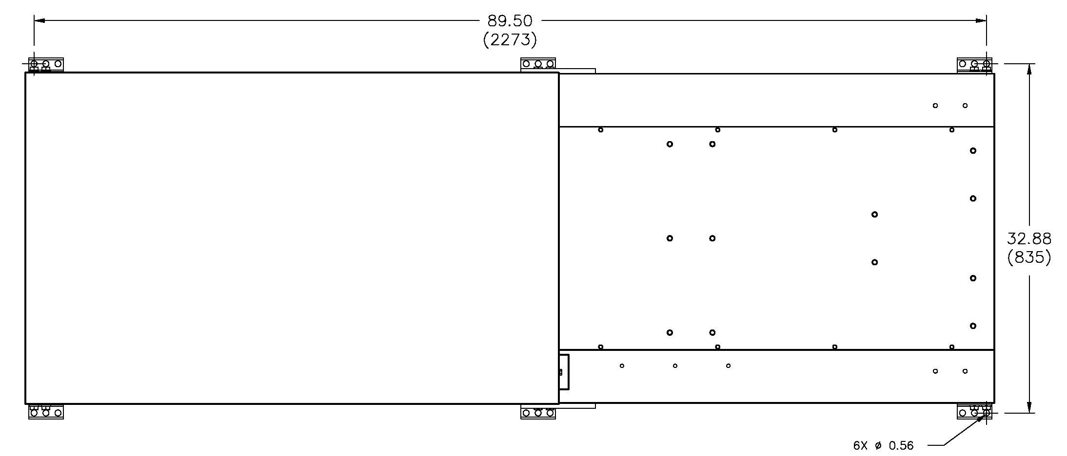

|  |  |  |
| --- | --- | --- |
| TDS Limit | Chlorine Limit | pH |
| 3,000 PPM | 2 – 3 PPM | 7.6 – 7.8 |

Water Chemistry

Models 2005A