Job:

MVB® - Type H

Heating Boilers
Models 504A-2004A

Engineer:

Contractor:
Prepared By: Date:
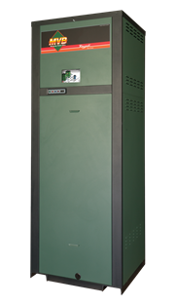Model: Indoor/Outdoor:
84% Thermal Efficiency at Full Rate
100% Factory Fire-Tested
VERSA IC® Modulating Controller with 7” color touchscreen display
Raymote™ remote connectivity provided standard
Electronic Modulation, 60% Minimum Fire
Full Safety Diagnostics with History
Status Display Lights
Modbus RTU BMS Port
Maximum Outlet Water Temperature: 235°F
Minimum Acceptable Inlet Water Temperature: 120°F
Limited Twenty-Five-Year Thermal Shock Warranty
Limited Ten-Year Heat Exchanger Warranty
Proudly Assembled in the USA
Ultra Low NOx – Less than 20PPM

Heat Exchanger
- Headers
Cast Iron – Standard
A-1 Bronze
- ASME H Stamped
160 PSIG MAWP
- National Board Approved
- Fin Tubing
Copper – Standard
A-3 Cupronickel
- ASME Powder-Coated Tube Sheet
- Silicone High-Temp O-Rings
- ASME Pressure Relief Valve
60 PSIG – Standard
PSIG – Optional
- Temperature and Pressure Gauge,
Shipped Loose
- Stainless Steel Evaporator Plate
- Four-pass heat exchanger

Control
- 120V, 60Hz, 1Ø, Power Supply
- 120/24V 60Hz Transformer
- VERSA IC® built-in control
- 7” color HD touchscreen display
- Raymote™ Wi-Fi remote connectivity
- Cascade up to 4 Boilers
- Ignition Module
3-Try – Standard
C-6 Single-Try
- Remote Flame Sensor
- Freeze Protection
- High Limit, Manual Reset, Fixed, 240ºF
- On/Off Power Switch
- Flow Switch
- Blocked Vent Pressure Switch
- Programmable Pump Time Delays
- Pump Outputs
- Boiler pump
- DHW Indirect – Pilot Duty
- System – Pilot Duty

Control (cont.)
- Water Temperature Sensors (7)
- Modbus RTU BMS Port
B-85 Gateway – BACnet MS/TP, BACnet IP, N2 Metasys or Modbus TCP
B-86 Gateway - LonWorks
- Cold Water Protection Function
Optional Variable Speed Pump
Optional Proportional Valve

Burner
- Hot Surface Ignition (HSI)
- Radially-Fired Knitted Burner

Gas Train
- Fuel
Natural Gas
Propane (Minimum Grade HD-5)
- Dual-Seat Combination Firing Valve
- Manual Shut-Off Valve

Construction
- Indoor/Outdoor Construction
- Enclosed Front Controls
- PolyTuf Powder Coat Finish
- Rear Connections (Water, Electrical, Gas, Vent, Combustion Air)
- Combustion Air Filter – Inline
- Design Certified ANSI Z21.13/CSA 4.9
- CSA Low Lead Certified ≤.25% Lead

Venting
- Vent Termination
D-11 Outdoor
D-15 Indoor, Horizontal
Indoor, Vertical (by others)
- Combustion Air
D-16 Air Intake Elbow
- Extractor – Optional
By others

Not required

Options
A-30 Air Vent, Auto, 150 PSI (Loose)
B-31 Dry-Well Assembly
B-32 Outdoor Air Sensor
F-10 Low Water Cut-Off, Remote Probe
I-1 High Limit, Auto Reset, Adj.,
100-240°F
I-2 High Limit, Manual Reset, Adj., 100-240°F (additional)
P- Pump: HP, 120V, 1∅, 60Hz
Cast Iron Bronze
Loose Mounted
P- Cold Water Start
P- Cold Water Run
S-1 Low Gas Pressure Switch,
Manual Reset
S-2 High Gas Pressure Switch, Manual Reset
Z-12 Condensate Treatment Kit

Additional Options or Accessories

Multi-Boiler Temperature Controllers
TempTracker Mod+ Hybrid
B-36 2-4 Heaters
B-37 5-10 Heaters
B-38 11-16 Heaters
B-39 EMS 4-20mA Remote Setpoint Interface Module
B-62 BACnet MS/TP Interface

MVB – Type H

Models 504A-2004A Model

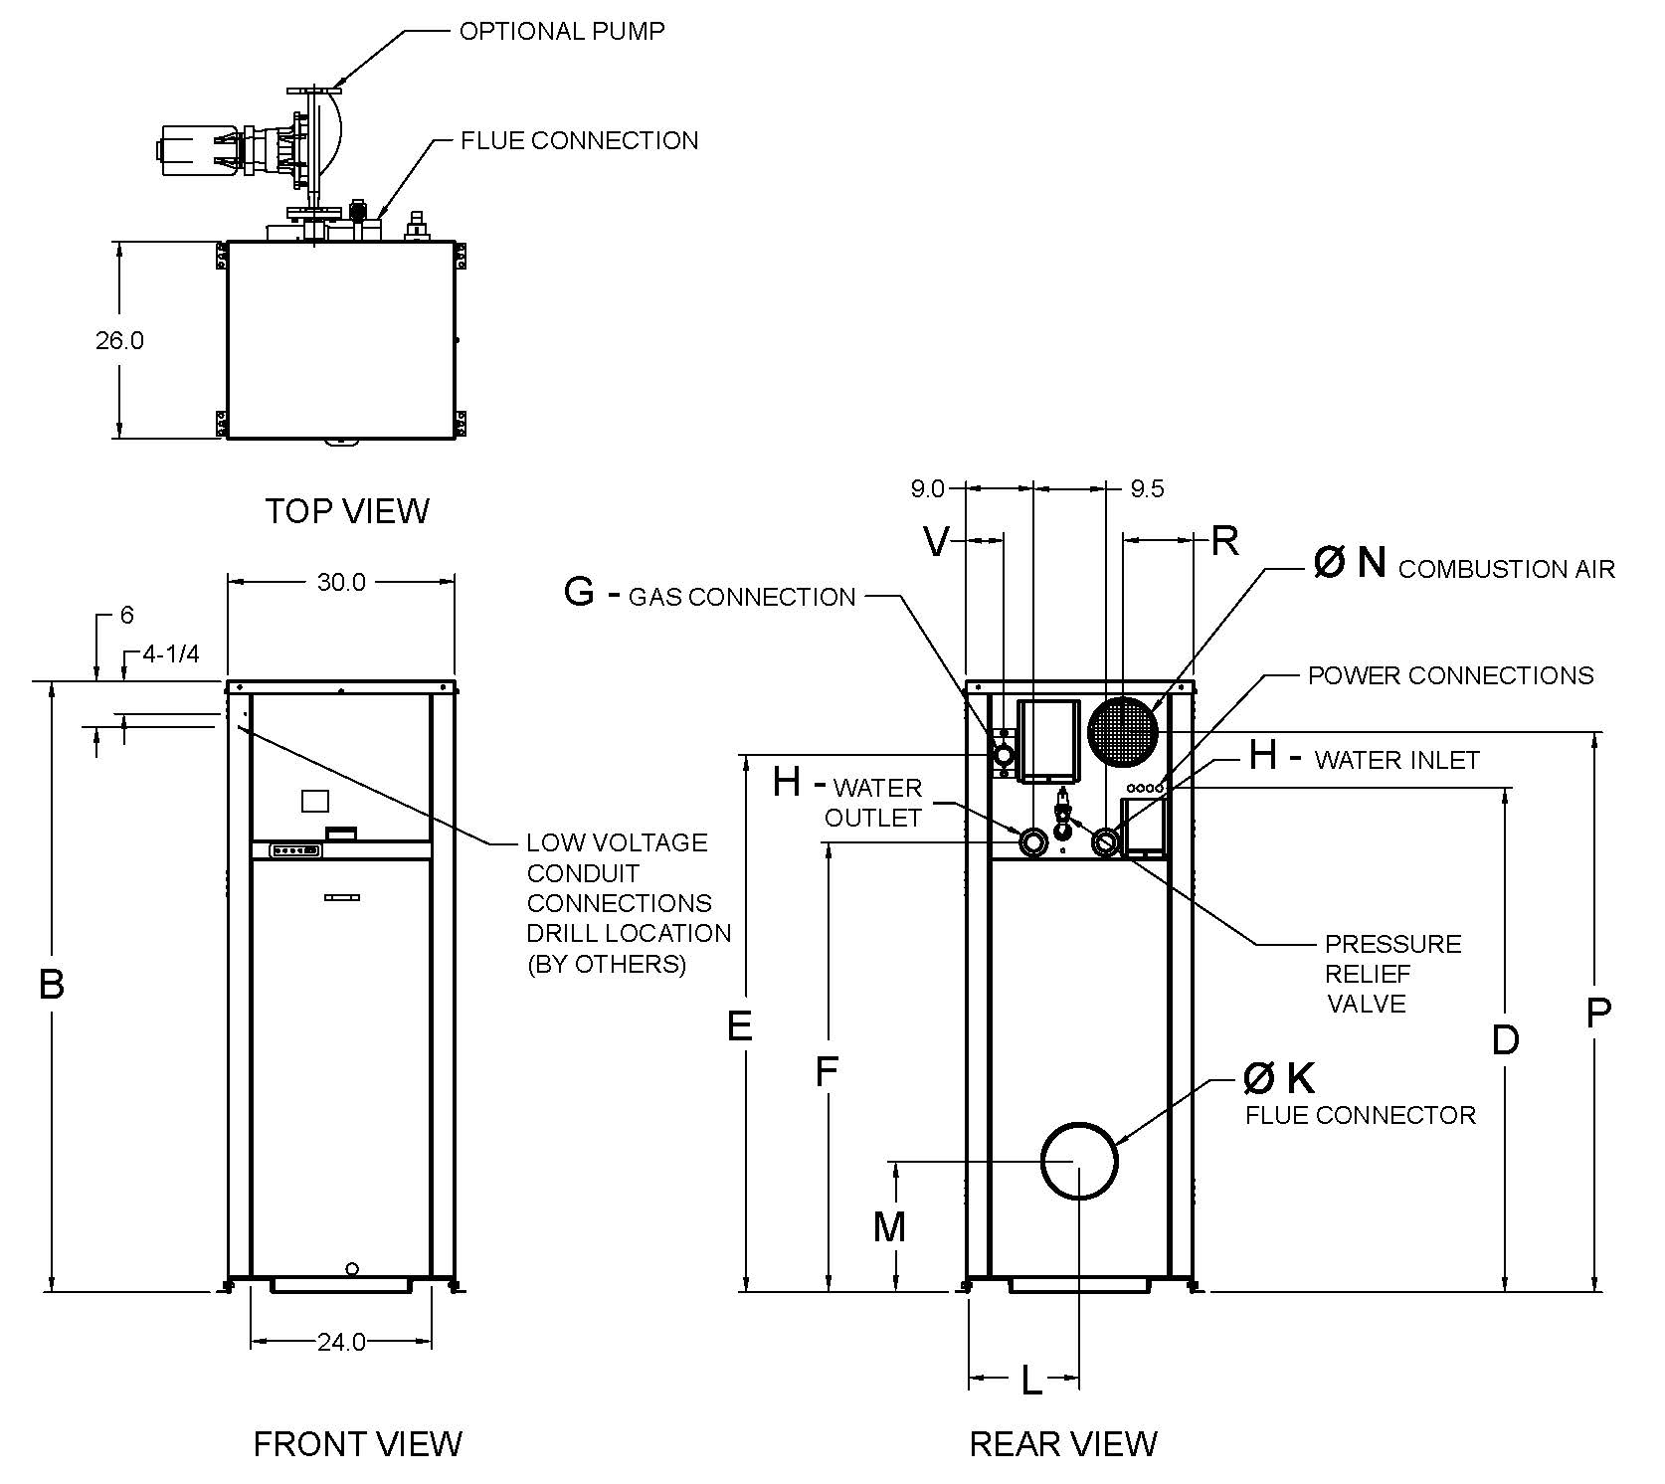
Model  (H7 - ) | Water Hardness
 | Soft | Medium | Hard
504A | 1/4 – 6 | 1/4 – 6 | 3/4 – 11
754A | 1/4 – 6 | 1/2 – 7 | 3/4 – 11
1104A | 1/4 – 6 | 1/2 – 7 | 1 – 14
1504A | 3/4 – 11 | 1 – 14 | 1 – 14
2004A | 1 – 14 | 1-1/2 – 16 | 1-1/2 – 16
PUMP HP – AMPS*

* Current draw is for Pump Only
CLEARANCES
 | Certified  Minimum | Recomm.  Service
Front | 24” | 24”
Rear | 12” | 24”
Right | 1” | N/A
Left | 1” | N/A
Top | 0” | 10”
Floor | 0” | N/A
Vent | 1” | N/A

Model  (H7-) | MBTUH |  |  | Dimensions (in.)
 |  |  | B  Height | D | E | F | G*  NPT | H  NPT | K  Flue Ø | L | M | N  C/A Ø | P | R | V
 | Input | Output
504A | 500 | 420 | 43-1/4 | 30-3/4 | 35 | 23-3/4 | 1 | 2 | 8 | 13-3/4 | 14-1/4 | 6 | 36-3/4 | 8-1/4 | 1-3/4
754A | 750 | 630 | 49 | 36-3/4 | 40-3/4 | 29-1/2 | 1 | 2 | 10 | 13-1/2 | 14-1/4 | 6 | 42-1/2 | 8-1/4 | 1-3/4
1104A | 1100 | 924 | 55 | 42-3/4 | 46-3/4 | 35-1/2 | 1-1/4 | 2-1/2 | 10 | 13-1/2 | 14-1/4 | 6 | 48-1/2 | 8-1/4 | 1-3/4
1504A | 1500 | 1260 | 61 | 48-3/4 | 53 | 41-3/4 | 1-1/4 | 2-1/2 | 12 | 13-3/4 | 17-1/4 | 8 | 54-3/4 | 8-1/4 | 1-3/4
2004A | 1999 | 1679 | 75 | 61 | 65-1/4 | 53-3/4 | 2 | 2-1/2 | 14 | 13-1/2 | 20 | 8 | 68-1/2 | 9-1/4 | 5
- *For natural gas. Propane all sizes 1” NPT.
- Ratings shown are for elevations up to 4,500 feet. For installations at elevations above 4,500 feet, please consult the factory for additional instructions. No hardware changes required below 10,000 ft.
- For direct vent applications, please contact the factory about relocating the pump.

* Current draw is for Boiler Only.
(Supply breaker must have delayed trip.)
Model  (H7 - ) | Shipping  Weight  (Lbs.) | Footprint  (ft²) | Amps*
504A | 600 | 5.4 | 12
754A  Raypak, Inc. 2151 Eastman Avenue, Oxnard, CA 93030 (805) 278-5300 Fax (800) 872-9725 www.raypak.com | 670 | 5.4 | 12
1104A | 720 | 5.4 | 12
1504A | 780 | 5.4 | 12
2004A | 940 | 5.4 | 18

MVB – Type H

Models 504A-2004A Model

RATES OF FLOW AND PRESSURE DROPS
Model  (H7-) | 20°F T |  | 30°F T |  | 39°F T* |  | Maximum Flow |  |  | Minimum Flow*
 | GPM | P (ft.) | GPM | P (ft.) | GPM | P (ft.) | GPM | P (ft.) | T (°F) | GPM | P (ft.) | T (°F)
504A | 42 | 2.7 | 28 | 1.4 | N/A | N/A | 100 | 11.3 | 8 | 25 | 1.1 | 34
754A | 63 | 6.0 | 42 | 2.9 | 32 | 1.7 | 100 | 13.8 | 13 | 32 | 1.7 | 39
1104A | 92 | 13.3 | 62 | 6.7 | 47 | 4.1 | 113 | 18.6 | 16 | 47 | 4.1 | 39
1504A | N/A | N/A | 84 | 13.3 | 65 | 8.0 | 113 | 22.2 | 22 | 65 | 8.0 | 39
2004A | N/A | N/A | 112 | 26.9 | 86 | 16.0 | 113 | 27.2 | 30 | 86 | 16.0 | 39
* Closed systems only
Raypak, Inc. • 2151 Eastman Avenue, Oxnard, CA 93030 • (805) 278-5300 • (Fax (800) 872-9725 • www.raypak.com

