Job:

# XTherm®

# Type H

## Heating Boilers

## Models 2505-4005

Engineer:

Contractor:

Prepared By:       Date:

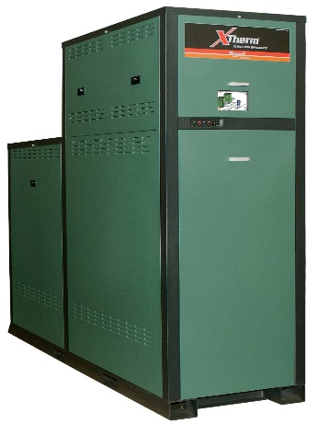Model:       Indoor/Outdoor:

96% Thermal Efficiency at Full Rate

100% Factory Fire-Tested

VERSA IC® Modulating Controller with Color Touch Screen Display

Full Electronic Modulation, Constant Ratio up to 11:1 Turndown

Full Safety Diagnostics with History

Status Display Lights

Cascade up to 4 Heaters – No External Sequencer Required

Modbus RTU BMS Port

Maximum Outlet Water Temperature: 235°F

Minimum Inlet Water Temperature: 50°F

Limited Twenty-Five-Year Thermal Shock Warranty

Limited Ten-Year Primary Heat Exchanger Warranty

flag%201Limited Ten-Year Stainless Steel Condensing Heat Exchanger Warranty

Proudly Assembled in the USA

Low NOx - BAAQMD Certified Per Rule 9-7.

#### Heat Exchanger

* Headers - Bronze
* ASME H Stamped; 160 PSIG MAWP
* National Board Listed
* Fin Tubing

Copper – Standard

A-3 Cupro-Nickel

* ASME Powder-Coated Tube Sheet
* Silicone High-Temp O-Rings
* ASME Pressure Relief Valve

60 PSIG – Standard

      PSIG – Optional

* Air Bleed Valve, Manual (2)
* T&P Gauge
* Four Pass Primary Heat Exchanger
* Stainless Steel Evaporator Plate
* 4 Inch Grooved Copper Water Connections

#### Control

* 240V, 60Hz, 1Ø, Power Supply
* 240/120V 60Hz Transformer
* 240/24V 60Hz Transformer
* VERSA IC® Integrated Control
* Cascade up to 4 Heaters
* Hot Surface Ignition (HSI)
* Ignition Module

3-Try – Standard

C-6 Single-Try

* Remote Flame Sensor
* Fixed High Limit, Manual Reset, 240°F
* On/Off Power Switch
* Flow Switch
* Blocked Vent Pressure Switch
* Freeze Protection
* Alarm Dry Contact
* High Gas Pressure Switch
* Pump outputs – Pilot Duty
* Injection Pump
* DHW Indirect
* System
* Programmable Pump Time Delays
* Color HD Touch Screen Display
* Modulating Temperature Control, Up to 11:1 Turndown
* Water Temperature Sensors (5)
* Cold Water Protection Function
* Modbus RTU BMS Port (Up to 115K Baud Rate, see Cat. No. 5000.73)

B-85 BMS Gateway, Modbus RTU to Modbus TCP, N2 Metasys, BACnet IP, or BACnet MS/TP

B-86 BMS Gateway, Modbus RTU to LonWorks

#### Burner

* Radially-Fired Knitted Burner

#### Gas Train

* Fuel

Natural Gas

Propane Gas (Minimum Grade HD5)

* Dual-Seat Combination Valve
* Manual Shut Off Firing Valve

#### Construction

* Indoor/Outdoor Construction
* Enclosed Front Controls
* PolyTuf Powder Coat Finish
* Rear Connections (Water, Gas, Vent, Electrical, Comb. Air)
* Combustion Air Filter
* Front Connection Low Voltage Wiring
* Design Certified ANSI Z21.13/CSA 4.9

#### Venting

* Vent Termination

D-11 Outdoor or Indoor, Vertical – (Cat IV)

D-15 Indoor, Horizontal – (Cat IV)

D-33 Polypropylene Vent Adaptor

* Extractor – Optional

By others

Not required

#### Options

B-31 Sensor well

B-32 Outdoor Air Sensor

F-10 Low Water Cut-Off, Remote Probe

I-6 High Limit, Auto Reset, Adj.,   
100-240°F

I-12 High Limit, Manual Reset, Adj., 100-240°F

S-1 Low Gas Pressure Switch,   
Manual Reset

Z-12 Condensate Treatment Kit

#### Additional Options or Accessories

#### 

#### Multi-Boiler System Controllers

TempTracker Mod+ Hybrid,

B-36 2-4 Boilers

B-37 5-10 Boilers

B-38 11-16 Boilers

B-39 EMS 4-20 mA Remote Set-point Interface Module

B-62 BACnet MS/TP Interface



Raypak-Rheem logo, submittals

XTherm® - Type H

Models 2505-4005 Model

**NOTE*:* Primary/Secondary plumbing arrangement is mandatory for proper operation.**

**Clearances – in**

|  |  |  |  |  |  |  |  |  |
| --- | --- | --- | --- | --- | --- | --- | --- | --- |
|  | Front | Rear | Right | Left | Top | Floor | Vent | Vent Cap (outdoor) |
| Combustible Minimum | 24 | 12 | 1 | 1 | 0 | 0 | 1 | 12 |
| Minimum Service | 30 | 36 | 24 | 1 | 12 | N/A | N/A | 12 |

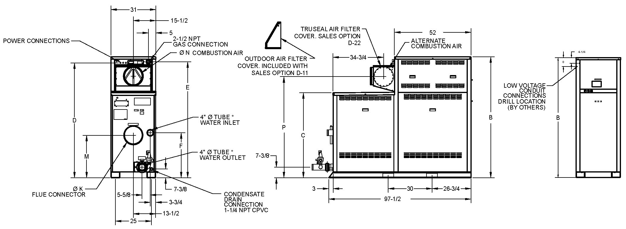

|  |  |  |  |  |  |  |  |  |  |  |  |  |  |  |  |
| --- | --- | --- | --- | --- | --- | --- | --- | --- | --- | --- | --- | --- | --- | --- | --- |
| **Model**  **(H7-)** | **MBTUH** | | **Dimensions – inches** | | | | | | | | | **Amp** Draw** | **Thermal Efficiency**  **(BTS-2000)** | **Turn Down** | **Shipping Weight**  **(Lbs.)** |
| **B** | **C** | **D** | **E** | **F** | **K**  **Flue** | **M** | **N**  **C/A** | **P** |
| **Input** | **Output** |
| 2505 | 2501 | 2401 | 68-1/4 | 43-1/2 | 64-1/8 | 65 | 21-1/4 | 10 | 18-1/2 | 10 | 54-5/8 | 12 | 96% | 11:1 | 2656 |
| 3005 | 3000 | 2880 | 73-1/4 | 48-1/2 | 69-1/8 | 70 | 26-1/4 | 10 | 23-1/2 | 10 | 59-1/2 | 15 | 10:1 | 2775 |
| 3505 | 3500 | 3360 | 78-1/4 | 53-1/2 | 74 | 75 | 31-1/4 | 10 | 28-1/2 | 12 | 64-3/4 | 17 | 10:1 | 2925 |
| 4005 | 4000 | 3840 | 83-1/4 | 58-1/2 | 79 | 80 | 31 | 12 | 29-1/4 | 12 | 69-5/8 | 20 | 7:1 | 3058 |

* Water connections are grooved copper tube.

** Amp draw is for boiler only and does not include pumps or accessories. Pump amp draw provided in separate table below.

|  |  |  |  |  |
| --- | --- | --- | --- | --- |
| **Model (H7-)** | **Internal Boiler Pump** | | **External Injection Pump\*** | |
| **HP** | **Amp Draw** | **HP** | **Amp Draw** |
| 2505 | 1.5 | 8.2 | 1.0 | 7 |
| 3005 | 1.5 | 8.2 | 1.5 | 8.2 |
| 3505 | 1.5 | 8.2 | 1.5 | 8.2 |
| 4005 | 3.0 | 16 | 1.5 | 8.2 |

Pumps are 240VAC/1PH.

*External injection pump ships loose for field installation.

**Performance capacity for injection pump, operating at full rate**

|  |  |  |  |  |  |  |  |  |  |  |  |  |  |
| --- | --- | --- | --- | --- | --- | --- | --- | --- | --- | --- | --- | --- | --- |
| System Return Temp. (ºF) | Model 2505 (30°F Delta T) | | | | Model 3005 (30°F Delta T) | | | Model 3505 (32°F Delta T) | | | Model 4005 (33°F Delta T) | | |
| Supply Temp. (ºF) | Flow (GPM) | Pipe Max  Equiv. Ft | | Supply Temp. (ºF) | Flow (GPM) | Pipe Max  Equiv. Ft | Supply Temp. (ºF) | Flow (GPM) | Pipe Max  Equiv. Ft | Supply Temp. (ºF) | Flow (GPM) | Pipe Max  Equiv. Ft |
| 3” | 4” | 4” | 4” | 4” |
| 60 | 144 | 57 | 230 | 450 | 146 | 67 | 110 | 148 | 76 | 100 | 144 | 91 | 100 |
| 80 | 144 | 75 | 230 | 450 | 146 | 87 | 110 | 148 | 99 | 100 | 144 | 120 | 100 |
| 100 | 144 | 109 | 230 | 450 | 146 | 125 | 110 | 148 | 140 | 100 | 144 | 175 | 100 |
| 120 | 150 | 160 | 230 | 450 | 150 | 192 | 110 | 152 | 210 | 100 | 153 | 233 | 100 |
| 140 | 170 | 160 | 230 | 450 | 170 | 192 | 110 | 172 | 210 | 100 | 173 | 233 | 100 |
| 160 | 190 | 160 | 230 | 450 | 190 | 192 | 110 | 192 | 210 | 100 | 193 | 233 | 100 |

*Pipe size is determined by velocity not to exceed 7.5 ft. per second.

XTherm® - Type H

Models 2505-4005 Model

**NOTE: Primary/Secondary plumbing arrangement is mandatory for proper operation.**

**Base Anchor Bolt Pattern**

**Models H7-2005 TO -4005**

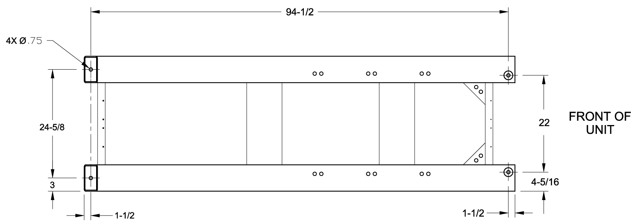

**External Injection Pump – Field Installed on Inlet Piping**

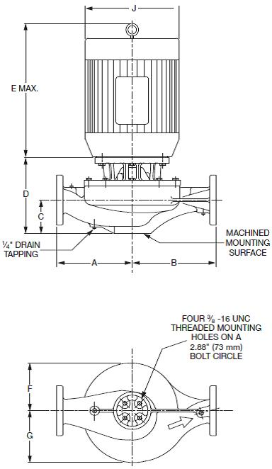

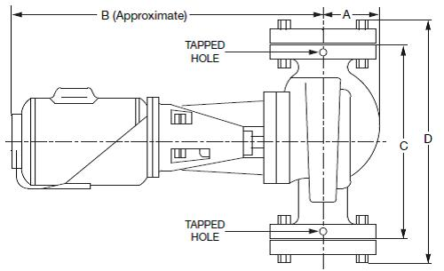

**H7–2505 TO -3005**

2-1/2” NPT Flanges Included

|  |  |  |  |  |  |  |  |  |  |
| --- | --- | --- | --- | --- | --- | --- | --- | --- | --- |
| **Model**  **(H7-)** | Dimensions – inches | | | | | | | | |
| **A** | **B** | **C** | **D** | **E** | **F** | **G** | **H** | **J** |
| 2505 | 3-1/2 | 19 | 13-1/2 | 16-1/8 | N/A | N/A | N/A | N/A | N/A |
| 3005 | 3-5/8 | 21 | 16-1/2 | 19-1/2 | N/A | N/A | N/A | N/A | N/A |
| 3505 | 10 | 10 | 6-5/16 | 10-1/2 | 13-15/16 | 5-5/16 | 6-5/16 | 1/4 | 7-7/8 |
| 4005 |

3” ANSI Flange – By Others

**H7–3505 TO -4005**

Raypak, Inc. • Eastman Avenue, Oxnard, CA 93030 • (805) 278-5300 • (805) 872-9725 • www.raypak.com