Job:

# XFyre® - Type H

## Condensing Heating Boilers Models 300A-850A

Engineer:

Contractor:

Prepared By:       Date:

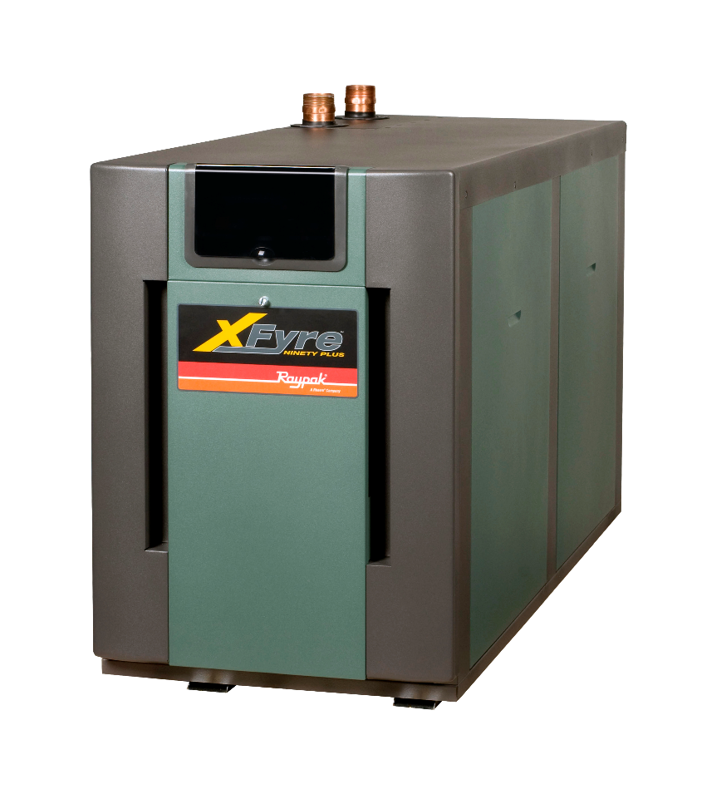Model:       Indoor/Outdoor:

Stainless Steel Water-tube Construction

94% Thermal Efficiency at Full Rate

VERSA IC® Modulating Controller

LCD Status Display with Full Diagnostics and Fault Memory

Cascade up to Four Heaters – No External Sequencer Required

Modbus RTU BMS Port

Soft Start, Electronic Modulation, 5:1 Turndown

Maximum Outlet Water Temperature: 195ºF

Maximum System Temperature: 190ºF

100% Factory Fire Tested

Zero Clearance to Combustibles

Indoor/Outdoor Construction Standard

PVC, CPVC, Centrotherm™ Polypropyleneor Stainless Venting Certified1

Meets 2012 NOx Requirements (< 20 ppm)

Limited Twenty-Five-Year Thermal Shock Warranty

Proudly Assembled in the USA

Limited Ten-Year Heat Exchanger Warranty

#### Heat Exchanger

* All Stainless Steel Construction with Copper Connections
* Gasketless Heat Exchanger Design
* ASME H Stamped  
  160 PSIG Working Pressure
* National Board Approved
* ASME Pressure Relief Valve, Loose

45 PSIG – Standard (300 & 400)

60 PSIG – Standard (500 – 850)

    PSIG – Optional

* Temperature and Pressure Gauge,  
  Shipped Loose

#### Control

* 120V, 60Hz, 1Ø, Power Supply
* VERSA IC with LCD display
* Outdoor Reset with Indirect Priority
* 0-10 VDC input for BMS
* Cascade up to 4 boilers
* Remote Flame Sensor
* High Limit, Manual Reset, Fixed, 200ºF
* Alarm Dry Contact Connection
* On/Off Power Switch
* Flow Switch
* Blocked Vent Pressure Switch
* Boiler, DHW & System Pump Contacts
* Water Temperature Sensors (5)10kΩ (3 shipped loose)

#### Burner

* Spark Ignition (DSI)
* Ultra-Low NOx: Less than 20 PPM

#### Gas Train

* Fuel

Natural Gas

Propane

* Dual-Seat Combination Valve
* H7 Electronic Modulating Firing Mode

#### Construction

* Indoor/Outdoor Construction
* Front Controls Enclosed
* PolyTuf Powder Coat Finish
* Rear Connections (Electrical, Gas, Vent, Combustion Air)
* Top Connections (Water)
* Design Certified ANSI Z21.13/  
  CSA 4.9
* Combustion Air Filter
* Condensate Trap
* CSA Low Lead Certified (≤.25% Pb)

#### Venting (PVC-CPVC-Centrotherm™ Polypropylene - Stainless1)

* Vent Termination

D-11 Outdoor

D-15 Indoor, Horizontal

D-33 Polypropylene Adapter

* Extractor - Optional

By others

Not required

#### Multi-Boiler System Controllers

B-36 TempTracker Mod+ Hybrid Digital

Controller, 2-4 Boilers, OA Reset

B-37 TempTracker Mod+ Hybrid Digital

Controller, 5-10 Boilers, OA Reset

B-38 TempTracker Mod+ Hybrid Digital

Controller, 11-16 Boilers, OA Reset

#### Options

B-31 Well Assembly

B-32 Outdoor Air Sensor (1) 10kΩ

D-21 TruSeal® Combustion Air Inlet (Mounted)

D-22 TruSeal® Combustion Air Inlet (Loose)

F-10 Low Water Cut-Off, Remote Probe

P-   Pump:      HP, 120V, 1∅, 60Hz

Cast Iron

Bronze/SS

S-1/S-2 High/Low Gas Pressure Switch,

Manual Reset

Z-12 Condensate Neutralizer Kit

#### Regulatory Agency Requirements



Raypak-Rheem logo, submittals

Note 1: PVC venting on Models H7-700A and H7-850A is acceptable with system temperatures below 130°F only.

See I & O Manual Cat. 1000.65

XFyre® – Type H

Models 300A-850A Model

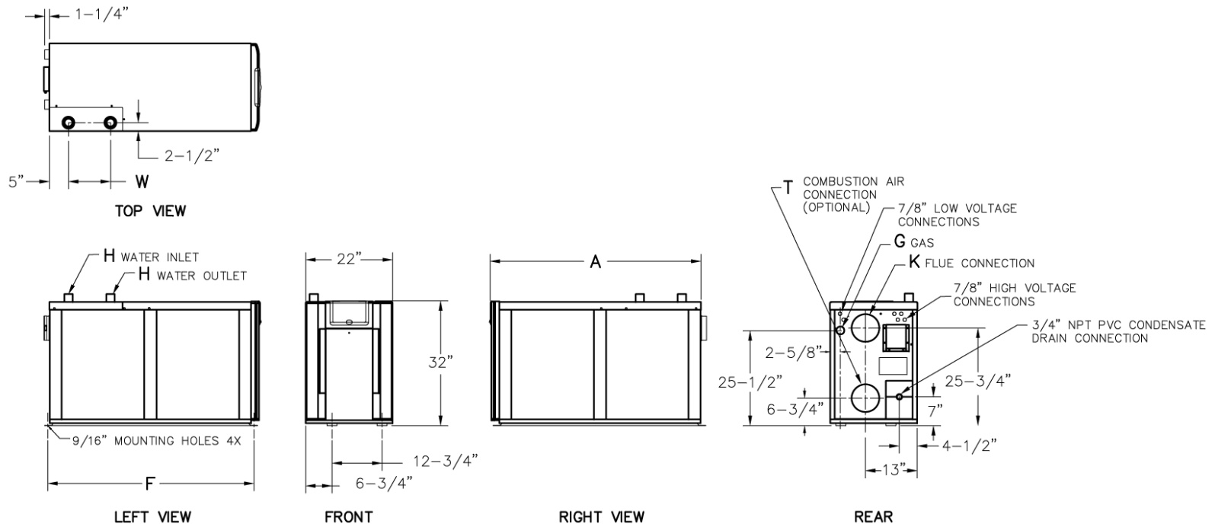

|  |  |  |
| --- | --- | --- |
|  | **CLEARANCES (in.)** | |
|  | **Certified**  **Minimum** | **Service**  **Minimum** |
|  |
| **Front** | 24 | 24 |
| **Rear** | 24 | 24 |
| **Right** | 0 | 0 |
| **Left** | 0 | 0 |
| **Top** | 12 | 24 |
| **Floor** | 0 | -- |
| **Vent** | 1 | -- |

|  |  |  |  |  |  |  |  |  |  |
| --- | --- | --- | --- | --- | --- | --- | --- | --- | --- |
| **Model**  **(H7-)** | **MBTUH** | | **Dimensions (in.)** | | | | | | |
| **Input** | **Output** | **A**  **Length** | **F**  **Mounting** | **G**  **NPT** | **H**  **NPT** | **K**  **Flue Ø** | **T**  **C/A Ø** | **W**  **(Water)** |
| 300A | 300 | 282 | 28-1/4 | 27-9/16 | 3/4 | 1-1/2 | 4 | 4 | 8-1/2 |
| 400A | 399 | 375 | 30-3/4 | 32-5/16 | 1 | 2 | 4 | 4 | 7 |
| 500A | 500 | 470 | 37-1/4 | 36-9/16 | 1 | 2 | 4 | 4 | 8-1/2 |
| 700A | 700 | 658 | 47-3/4 | 49-5/16 | 1-1/4 | 2 | 6 | 6 | 10-5/8 |
| 850A | 850 | 799 | 54-1/4 | 53-9/16 | 1-1/4 | 2 | 6 | 6 | 10-5/8 |

|  |  |  |  |  |  |  |  |  |  |  |  |  |
| --- | --- | --- | --- | --- | --- | --- | --- | --- | --- | --- | --- | --- |
| **RATES OF FLOW AND PRESSURE DROPS** | | | | | | | | | | | | |
| **Model**  **(H7-)** | **20ºF ∆T** | | **30ºF ∆T** | | **35ºF ∆T** | | **Min Flow** | | | **Max Flow** | | |
| **GPM** | **∆P\*\*** | **GPM** | **∆P\*\*** | **GPM** | **∆P** | **GPM** | **∆P\*\*** | **∆T** | **GPM** | **∆P\*\*** | **∆T** |
| 300A | 28 | 17 | 19 | 8 | 16 | 6 | 14 | 5 | 39 | 36 | 28 | 16 |
| 400A | 38 | 18 | 25 | 7 | 21 | 5 | 19 | 4 | 39 | 47 | 29 | 16 |
| 500A | 47 | 16 | 31 | 7 | 27 | 5 | 24 | 4 | 39 | 56 | 23 | 17 |
| 700A | 66 | 30 | 44 | 13 | 38 | 9 | 34 | 7 | 39 | 70 | 34 | 19 |
| 850A* | 80 | 40* | 53 | 17 | 46 | 12 | 41 | 10 | 39 | 80 | 40 | 20 |

|  |  |  |  |
| --- | --- | --- | --- |
| **Model**  **(H7-)** | **Amps\*** | **Foot-**  **Print**  **(ft2)** | **Ship**  **Weight**  **(lbs.)** |
| 300A | 3 | 4.3 | 410 |
| 400A | 4 | 4.7 | 465 |
| 500A | 4 | 5.7 | 505 |
| 700A | 5 | 7.3 | 580 |
| 850A | 5 | 8.3 | 580 |

* Closed systems only

** Connected plumbing pressure drops are not included.

* Current draw is for heater only.

(Supply breaker must have delayed trip.)