Job:

MVB® - Type WH

Water Heaters
Models 504A-2004A

Engineer:

Contractor:
Prepared By: Date:
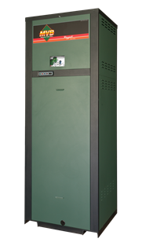Model: Indoor/Outdoor:
83% to 83.3% Thermal Efficiency at full rate
100% Factory Fire-Tested
VERSA IC® Integrated Controller with 7” color touchscreen display
Raymote™ remote connectivity provided standard
On/Off Firing with Soft-Start ignition
Full Safety Diagnostics with History
Status Display Lights
Cascade up to 4 Heaters – No External Sequencer Needed
Modbus RTU BMS Port
CSA Low Lead Certified ≤.25% Lead
Maximum Outlet Water Temperature: 200°F
Maximum Tank Setpoint: 150°F
Minimum Acceptable Inlet Water Temperature: 120°F
Limited Five-Year Copper/Ten-Year Cupronickel Heat Exch. Warranty
Proudly Assembled in the USA
Ultra-Low NOx, Less than 20 PPM

Heat Exchanger
- Headers - Bronze
- ASME HLW Stamped
160 PSIG MAWP
- National Board Approved
- Fin Tubing
Copper – Standard
A-3 Cupronickel
- ASME Powder-Coated Tube Sheet
- Silicone High-Temp O-Rings
- ASME Pressure Relief Valve
125 PSIG – Standard
150 PSIG – Optional
- Temperature and Pressure Gauge,
Shipped Loose
- Four pass primary heat exchanger
- Stainless Steel Evaporator Plate

Control
- 120V, 60Hz, 1Ø, Power Supply
- 120/24V 60Hz Transformer
- VERSA IC® built-in controller
- 7” color HD touchscreen display
- Raymote Wi-Fi remote connectivity
- Cascade up to 4 Heaters
- Ignition Module
3-Try – Standard
C-6 Single-Try
- Remote Flame Sensor
- Freeze Protection
- High Limit, Manual Reset, Fixed, 200ºF
- On/Off Power Switch
- Flow Switch
- Blocked Vent Pressure Switch
- Programmable Pump Time Delays
- Pump Outputs
- Water Heater
- System – Pilot Duty

Control (cont.)
- Water Temperature Sensors (3)
- Cold Water Protection Function
Optional Variable-Speed Pump
- Modbus RTU BMS Port
B-85 BMS Gateway – BACnet MS/TP, BACnet IP, N2 Metasys or Modbus TCP
B-86 BMS Gateway – LonWorks

Burner
- Hot Surface Ignition (HSI)
- Radially-Fired Knitted Burner

Gas Train
- Fuel
Natural Gas
Propane (Minimum Grade HD-5)
- Dual-Seat Combination Firing Valve
- Manual Shut-Off Valve

Construction
- Indoor/Outdoor Construction
- Front Controls Enclosed
- PolyTuf Powder Coat Finish
- Rear Connections (Water, Electrical, Gas, Vent, Combustion Air)
- In-line Combustion Air Filter Kit
- Design Certified ANSI Z21.10.3/CSA 4.3
- CSA Low Lead Certified ≤.25% Lead

Venting
- Vent Termination
D-11 Outdoor
D-15 Indoor, Horizontal
Indoor, Vertical (by others)
- Combustion Air
D-16 Air Intake Elbow
- Extractor – Optional
By others
Not required

Options
A-30 Air Vent, Auto, 150 PSI (loose)
F-10 Low Water Cut-Off, Remote Probe
I-1 High Limit, Auto Reset, Adj.,
40-180°F
I-2 High Limit, Manual Reset, Adj., 100-200°F (additional)
P- Pump: HP, 120V, 1∅, 60Hz
Water Hardness: GPG
Bronze
Loose Mounted
P- Cold Water Run
S-1 Low Gas Pressure Switch,
Manual Reset
S-2 High Gas Pressure Switch, Manual Reset
Z-12 Condensate Treatment Kit

Additional Options or Accessories

MVB – Type WH

Models 504A-2004A Model

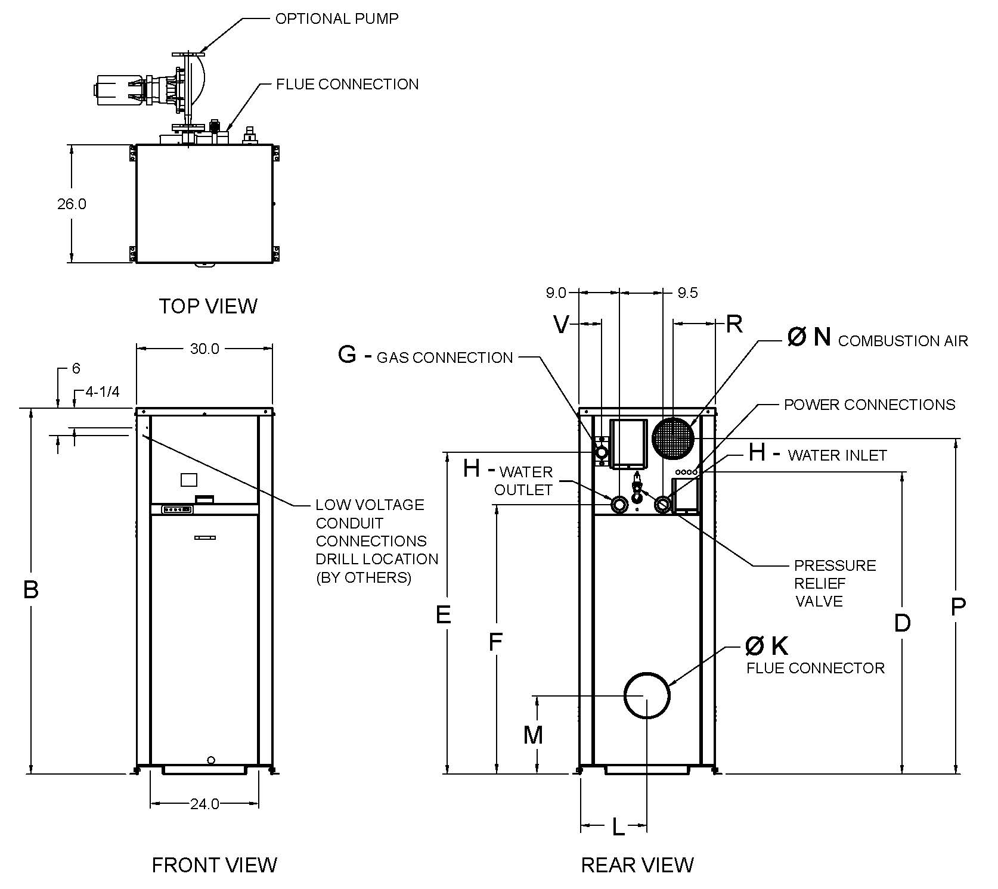

Model  (WH1-) | MBTUH |  |  | Dimensions (in.) |  |  |  |  |  |  |  |  |  |  |  | Ship  Weight  (Lbs.) | Foot-  print  (Ft²) | Amps**
 |  |  | B | D | E | F | G* | H | K | L | M | N | P | R | V
 | Input | Output | Height |  |  |  | NPT | NPT | Flue Ø |  |  | C/A Ø
504A | 500 | 415 | 43 | 30 | 35 | 23-3/4 | 1 | 2 | 8 | 13-3/4 | 14-1/8 | 6 | 36 | 8 | 2 | 600 | 5.4 | 12
754A  Raypak, Inc. 2151 Eastman Avenue, Oxnard, CA 93030 (805) 278-5300 Fax (800) 872-9725 www.raypak.com | 750 | 623 | 49 | 36 | 41 | 29-3/4 | 1 | 2 | 10 | 13-1/2 | 16 | 6 | 42 | 8 | 2 | 670 | 5.4 | 12
1104A | 1045 | 870 | 55 | 43 | 47 | 35-3/4 | 1-1/4 | 2-1/2 | 10 | 13-1/2 | 16 | 6 | 49 | 8 | 2 | 720 | 5.4 | 12
1504A | 1425 | 1187 | 61 | 50 | 53 | 41-3/4 | 1-1/4 | 2-1/2 | 12 | 13-3/4 | 18-1/8 | 8 | 53 | 8 | 2 | 780 | 5.4 | 12
2004A | 1900 | 1583 | 75 | 61 | 65 | 53-3/4 | 2 | 2-1/2 | 14 | 13-1/2 | 20-1/8 | 8 | 69 | 9 | 5 | 940 | 5.4 | 18

- Ratings shown are for elevations up to 4,500 feet. For installations at elevations above 4,500 feet, please consult the factory for additional instructions. NO hardware changes required under 10,000 ft.
* For Natural Gas. For Propane, all Sizes 1 NPT.
** Current draw is for heater only. (Supply breaker must have delayed trip.)

MVB – Type WH

Models 504A-2004A Model

PUMP HP – AMPS* CLEARANCES

Model (WH-1) | Water Hardness
 | Soft | Medium | Hard
504A | 1/4 – 6 | 1/4 – 6 | 3/4 - 11
754A | 1/4 – 6 | 1/2 – 7 | 3/4 - 11
1104A | 1/4 – 6 | 1/2 – 7 | 1 - 14
1504A | 1/2 – 7 | 1 - 14 | 1 - 14
2004A | 1 – 14 | 1 1/2 - 16 | 1 1/2 - 16
 | Certified Minimum | Recommended Service
Front | 24” | 24”
Rear | 12” | 24”
Right | 1” | 1”
Left | 1” | 1”
Top | 0” | 10”
Floor | 0” | 0”
Vent | 1” | 1”
*Current draw is for pump only

SHL includes 50ft of tubing each way (total 100 ft.).
* Must use optional cupronickel heat exchanger.
** If over 25 GPG, a water softener MUST be used.
 | Water Hardness
 | Soft |  |  |  |  | Medium |  |  |  |  | Hard*
 | 3-4 Grains Per Gallon |  |  |  |  | 5-15 Grains Per Gallon |  |  |  |  | 16-25 Grains Per Gallon**
Model | ΔT  (ºF) | GPM | ΔP  (ft wc) | MTS  (in) | SHL  (ft wc) | ΔT  (ºF) | GPM | ΔP  (ft wc) | MTS  (in) | SHL  (ft wc) | ΔT  (ºF) | GPM | ΔP  (ft wc) | MTS  (in) | SHL  (ft wc)
504A | 17 | 50 | 3.6 | 2 | 8.3 | 17 | 50 | 3.6 | 2 | 8.3 | 9 | 95 | 10.4 | 2 | 25.7
754A | 25 | 50 | 4.0 | 2 | 8.7 | 17 | 73 | 7.8 | 2 | 17.3 | 14 | 90 | 11.4 | 2 | 25.3
1104A | 20 | 85 | 11.5 | 2-1/2 | 16.2 | 20 | 85 | 11.5 | 2-1/2 | 16.2 | 15 | 116 | 19.6 | 2-1/2 | 27.8
1504A | 25 | 94 | 18.4 | 2-1/2 | 24.0 | 23 | 105 | 22.5 | 2-1/2 | 29.3 | 21 | 115 | 26.5 | 2-1/2 | 34.6
2004A | 29 | 109 | 28.6 | 2-1/2 | 36.0 | 29 | 109 | 28.6 | 2-1/2 | 36.0 | 29 | 109 | 28.6 | 2-1/2 | 36.0

 | Recovery Rates
 | Temperature Rise (°F)
 | 20 | 30 | 40 | 50 | 60 | 70 | 80 | 90 | 100 | 110
504A | 2515 | 1677 | 1258 | 1006 | 838 | 719 | 629 | 559 | 503 | 457
754A | 3773 | 2515 | 1886 | 1509 | 1258 | 1078 | 943 | 838 | 755 | 686
1104A | 5226 | 3517 | 2638 | 2110 | 1759 | 1507 | 1319 | 1172 | 1055 | 959
1504A | 7194 | 4796 | 3597 | 2878 | 2398 | 2055 | 1799 | 1599 | 1439 | 1308
2004A | 9592 | 6395 | 4796 | 3837 | 3197 | 2741 | 2398 | 2132 | 1918 | 1744

Raypak, Inc. ▪ 2151 Eastman Avenue, Oxnard, CA 93030 ▪ (805) 278-5300 ▪ Fax (805) 872-9725 ▪ www.raypak.com

