Job:

# Hi Delta® FlexGas® - Type WH

## Dual-Fuel Water Heaters Models 992BD-2342BD

Engineer:

Contractor:

Prepared By:       Date:

992-2342%20FlexGas%20IsoModel:       Indoor/Outdoor:       MBTUH Input:

Fast, Economical Natural-to-Propane Gas Switchover

100% Factory Fire Tested

Efficiency: 85%

Maximum Outlet Temperature: 200°F

Minimum Non-Condensing Inlet Temperature: 105°F

Thermal Shock Proof Heat Exchanger

Limited Twenty-Five-Year Thermal Shock Warranty

Limited Five-Year Heat Exchanger Warranty

Diagnostic Center with Fault History

Patent Nos. 6,904,873 & 7,044,124; other patents pending

PolyTuf Powder Coated Cabinet

No Combustible Floor Shield Required

Fan-Assisted

 Proudly Assembled in the USA

Patented Burner Security Blanket

#### Heat Exchanger

* HLW Stamp
* Headers

Bronze – Standard

Glass-Lined Cast Iron –   
Option A-2

* ASME Inspected and Stamped  
  160 PSIG Working Pressure
* National Board Approved
* Fin Tubing

Copper – Standard

Cupro Nickel – Option A-3

* ASME Steel Tube Sheet
* Silicone High Temp. O-Rings
* ASME Pressure Relief Valve

125 PSIG – Standard

A6 – 150 PSIG – Optional

* Temperature and Pressure Gauge
* Water Connections

Left – Standard

Right – Option A-6

#### Controls

* 120V, 60Hz, 1∅ Power Supply
* 120/24V 60Hz Transformer
* 100% Shut-Off/Lockout
* Hot Surface Ignition
* Remote Flame Sensor
* High Limit Control, Manual Reset
* On/Off Power Switch
* Manual Shut-Off, Front-Mounted
* Flow Switch
* Blocked Vent Pressure Switch
* Combustion Air Proving Switches
* Economaster Pump Time Delay
* Enable/Disable

#### Raypak-Rheem logo_submittalsGas Train

* Manual Gas Shut-Off Valve(s)
* Low Gas Pressure Switch - Manual
* Safety Shut-Off Valve
* Firing Control Valve
* Firing Mode

3-Stage: Model 992BD

4-Stage: Models 1262BD -  
2342BD

* Natural/Propane Gas
* Gas Connection

Left – Standard

Right – Option Z-1

* Design Certified - ANSI Z21.10.3/  
  CSA 4.3

#### Construction

* Indoor/Outdoor Construction
* Enclosed Front Controls
* CSA Low Lead Certified ≤ .25% Lead

#### Venting

* Vent Location

Top – Standard

Rear – Option D-14

* Vent Termination Cap

Outdoor D-11

Indoor, Horizontal D-15

Indoor, Vertical (by others)

* Combustion Air

In-Line Filter Kit (TruSeal   
only) D-17

Air Intake Elbow D-16

* Extractor – Optional

By others

Not required

#### Raypak-Rheem logo_submittalsBurner

* Ultra-Low NOx: Less than 20 PPM

#### Temperature Controls

B-2 Tankstat, Single-Stage (100-200°F)

B-3 Tankstat, 2-Stage (100-200°F)

B-21 TempTracker Digital Controller,   
4-Stage

B-26 TempTracker Digital Controller,   
2-Stage (Mtd)

B-      TempTracker Mod+ Hybrid,  
 (up to 16 heaters)

B-60 Stage Interface Card

#### Options

C-6 Ignition Module, Manual Reset

D-21 TruSeal® Direct Vent

F-10 Low Water Cut-Off, Remote Probe

I-1 High Limit Control, Auto Reset

P-   Pump:       HP, 120V, 1∅, 60Hz Water Hardness:       GPG

Bronze  
 Mounted  Loose

Front  Rear

P-     Cold Water Run (See 1000.19)

S-2 High Gas Pressure Switch, Manual

X-1 SureRack™ Kit

X-2 SureRack Add-on

    



*For Metric information, see Catalog*

#### Regulatory Agency Requirements



*For Metric information, see Catalog*



*For Metric information, see Catalog*





*For Metric information, see Catalog*

#### Hi Delta FlexGas – Type WH Models 992BD-2342BD Model

NOTE: Pump location varies based on model and application.

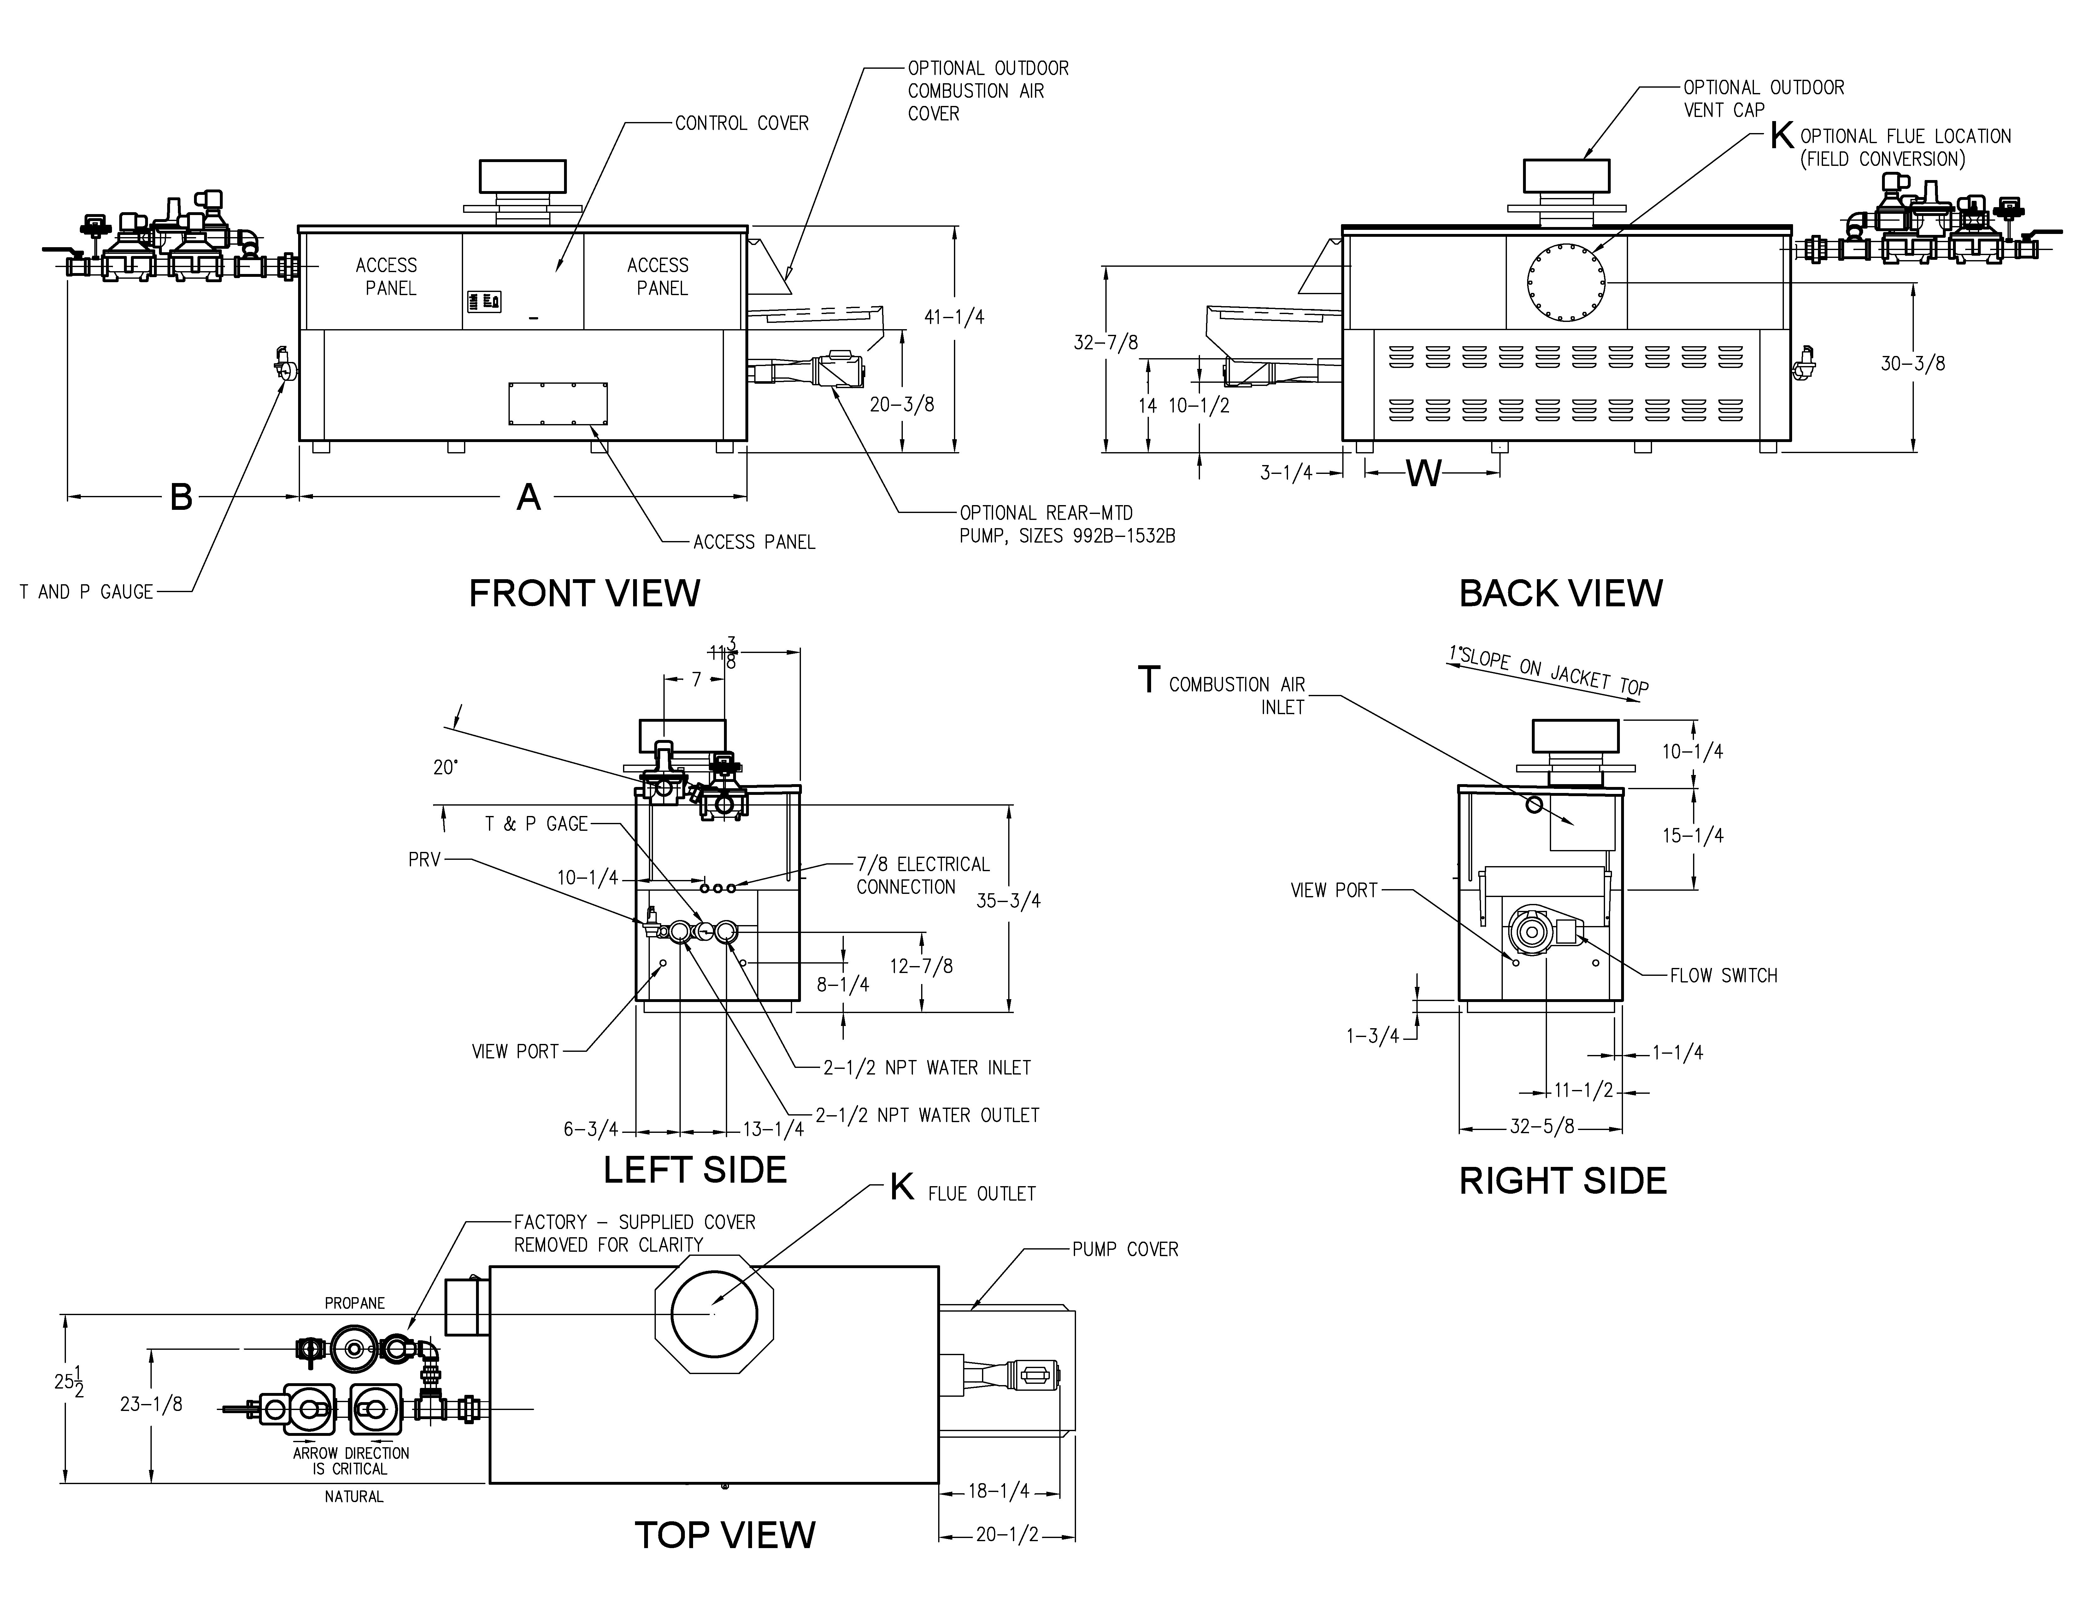

NOTES

1. Dimensions are in inches

2. Rates shown are for natural or propane gas, and elevations up to 4,500 feet. For installation above 4,500 feet, please contact manufacturer.

3. Required natural gas supply pressure is   
7 - 10.5” WC. Required propane gas supply pressure is 11 - 13” WC.

**SPECIFICATIONS**

|  |  |  |  |  |  |  |  |  |  |  |
| --- | --- | --- | --- | --- | --- | --- | --- | --- | --- | --- |
| Model | MBTUH | | Firing  Stages | A  Width | B | K | T | W | Amp  Draw\* | Approx.  Shipping  Wt. (Lbs.) |
| Input | Output |
| 992BD | 990 | 842 | 3 | 57-1/8 | 41-3/8 | 10 | 10 | 16-13/16 | <12 | 930 |
| 1262BD | 1260 | 1071 | 4 | 68-1/2 | 41-1/2 | 12 | 10 | 20-9/16 | <12 | 1040 |
| 1532BD | 1530 | 1301 | 4 | 79-7/8 | 36 | 12 | 10 | 24-3/8 | <12 | 1255 |
| 1802BD | 1800 | 1530 | 4 | 91-1/8 | 33-1/2 | 14 | 10 | 28-1/8 | <12 | 1380 |
| 2072BD | 2070 | 1760 | 4 | 102-1/2 | 39 | 14 | 10 | 31-15/16 | <12 | 1480 |
| 2342BD | 2340 | 1989 | 4 | 113-7/8 | 34 | 16 | 10 | 35-11/16 | <12 | 1550 |

Raypak, Inc. ▪ 2151 Eastman Avenue, Oxnard, CA 93030 ▪ (805) 278-5300 ▪ Fax (800) 872-9725 ▪ www.raypak.com

\*Without Pump

|  |  |  |  |  |  |  |  |  |  |  |  |  |  |  |  |  |  |  |  |
| --- | --- | --- | --- | --- | --- | --- | --- | --- | --- | --- | --- | --- | --- | --- | --- | --- | --- | --- | --- |
| Model | RATES OF FLOW AND PRESSURE DROPS | | | | | | | | | | RECOVERY RATES (GPH) | | | | | | | | |
| 20ºT ΔT | | 30ºT ΔT | | Min. Flow | | | Max. Flow | | | Temperature Rise (ºF) | | | | | | | | |
| GPM | ΔP (ft.) | GPM | ΔP (ft.) | GPM | ΔP (ft.) | ΔT | GPM | ΔP  (ft.) | ΔT | 20º | 30º | 40º | 50º | 60º | 70º | 80º | 90º | 100º |
| 992BD | 85 | 5.7 | N/A | N/A | 60 | 2.7 | 28 | 132 | 13.1 | 13 | 5100 | 3400 | 2550 | 2040 | 1700 | 1457 | 1275 | 1133 | 1020 |
| 1262BD | 107 | 10.2 | 71 | 4.4 | 71 | 4.4 | 30 | 132 | 14.8 | 16 | 6491 | 4327 | 3245 | 2596 | 2164 | 1855 | 1623 | 1442 | 1298 |
| 1532BD | 130 | 16.2 | 87 | 7.2 | 87 | 7.2 | 30 | 132 | 16.5 | 20 | 7882 | 5255 | 3941 | 3153 | 2627 | 2252 | 1970 | 1752 | 1576 |
| 1802BD | N/A | N/A | 103 | 11.0 | 102 | 10.8 | 30 | 132 | 18.3 | 23 | 9273 | 6182 | 4636 | 3709 | 3091 | 2649 | 2318 | 2061 | 1855 |
| 2072BD | N/A | N/A | 118 | 15.3 | 117 | 15.0 | 30 | 132 | 19.0 | 27 | 10664 | 7109 | 5332 | 4265 | 3555 | 3047 | 2666 | 2370 | 2133 |
| 2342BD | N/A | N/A | 132 | 21.0 | 132 | 21.4 | 30 | 132 | 21.4 | 30 | 12055 | 8036 | 6027 | 4822 | 4018 | 3444 | 3014 | 2679 | 2411 |

Basis is 60 GPM or 30ºF ΔT for minimum flow, 132 GPM for maximum flow.