Job:

# XTherm® - Type WH

## Water Heaters Models 1005A-2005A

Engineer:

Contractor:

Prepared By:       Date:

Model:       Indoor/Outdoor:

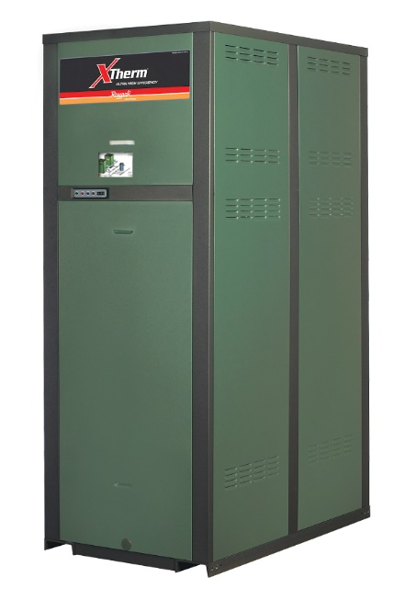

97% Thermal Efficiency at Full Rate

100% Factory Fire Tested

VERSA IC® Modulating Controller with 7” color touchscreen display

Raymote™ remote connectivity provided standard

Soft-Start Ignition; 60% Min Fire

Full Safety Diagnostics with History

Status Display Lights

Cascade up to 4 Heaters – No External Sequencer Required

Modbus RTU BMS Port

Maximum Outlet Water Temperature: 180°F

Maximum Tank Setpoint: 150°F

Limited Twenty-Five-Year Thermal Shock Warranty

Limited Five-Year Copper/Ten-Year Cupro-Nickel Primary Heat Exch. Warranty

Proudly Assembled in the USA



Limited Ten-Year Secondary Heat Exchanger Warranty

#### Heat Exchanger

* Bronze Headers
* ASME HLW Stamped; 160 PSIG MAWP
* National Board Listed
* Fin Tubing

Copper – Standard

A-3 Cupro-Nickel

* ASME Powder-Coated Tube Sheet
* Silicone High-Temp O-Rings
* ASME Pressure Relief Valve

125 PSIG – Standard

      PSIG – Optional

* Manual Air Bleed Valve
* T&P Gauge
* Stainless Steel Condensing Heat Exchanger – U stamped
* Stainless Steel Evaporator Plate
* Boiler Pump: Bronze, 120V, 1∅, 60Hz  
  Water Hardness:       GPG

#### Control

* 120V, 60Hz, 1Ø, Power Supply
* 120/24V 60Hz Transformer
* VERSA IC®
* 7” color HD touchscreen display
* Raymote™ Wi-Fi remote connectivity
* Ignition Module

3-Try – Standard

C-6 Single-Try

* Remote Flame Sensor
* Fixed High Limit, Manual Reset, 200ºF
* On/Off Power Switch
* Flow Switch
* Blocked Vent Pressure Switch
* Freeze Protection
* Alarm Dry Contact
* Pump Outputs – Pilot Duty
* System
* Programmable Pump Time Delays
* Water Temperature Sensors (3)
* Cold Water Protection
* Blocked Condensate Switch
* Modbus RTU BMS Port (Up to 115K Baud Rate, See Cat. 5000.73)
* B-85 BMS Gateway, Modbus RTU to Modbus TCP, N2 Metasys, BACnet IP, or BACnet MS/TP.
* B-86 BMS Gateway, Modbus RTU to LonWorks.

#### Burner

* Hot Surface Ignition (HSI)
* Radially-Fired Knitted Burner

#### Gas Train

* Fuel

Natural Gas

Propane (Grade HD-5)

* Dual-Seat Combination Valve
* Electronic Modulating Firing Mode (WH7)

#### Construction

* Indoor/Outdoor Construction
* Enclosed Front Controls
* PolyTuf Powder Coat Finish
* Rear Connections (Water, Gas, Vent, Electrical, Comb. Air, Cond. Drain)
* Combustion Air Filter
* Design Certified ANSI Z21.10.3/CSA 4.3
* CSA Low Lead Certified ≤ .25% Lead
* Front Connection Low Voltage Wiring

#### Venting

* Vent Termination, Cat IV

D-11 Outdoor or Indoor, Vertical

D-15 Indoor, Horizontal

* Extractor – Optional, Cat II

By others

Not required

#### Options

D-32 PVC Vent Adapter, maximum return water temperature allowed 170ºF (Factory Mounted Only)

D-33 Centrotherm® Polypropylene Vent Adapter, maximum return water temperature allowed 190ºF (Includes Manual Vent Limit, Shipped Loose)

F-10 Low Water Cut-Off, Remote Probe

I-6 High Limit, Manual Reset, Adj., 100-200°F

I-14 High Limit, Auto Reset, Adj., 40-180°F

S-1 Low Gas Pressure Switch,   
Manual Reset

S-2 High Gas Pressure Switch, Manual Reset

Z-12 Condensate Treatment Kit

#### Additional Options or Accessories



Raypak-Rheem logo, submittals**XTherm – Type WH**

Models 1005A-2005A Model

**NOTE: Use in conjunction with storage tank for proper operation.**

**CLEARANCES (in.)**

|  |  |  |  |  |  |  |  |
| --- | --- | --- | --- | --- | --- | --- | --- |
|  | **Front** | **Rear** | **Right** | **Left** | **Top** | **Floor** | **Vent** |
| **Certified Minimum** | 24 | 12 | 1 | 1 | 0 | 0 | 1 |
| **Minimum Service** | 24 | 36 | 24 | 1 | 10 | N/A | N/A |

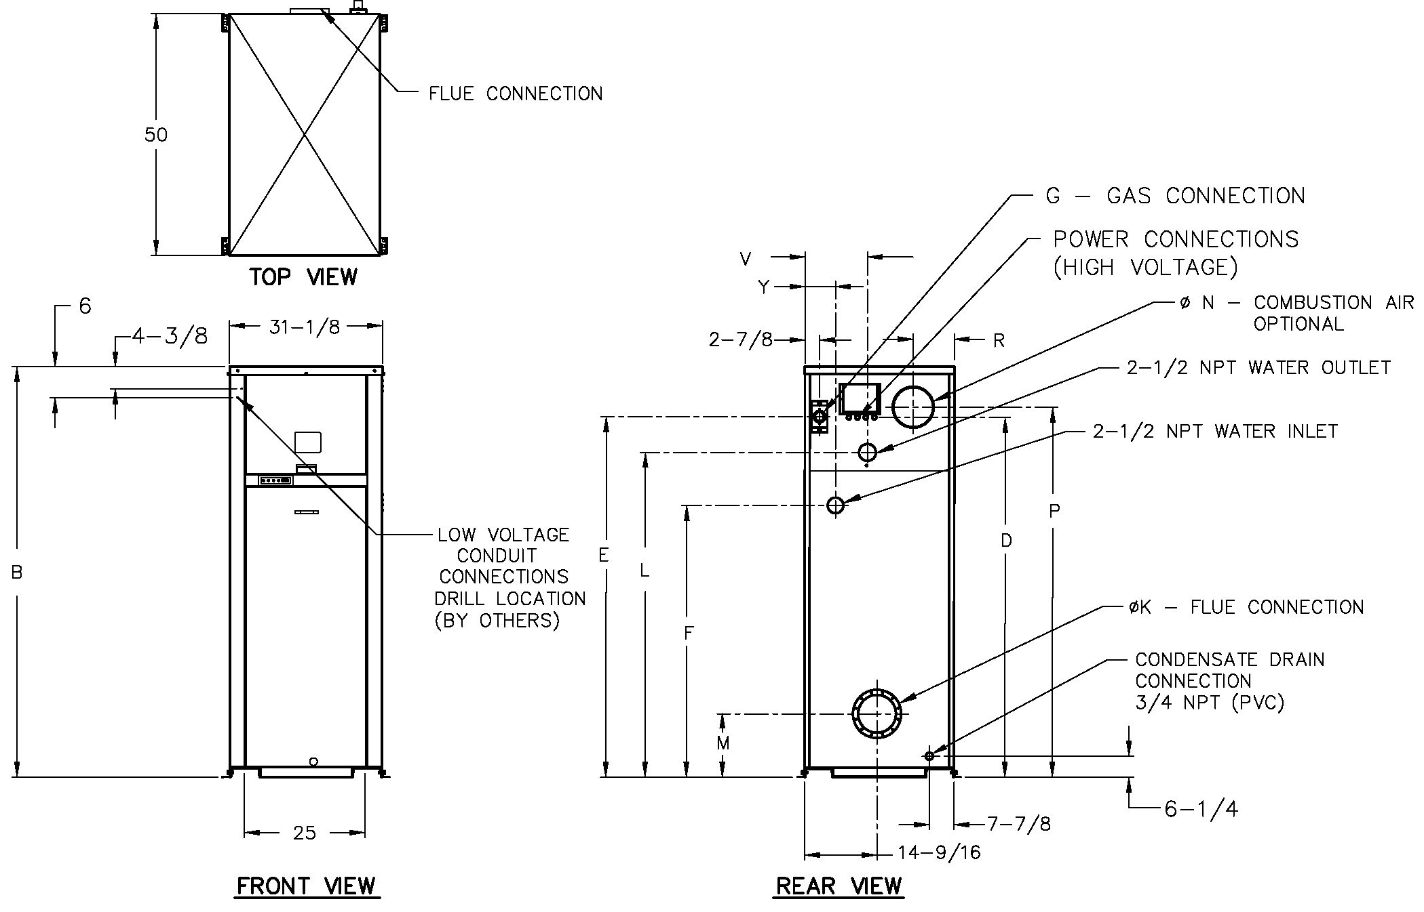

**POWER REQUIREMENTS – AMPS†**

|  |  |  |  |  |
| --- | --- | --- | --- | --- |
| **Model**  **(WH7-)** | **Heater Amp Draw †** | **Pump Amp Draw †** | | |
| **Soft**  **1-4 Gr.** | **Medium**  **5-15 Gr.** | **Hard**  **16-25 Gr.** |
| 1005A | 12 ** | 10 | 10 | 14 |
| 1505A | 12 ** | 10 | 14 | 17 |
| 2005A | 18 ** | 17 | 17 | N/A |

† Separate power connections are factory supplied and separate supply breakers must be field supplied.

** Current draw is for heater only (Supply breaker must have delayed trip).

|  |  |  |  |  |  |  |  |  |  |  |  |  |  |  |  |  |
| --- | --- | --- | --- | --- | --- | --- | --- | --- | --- | --- | --- | --- | --- | --- | --- | --- |
| **Model**  **(WH7-)** | **MBTUH** | | **Dimensions (in)** | | | | | | | | | | | | | **Ship**  **Weight**  **(Lbs.)** |
| **B**  **Height** | **D** | **E** | **F** | **G\***  **NPT** | **K**  **Flue**  **Ø** | **L** | **M** | **N**  **C/A**  **Ø** | **P** | **R** | **V** | **Y** |
| **In** | **Out** |
| 1005A | 999 | 969 | 55-1/4 | 45 | 47 | 37 | 1-1/4 | 6 | 41 | 11-1/2 | 6 | 47-1/8 | 8-5/16 | 13 | 6-1/4 | 1065 |
| 1505A | 1500 | 1455 | 67-1/8 | 57 | 59 | 38-5/8 | 1-1/4 | 8 | 53 | 12-5/8 | 8 | 59-1/8 | 8-3/16 | 13 | 6-1/4 | 1234 |
| 2005A | 1999 | 1939 | 81-1/8 | 71 | 72 | 39-5/8 | 2 | 8 | 65-1/2 | 12-5/8 | 8 | 73-1/8 | 8-3/16 | 10 | 6-1/2 | 1461 |

|  |  |
| --- | --- |
| Note: Ratings shown are for elevations up to 4,500 feet. For installations at elevations  above 4,500 feet, please consult the factory for additional instructions. | * For Propane Gas, all models are 1” NPT |

|  |  |  |  |  |  |  |  |  |  |  |
| --- | --- | --- | --- | --- | --- | --- | --- | --- | --- | --- |
| **Model (WH7-)** | **RECOVERY RATES** | | | | | | | | | |
| **Temperature Rise (°F)** | | | | | | | | | |
| **20** | **30** | **40** | **50** | **60** | **70** | **80** | **90** | **100** | **110** |
| 1005A | 5873 | 3915 | 2936 | 2349 | 1958 | 1678 | 1468 | 1305 | 1175 | 1068 |
| 1505A | 8818 | 5879 | 4409 | 3527 | 2939 | 2519 | 2205 | 1960 | 1764 | 1603 |
| 2005A | 11752 | 7834 | 5876 | 4701 | 3917 | 3358 | 2938 | 2611 | 2350 | 2137 |