Job:      

# Hi Delta® FlexGas® - Type H

## Dual-Fuel Hot Water Boilers Models 992BD-2342BD

Engineer:

Contractor:

Prepared By:       Date:

Model:       Indoor/Outdoor:       MBTUH Input:

992-2342%20FlexGas%20Iso

Fast, Economical Natural-to-Propane Gas Switchover

100% Factory Fire Tested

84% Efficiency

Maximum Outlet Temperature: 230°F

Minimum Non-Condensing Inlet Temperature: 105°F

Thermal Shock Proof Heat Exchanger

Limited Twenty-Year Thermal Shock Warranty

Diagnostic Center with Fault History

PolyTuf Powder Coated Cabinet

No Combustible Floor Shield Required

Patent Nos. 6,904,873 & 7,044,124; other patents pending

Fan-Assisted Low NOx Burners



Proudly Assembled in the USA

Patented Burner Security Blanket

#### Heat Exchanger

* H Stamp
* Headers

Glass-Lined Cast Iron – Standard

Bronze – Option A-1

* ASME Inspected and Stamped  
  160 PSIG Working Pressure
* National Board Approved
* Fin Tubing

Copper – Standard

Cupro Nickel – Option A-3

* ASME Steel Tube Sheet
* Silicone High Temp. O-Rings
* ASME Pressure Relief Valve

60 PSIG – Standard

      PSIG – Optional

* Temperature and Pressure Gauge
* Water Connections

Left – Standard

Right – Option A-6

#### Controls

* 120V, 60Hz, 1∅ Power Supply
* 120/24V 60Hz Transformer
* 100% Shut-Off/Lockout
* Hot Surface Ignition
* Remote Flame Sensor
* High Limit Control, Manual Reset
* On/Off Power Switch
* Manual Shut-Off, Front-Mounted
* Flow Switch
* Blocked Vent Pressure Switch
* Combustion Air Proving Switches
* Economaster Pump Time Delay
* Enable/Disable

#### Raypak-Rheem%20logo_submittalsGas Train

* Manual Gas Shut-Off Valve(s)
* Combination Valve(s)
* Low Gas Pressure Switch, Manual
* Firing Mode

3-Stage (H8): Model 992BD

4-Stage (H9): Models 1262BD -  
2342BD

* Natural/Propane Gas
* Gas Connection

Left – Standard

Right – Option Z-1

* Design Certified ANSI Z21.13/  
  CSA 4.9

#### Venting

* Vent Location

Top – Standard

Rear – Option D-14

* Vent Termination Cap

Outdoor D-11

Indoor, Horizontal D-15

Indoor, Vertical (by others)

* Combustion Air

In-Line Filter Kit (TruSeal only)  
D-17

Air Intake Elbow D-16

* Extractor – Optional

By others

Not required

#### Construction

* Indoor/Outdoor Construction
* Enclosed Front Controls
* CSA Low Lead Certified (≤ .25 Pb)

#### Burner

* Ultra-Low NOx: Less than 20 PPM

#### Temperature Controls

B-   TempTracker Digital Controller, 2-Stage

B-   TempTracker Digital Controller, 4-Stage

B-   TempTracker Mod+ Hybrid (2-16 Boilers)

B-60 Stage Interface

#### Options

C-6 Ignition Module, Manual Reset

D-21 TruSeal® Direct Vent

F-10 Low Water Cut-Off, Remote Probe

I-1 High Limit Control, Auto Reset

P-   Pump:       HP, 120V, 1∅, 60Hz

Cast Iron  Bronze  
 Mounted  Loose

Front  Rear

P-   Cold Water Start (See 2000.49)

S-2 High Gas Pressure Switch, Manual

X-1 SureRack™ Kit

X-2 SureRack Add-on

    

#### Regulatory Agency Requirements



*For Metric information, see Catalog*

#### Hi Delta FlexGas – Type H

**Models 992BD-2342BD Model**

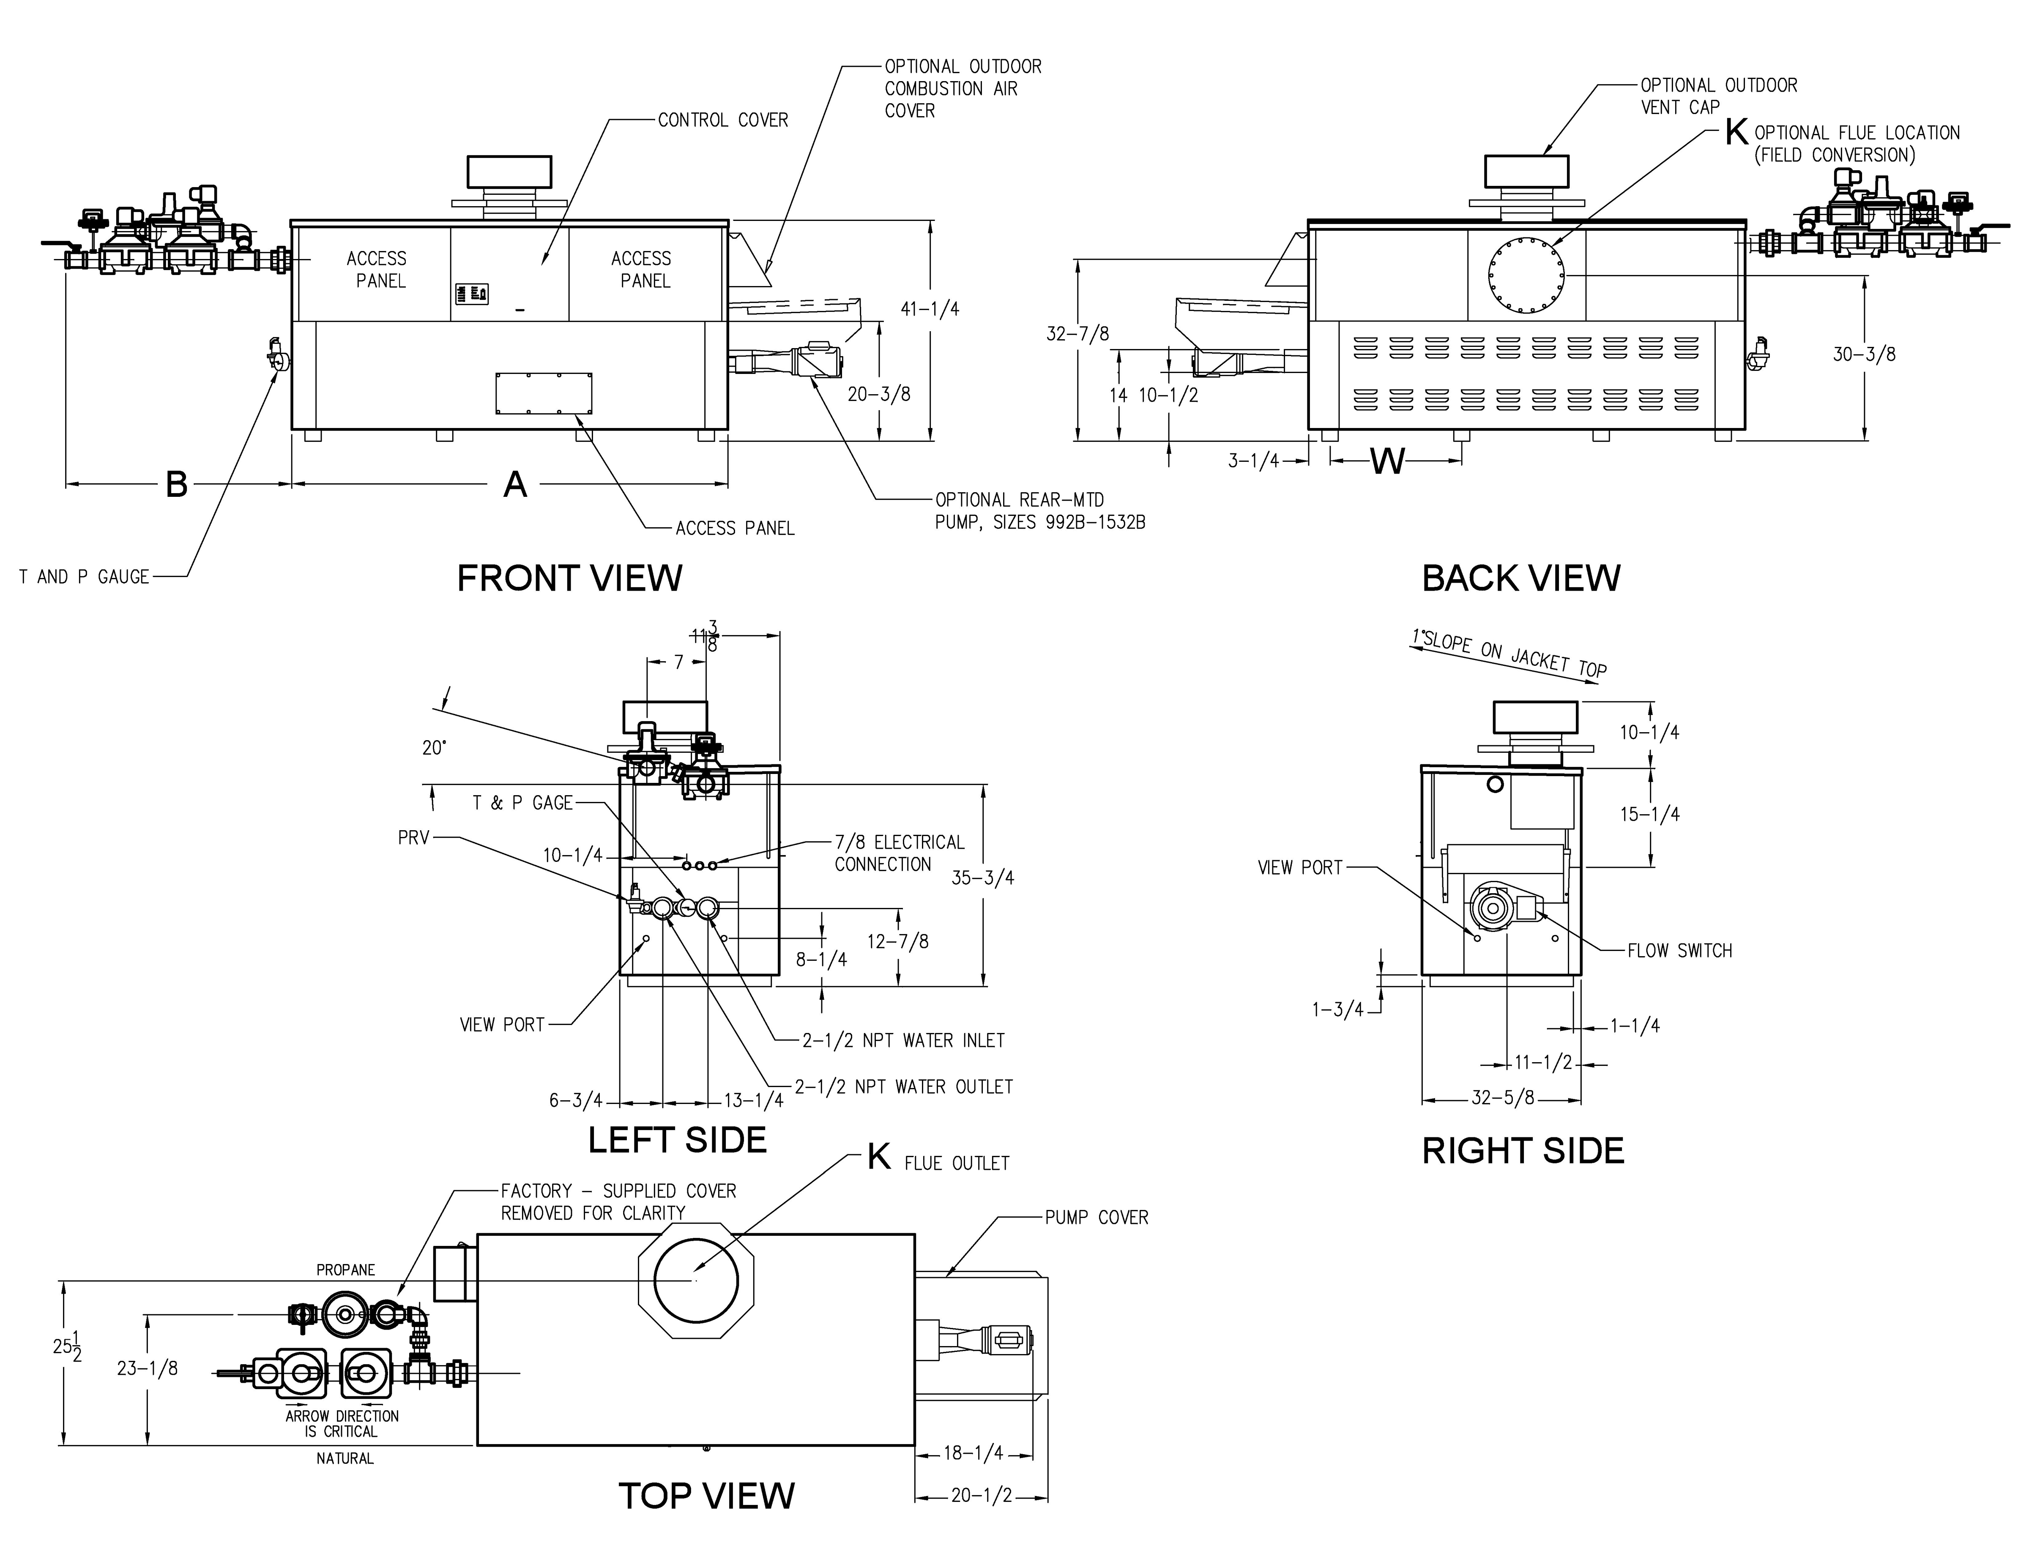

**RATES OF FLOW AND PRESSURE DROPS**

NOTE: Pump location varies based on model and application

Raypak, Inc. ▪ 2151 Eastman Avenue, Oxnard, CA 93030 ▪ (805) 278-5300 ▪ Fax (800) 872-9725 ▪ www.raypak.com

|  |  |  |  |  |  |  |  |  |  |  |
| --- | --- | --- | --- | --- | --- | --- | --- | --- | --- | --- |
| Model | 20ºF ΔT | | 30ºF ΔT | | Min. Flow | | | Max. Flow | | |
| GPM | ΔP (FT) | GPM | ΔP (FT) | GPM | ΔP (FT) | ΔT | GPM | ΔP (FT) | ΔT |
| 992BD | 84 | 5.6 | 56 | 2.5 | 42 | 1.5 | 40 | 132 | 14.0 | 13 |
| 1532BD | 107 | 10.0 | 71 | 4.5 | 53 | 2.6 | 40 | 132 | 15.5 | 16 |
| 1802BD | 130 | 16.0 | 86 | 7.1 | 65 | 4.1 | 40 | 132 | 16.5 | 20 |
| 2072BD | N/A | N/A | 117 | 15.0 | 88 | 8.7 | 40 | 132 | 19.5 | 27 |
| 2342BD | N/A | N/A | 132 | 21.0 | 99 | 12.0 | 40 | 132 | 21.0 | 30 |

Basis is 30 GPM or 40ºF ΔT for minimum flow, 132 GPM for maximum flow.

NOTES:

1. Dimensions are in inches.

2. Rates shown are for natural or propane gas, and elevations up to 4,500 feet. For installation above 4,500 feet, please contact manufacturer.

3. Required natural gas supply pressure is   
7 - 10.5” WC. Required propane gas supply pressure is 11 - 13” WC.

|  |  |  |  |  |  |  |  |  |  |  |
| --- | --- | --- | --- | --- | --- | --- | --- | --- | --- | --- |
| Model | MBTUH | | Firing  Stages | A  Width | B | K | T | W | Amp  Draw\* | Approx.  Shipping  Wt. (Lbs.) |
| Input | Output |
| 992BD | 990 | 832 | 3 | 57-1/8 | 41-3/8 | 10 | 10 | 16-3/16 | <12 | 930 |
| 1262BD | 1260 | 1058 | 4 | 68-1/2 | 41-1/2 | 12 | 10 | 20-9/16 | <12 | 1040 |
| 1532BD | 1530 | 1285 | 4 | 79-7/8 | 36 | 12 | 10 | 24-3/8 | <12 | 1255 |
| 1802BD | 1800 | 1512 | 4 | 91-1/8 | 33-1/2 | 14 | 10 | 28-1/8 | <12 | 1380 |
| 2072BD | 2070 | 1739 | 4 | 102-1/2 | 39 | 14 | 10 | 31-15/16 | <12 | 1480 |
| 2342BD | 2340 | 1966 | 4 | 113-7/8 | 34 | 16 | 10 | 35-11/16 | <12 | 1550 |

\*Without Pump