Job: ­­

# Delta Limited® - Type WH

## Water Heaters Models 399B-899B

Engineer:

Contractor:

Prepared By:       Date:

Model:       Indoor/Outdoor:       MBTUH Input:

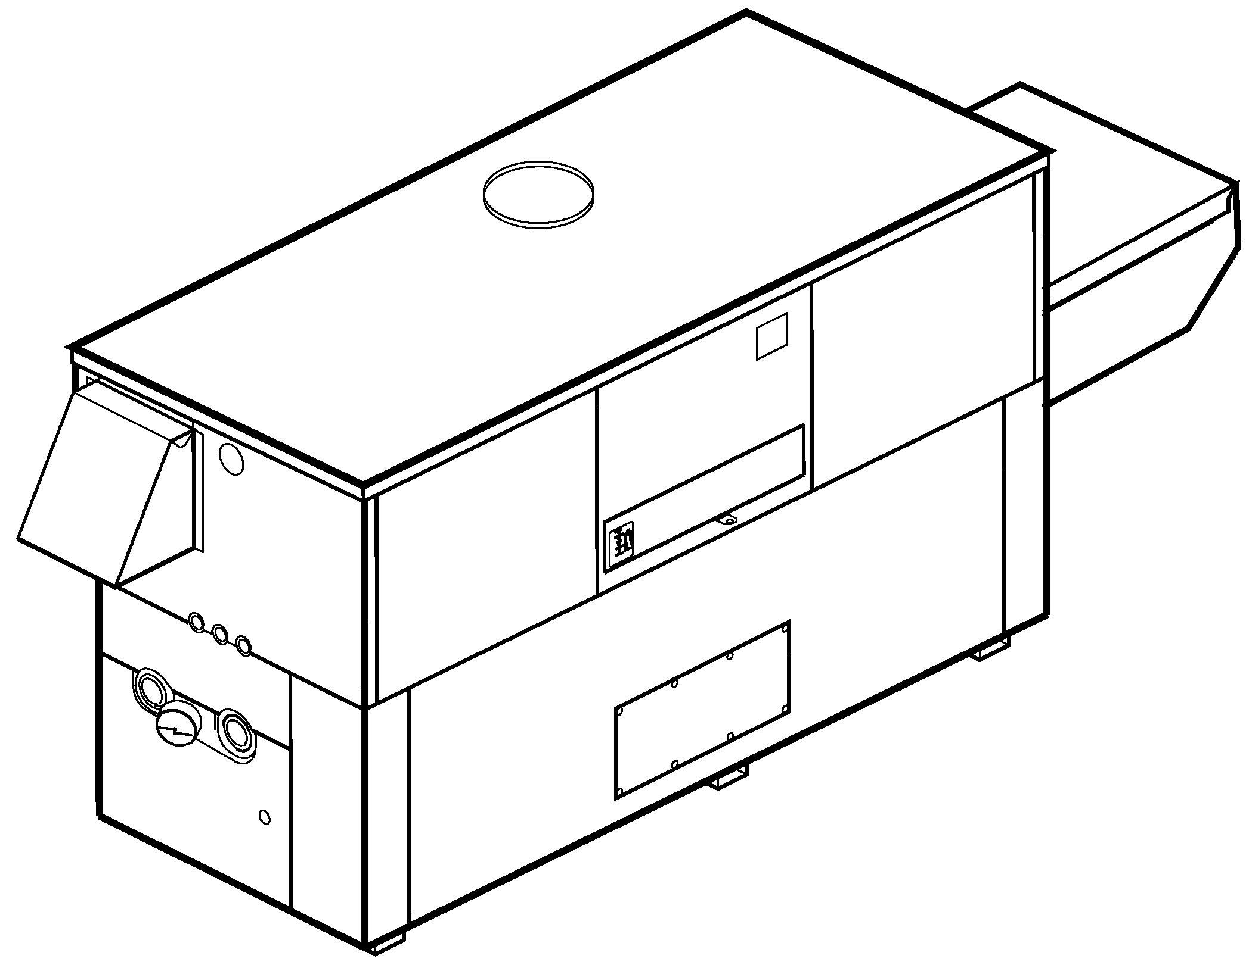

100% Factory Fire Tested

Efficiency: Up to 85%

Maximum Setpoint: 150°F

Maximum Outlet Temperature: 200°F

Minimum Non-Condensing Inlet Temperature: 105°F

Thermal Shock Proof Heat Exchanger

Limited Twenty-Year Thermal Shock Warranty

Limited Ten-Year Cupro-Nickel Heat Exchanger Warranty

Shown with outdoor   
air inlet and pump covers

Limited Five-Year Copper Heat Exchanger Warranty

PolyTuf Powder Coated Cabinet

Combustible Floor Shield Required

Fan-Assisted

Patented Burner Security Blanket

Proudly Assembled in the U.S.A.



#### Heat Exchanger

* ASME HLW Stamp
* Headers

Glass-Lined Cast Iron – Standard

A-1 Bronze

* ASME Inspected and Stamped  
  160 PSIG Working Pressure
* National Board Approved
* Fin Tubing

Copper (Std.) 85%

Cupro-Nickel 83.1%

* ASME Steel Tube Sheet
* Silicone High Temp O-Rings
* ASME Pressure Relief Valve

125 PSIG – Standard

      PSIG – Optional

* Temperature and Pressure Gauge
* Water Connections

Left – Standard

A-6 Right

#### Controls

* 120V, 60Hz, 1∅ Power Supply
* 120/24V 60Hz Transformer
* 100% Shut-Off/Lockout
* Hot Surface Ignition
* Ignition Module

3-Try Standard

C-6 Single-Try

* Remote Flame Sensor
* High Limit Control, Manual Reset
* On/Off Power Switch
* Manual Shut-Off, Front-Mounted Switch
* Flow Switch
* Blocked Vent Pressure Switch
* Combustion Air Proving Switch
* Pump Time Delay Relay, 5 Minute, Fixed
* Status Display Lights

#### Raypak-Rheem%20logo_submittalsGas Train

* Manual Gas Shut-Off Valve(s)
* Combination Valves
* Firing Mode

On/Off: Model 399B

2 Stage: Models 499B-899B

* Fuel

Natural Gas

Propane Gas

* Design Certified –   
  ANSI Z21.10.3/CSA 4.3

#### Burner

* Ultra-Low NOx:  
  Less than 20 PPM

#### Construction

* Indoor/Outdoor Construction
* Enclosed Front Controls
* CSA Low Lead Certified ≤ 0.25% Lead

#### Venting

**Vent Category I/III Cupro-Nickel**

**Vent Category II/IV Copper**

* Vent Location

Top, Outdoor – Standard

D-20 Top, Indoor

D-14 Rear

* Vent Termination Cap

D-11 Outdoor

D-15 Horizontal

Indoor, Vertical (by others)

* Extractor – Optional

By others

Not required

#### Temperature Controls

Delta Limited models not approved for use in California

B-2 Tankstat, Single-Stage   
(100-200°F)

B-3 Tankstat, 2-Stage (100-200°F)

B-\_\_ TempTracker Digital Controller, 2-Stage (Loose)

B-\_\_ TempTracker Digital Controller, 4-Stage (Loose)

#### Options

C-6 Ignition Module, Manual Reset

F-10 Low Water Cut-Off, Remote Probe

I-1 High Limit Control, Auto Reset

P-   Pump:       HP, 120V, 1∅, 60Hz   
Water Hardness:       GPG

Bronze  
 Mounted  Loose

Front  Rear

S-1 Low Gas Pressure Switch, Manual

S-2 High Gas Pressure Switch, Manual

X-1 SureRack Kit

X-2 SureRack Add-on

    



*For Metric information, see Catalog*

#### Regulatory Agency Requirements



*For Metric information, see Catalog*



*For Metric information, see Catalog*



#### Delta Limited – Type WH Models 399B-899B Model

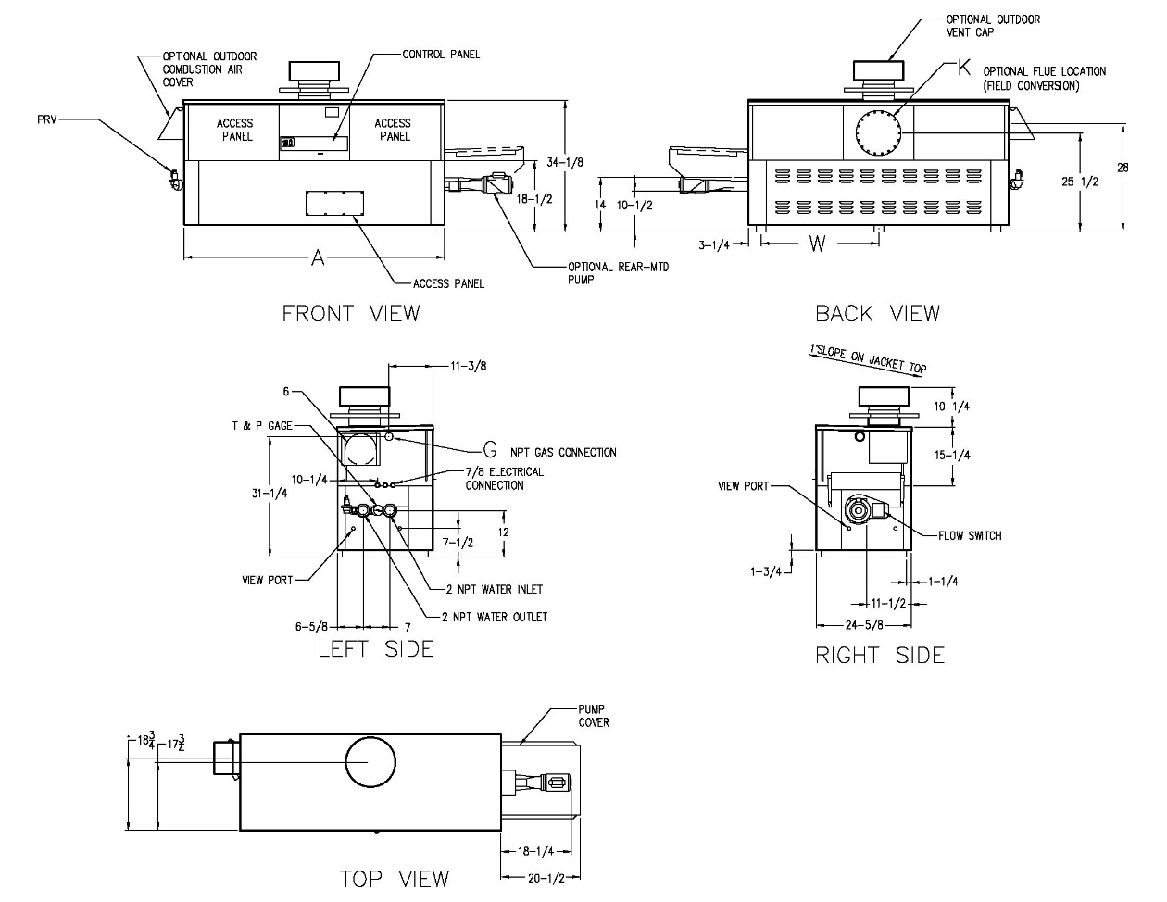

NOTE: Pump location varies based on model selected

Raypak, Inc. ▪ 2151 Eastman Avenue, Oxnard, CA 93030 ▪ (805) 278-5300 ▪ Fax (800) 872-9725 ▪ www.raypak.com

|  |  |  |  |  |  |  |  |  |  |
| --- | --- | --- | --- | --- | --- | --- | --- | --- | --- |
| **Model** | **SPECIFICATIONS** | | | | | | | | **Approx.**  **Shipping**  **Wt. (lbs.)** |
| **MBTUH** | | | **A**  **Width** | **G**  **NPT** | **K** | **W** | **Amp.**  **Draw** |
| **Input** | **Output**  **85%** | **Output**  **83.1%** |
| 399B | 399 | 339 | 332 | 43 | 3/4 | 6 | 18-1/2 | 6 | 445 |
| 499B | 500 | 425 | 416 | 50 | 1-1/4 | 6 | 22 | 6 | 545 |
| 649B | 650 | 553 | 540 | 60-1/2 | 1-1/4 | 8 | 27-1/4 | 6 | 590 |
| 749B | 750 | 638 | 623 | 67-1/2 | 1-1/4 | 8 | 30-3/4 | 6 | 675 |
| 899B | 900 | 765 | 748 | 78 | 1-1/4 | 8 | 36 | 7 | 740 |

NOTES: 1. Rates shown are for natural or propane gas, and elevations up to 4,500 feet. For installation above 4,500 feet, please contact manufacturer.

2. Recommended natural gas supply pressure is 7 – 10.5” WC. Recommended propane gas supply pressure is 11 - 13” WC.

3. Amp draw is heater less pump

#### Delta Limited – Type WH Models 399B-899B Model

|  |  |  |  |  |  |  |  |  |  |  |  |  |  |  |  |
| --- | --- | --- | --- | --- | --- | --- | --- | --- | --- | --- | --- | --- | --- | --- | --- |
| **Model** | **83.1% System Flow and Head Loss** | | | | | | | | | | | | | | |
| **3-4 Grains Per Gallon** | | | | | **5-15 Grains Per Gallon** | | | | | **16-25\*\* Grains Per Gallon** | | | | |
| ΔT  (°F) | GPM | ΔP  (FT WC) | MTS  (IN) | SHL  (FT WC) | ΔT  (°F) | GPM | ΔP  (FT WC) | MTS  (IN) | SHL  (FT WC) | ΔT  (°F) | GPM | ΔP  (FT WC) | MTS  (IN) | SHL  (FT WC) |
| 399B | 17 | 40 | 2.0 | 2 | 5.1 | 13 | 52 | 3.4 | 2 | 8.4 | 7 | 90 | 10.0 | 2 | 23.8 |
| 499B | 21 | 40 | 2.1 | 2 | 5.2 | 16 | 52 | 3.5 | 2 | 8.6 | 9 | 90 | 10.4 | 2 | 24.2 |
| 649B | 27 | 40 | 2.2 | 2 | 5.3 | 21 | 52 | 3.7 | 2 | 8.7 | 12 | 90 | 10.8 | 2 | 24.7 |
| 749B | 28 | 45 | 3.0 | 2 | 6.8 | 23 | 55 | 4.4 | 2 | 9.9 | 14 | 90 | 11.3 | 2 | 25.1 |
| 899B | 28 | 54 | 4.3 | 2 | 9.7 | 21 | 73 | 7.8 | 2 | 17.2 | 17 | 90 | 11.7 | 2 | 25.5 |

|  |  |  |  |  |  |  |  |  |  |  |  |  |  |  |  |
| --- | --- | --- | --- | --- | --- | --- | --- | --- | --- | --- | --- | --- | --- | --- | --- |
| **Model** | **85% System Flow and Head Loss** | | | | | | | | | | | | | | |
| **3-4 Grains Per Gallon** | | | | | **5-15 Grains Per Gallon** | | | | | **16-25\*\* Grains Per Gallon** | | | | |
| ΔT  (°F) | GPM | ΔP  (FT WC) | MTS  (IN) | SHL  (FT WC) | ΔT  (°F) | GPM | ΔP  (FT WC) | MTS  (IN) | SHL  (FT WC) | ΔT  (°F) | GPM | ΔP  (FT WC) | MTS  (IN) | SHL  (FT WC) |
| 399B | 17 | 40 | 2.0 | 2 | 5.1 | 13 | 52 | 3.4 | 2 | 8.4 | 8 | 90 | 10.0 | 2 | 23.8 |
| 499B | 21 | 40 | 2.1 | 2 | 5.2 | 17 | 52 | 3.5 | 2 | 8.6 | 10 | 90 | 10.4 | 2 | 24.2 |
| 649B | 28 | 40 | 2.2 | 2 | 5.3 | 21 | 52 | 3.7 | 2 | 8.7 | 12 | 90 | 10.8 | 2 | 24.7 |
| 749B | 29 | 45 | 3.0 | 2 | 6.8 | 23 | 55 | 4.4 | 2 | 9.9 | 14 | 90 | 11.3 | 2 | 25.1 |
| 899B | 29 | 54 | 4.3 | 2 | 9.7 | 21 | 73 | 7.8 | 2 | 17.2 | 17 | 90 | 11.7 | 2 | 25.5 |

SHL includes 50 ft of tubing each way (100 total)

\*\* Must use optional cupro-nickel tubes. For hardness exceeding 25 GPG, must use water softener

Basis for minimum flow is 40 GPM or 30°F ∆T, 90 GPM for maximum flow

|  |  |  |  |  |  |  |  |  |  |
| --- | --- | --- | --- | --- | --- | --- | --- | --- | --- |
| **Model** | **83.1 % Recovery Rates** | | | | | | | | |
| **20°** | **30°** | **40°** | **50°** | **60°** | **70°** | **80°** | **90°** | **100°** |
| 399B | 2010 | 1340 | 1005 | 804 | 670 | 574 | 502 | 447 | 402 |
| 499B | 2518 | 1679 | 1259 | 1007 | 839 | 709 | 630 | 560 | 504 |
| 649B | 3274 | 2182 | 1637 | 1309 | 1091 | 935 | 818 | 727 | 655 |
| 749B | 3777 | 2518 | 1889 | 1511 | 1259 | 1079 | 944 | 839 | 755 |
| 899B | 4533 | 3022 | 2266 | 1813 | 1511 | 1295 | 1133 | 1007 | 907 |

|  |  |  |  |  |  |  |  |  |  |
| --- | --- | --- | --- | --- | --- | --- | --- | --- | --- |
| **Model** | **85 % Recovery Rates** | | | | | | | | |
| **20°** | **30°** | **40°** | **50°** | **60°** | **70°** | **80°** | **90°** | **100°** |
| 399B | 2055 | 1370 | 1028 | 822 | 685 | 587 | 514 | 457 | 411 |
| 499B | 2576 | 1717 | 1288 | 1030 | 859 | 736 | 644 | 572 | 515 |
| 649B | 3348 | 2232 | 1674 | 1339 | 1116 | 957 | 837 | 744 | 670 |
| 749B | 3864 | 2576 | 1932 | 1545 | 1288 | 1104 | 966 | 859 | 773 |
| 899B | 4636 | 3091 | 2318 | 1855 | 1545 | 1325 | 1159 | 1030 | 927 |

Raypak, Inc. ▪ 2151 Eastman Avenue, Oxnard, CA 93030 ▪ (805) 278-5300 ▪ Fax (800) 872-9725 ▪ www.raypak.com