Job:

MVB® - Type WH

Water Heaters
Models 503A-2003A

Engineer:

Contractor:
Prepared By: Date:
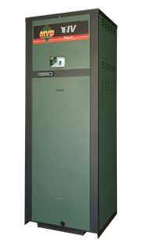Model: Indoor/Outdoor:
87% Thermal Efficiency at Full Rate
100% Factory Fire-Tested
VERSA IC® Modulating Controller with with 7” color touchscreen display
Raymote™ remote connectivity provided standard
On/Off Firing with Soft-Start Ignition
Full Safety Diagnostics with History
Status Display Lights
Cascade up to 4 Heaters – No External Sequencer Required
Modbus RTU BMS Port
CSA Low Lead Certified ≤.25% Lead
Maximum Outlet Water Temperature: 200°F
Maximum Tank Setpoint: 150°F
Minimum Acceptable Inlet Water Temperature: 120°F
Proudly Assembled in the USA
Limited Five-Year Copper/Ten-Year Cupro-Nickel Heat Exch. Warranty
Ultra Low NOx, Less than 20 PPM

Heat Exchanger
- Headers, Bronze
- ASME HLW Stamped
160 PSIG MAWP
- National Board Approved
- Fin Tubing
Copper – Standard
A-3 Cupronickel
- ASME Powder-Coated Tube Sheet
- Silicone High-Temp O-Rings
- ASME Pressure Relief Valve
125 PSIG – Standard
150 PSIG – Optional
- Temperature and Pressure Gauge,
Shipped Loose
- Four pass primary heat exchanger
- Stainless Steel Evaporator Plate

Control
- 120V, 60Hz, 1Ø, Power Supply
- 120/24V 60Hz Transformer
- VERSA IC® built-in controller
- 7” color HD touchscreen display
- Raymote Wi-Fi remote connectivity
- Cascade up to 4 Heaters
- Ignition Module
3-Try – Standard
C-6 Single-Try
- Remote Flame Sensor
- Freeze Protection
- High Limit, Manual Reset, Fixed, 200ºF
- On/Off Power Switch
- Flow Switch
- Blocked Vent Pressure Switch
- Programmable Pump Time Delays
- Pump Outputs
- Water Heater
- System – Pilot Duty
- Modulating Temperature Control
- Water Temperature Sensors (3)
- Cold Water Protection Function
Optional Variable-Speed Pump
- Modbus RTU BMS Port
B-85 Gateway – BACnet MS/TP, BACnet IP, N2 Metasys or Modbus TCP
B-86 Gateway - LonWorks

Burner
- Radially-Fired Knitted Burner
- Hot Surface Ignition (HSI)

Gas Train
- Fuel
Natural Gas
Propane (Minimum Grade HD-5)
- Dual-Seat Combination Firing Valve
- Manual Shut Off Valve

Construction
- Indoor/Outdoor Construction
- Front Controls Enclosed
- PolyTuf Powder Coat Finish
- Rear Connections (Water, Electrical, Gas, Vent, Combustion Air)
- In-line Combustion Air Filter Kit
- Design Certified ANSI Z21.10.3/CSA 4.3
- CSA Low Lead Certified ≤.25% Lead

Venting
- Vent Termination
D-11 Outdoor
D-15 Indoor, Horizontal
Indoor, Vertical (by others)
- Combustion Air
D-16 Air Intake Elbow
- Extractor – Optional
By others
Not required

Options
A-30 Air Vent, Auto, 150 PSI (Loose)
F-10 Low Water Cut-Off, Remote Probe
I-1 High Limit, Auto Reset, Adj.,
40-180°F
I-2 High Limit, Manual Reset, Adj., 100-200°F (additional)
P- Bronze Pump: HP, 120V, 1∅, 60Hz
Water Hardness: GPG
Loose Mounted
P- Cold Water Run
S-1 Low Gas Pressure Switch,
Manual Reset
S-2 High Gas Pressure Switch, Manual Reset
Z-12 Condensate Treatment Kit

Additional Options or Accessories

MVB® – Type WH

Models 503A-2003A Model

Clearances
 | Certified Minimum | Recomm. Service
Front | 24” | 24”
Rear | 12” | 24”
Right | 1’ | 1”
Left | 1” | 1”
Top | 0” | 10”
Floor | 0” | 0”
Vent | 1” | 1”

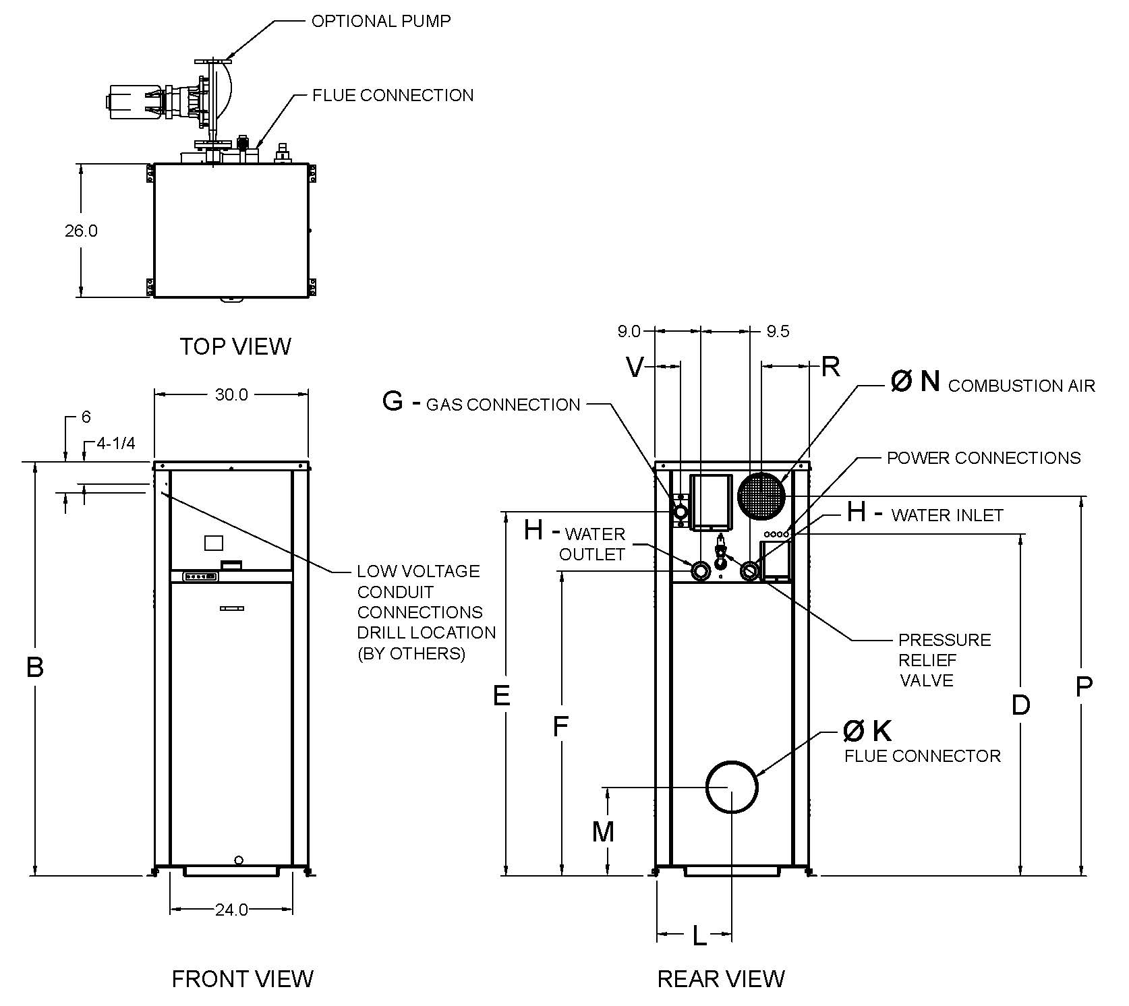

Model  (WH1-) | MBTUH |  |  | Dimensions (in.) |  |  |  |  |  |  |  |  |  |  |  | Ship  Weight  (Lbs.) | Foot-  print  (Ft²) | Amps**
 |  |  | B | D | E | F | G* | H | K | L | M | N | P | R | V
 | Input | Output | Height |  |  |  | NPT | NPT | Flue Ø |  |  | C/A Ø
503A | 500 | 435 | 43 | 32 | 35 | 23-3/4 | 1 | 2 | 6 | 13-3/4 | 14-1/4 | 6 | 35 | 8 | 2 | 600 | 5.4 | 12
753A | 750 | 653 | 49 | 38 | 41 | 29-3/4 | 1 | 2 | 6 | 13-1/2 | 14-1/4 | 6 | 41 | 8 | 2 | 670 | 5.4 | 12
1003A | 999 | 869 | 55 | 44 | 47 | 35-3/4 | 1-1/4 | 2-1/2 | 6 | 13-1/2 | 14-1/4 | 6 | 47 | 8 | 2 | 720 | 5.4 | 12
1253A | 1250 | 1088 | 61 | 50 | 53 | 41-3/4 | 1-1/4 | 2-1/2 | 8 | 13-3/4 | 17-1/4 | 8 | 53 | 8 | 2 | 780 | 5.4 | 12
1503A | 1500 | 1305 | 67 | 56 | 59 | 47-3/4 | 1-1/4 | 2-1/2 | 8 | 13-3/4 | 17-1/4 | 8 | 59 | 8 | 2 | 840 | 5.4 | 12
1753A | 1750 | 1523 | 75 | 62 | 65 | 53-3/4 | 2 | 2-1/2 | 8 | 13-1/2 | 17-1/4 | 8 | 68 | 9 | 5 | 940 | 5.4 | 18
2003A | 1999 | 1739 | 81 | 68 | 71 | 59-3/4 | 2 | 2-1/2 | 8 | 13-3/4 | 17-1/4 | 8 | 74 | 9 | 5 | 1000 | 5.4 | 18

*For natural gas. For propane, all sizes are 1” NPT
**Current draw is for heater only. (Supply breaker must have delayed trip.)
- Ratings shown are for elevations up to 4,500 feet. For installations at elevations above 4,500 feet, please consult the factory for additional instructions. No hardware changes required below 10,000 feet.

MVB® – Type WH

Models 503A-2003A Model

PUMP HP – AMPS*
Model (WH-1) | Water Hardness
 | Soft | Medium | Hard
503A | 1/4 – 6 | 1/4 – 6 | 3/4 – 11
753A | 1/4 – 6 | 1/2 – 7 | 3/4 – 11
1003A | 1/4 – 6 | 1/2 – 7 | 1 – 14
1253A | 1/2 – 7 | 1 – 14 | 1 – 14
1503A | 3/4 – 11 | 1 – 14 | 1 – 14
1753A | 1 – 14 | 1 1/2 – 16 | 1 1/2 – 16
2003A | 1 – 14 | 1 1/2 – 16 | 1 1/2 – 16
* Current draw is for pump only.

SHL includes 50ft of tubing each way (total 100 ft)
* Must use optional cupronickel heat exchanger
** If over 25 GPG, a water softener MUST be used.
 | Water Hardness
 | Soft |  |  |  |  | Medium |  |  |  |  | Hard*
 | 3-4 Grains Per Gallon |  |  |  |  | 5-15 Grains Per Gallon |  |  |  |  | 16-25 Grains Per Gallon**
Model | ΔT  (ºF) | GPM | ΔP  (ft wc) | MTS  (in) | SHL  (ft wc) | ΔT  (ºF) | GPM | ΔP  (ft wc) | MTS  (in) | SHL  (ft wc) | ΔT  (ºF) | GPM | ΔP  (ft wc) | MTS  (in) | SHL  (ft wc)
503A | 17 | 50 | 3.6 | 2 | 8.3 | 17 | 50 | 3.6 | 2 | 8.3 | 9 | 95 | 10.4 | 2 | 25.7
753A | 26 | 50 | 4.0 | 2 | 8.7 | 18 | 73 | 7.8 | 2 | 17.3 | 15 | 90 | 11.4 | 2 | 25.3
1003A | 20 | 85 | 11.5 | 2-1/2 | 16.2 | 20 | 85 | 11.5 | 2-1/2 | 16.2 | 15 | 116 | 19.6 | 2-1/2 | 27.8
1253A | 27 | 80 | 12.2 | 2-1/2 | 16.3 | 20 | 109 | 21.0 | 2-1/2 | 28.3 | 20 | 109 | 21.0 | 2-1/2 | 28.3
1503A | 28 | 94 | 18.4 | 2-1/2 | 24.0 | 25 | 105 | 22.5 | 2-1/2 | 29.3 | 23 | 115 | 26.5 | 2-1/2 | 34.6
1753A | 29 | 104 | 23.6 | 2-1/2 | 30.3 | 27 | 113 | 27.4 | 2-1/2 | 35.2 | 27 | 113 | 27.4 | 2-1/2 | 35.2
2003A | 32 | 108 | 28.1 | 2-1/2 | 35.3 | 32 | 108 | 28.1 | 2-1/2 | 35.3 | 30 | 116 | 33.0 | 2-1/2 | 41.5

 | RECOVERY RATES
 | Temperature Rise (°F)
 | 20 | 30 | 40 | 50 | 60 | 70 | 80 | 90 | 100 | 110
503A | 2636 | 1758 | 1318 | 1055 | 879 | 753 | 659 | 586 | 527 | 479
753A | 3955 | 2636 | 1977 | 1582 | 1318 | 1130 | 989 | 879 | 791 | 719
1003A | 5267 | 3512 | 2634 | 2107 | 1756 | 1505 | 1317 | 1171 | 1053 | 958
1253A | 6591 | 4394 | 3295 | 2636 | 2197 | 1883 | 1648 | 1465 | 1318 | 1198
1503A | 7909 | 5273 | 3955 | 3164 | 2637 | 2260 | 1978 | 1758 | 1582 | 1438
1753A | 9227 | 6152 | 4614 | 3691 | 3076 | 2636 | 2307 | 2051 | 1845 | 1678
2003A | 10540 | 7027 | 5270 | 4216 | 3513 | 3011 | 2635 | 2342 | 2108 | 1916
Raypak, Inc. 2151 Eastman Avenue, Oxnard, CA 93030 (805) 278-5300 Fax (800) 872-9725 www.raypak.com

