Job:

84 Professional

ASME

Gas Pool Heaters

Models BR-259 and BR-409

Engineer:

Contractor:
Prepared By: Date:
Model: Indoor/Outdoor

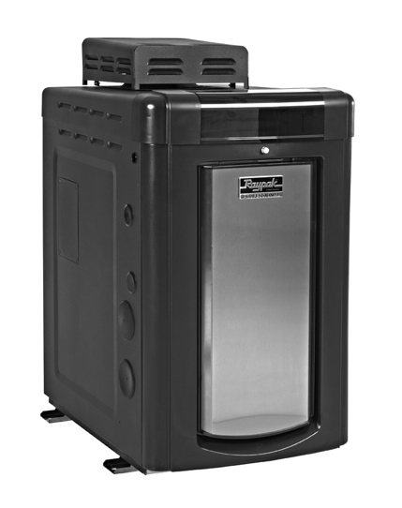

- 84% Efficiency
- ASME Code Bronze Header
- ASME Code Cupro-Nickel Fin Tube
- 125 lb. Pressure Relief Valve
- Small Footprint
- Direct Vent Capable
- Internal Bypass for High Flow Rates (up to 125 gpm)
- Indoor/Outdoor
84 Professional Shown with outdoor top
- 3 Years Parts and Labor Limited Warranty – see warranty for details

Heat Exchanger
- ASME Inspected and Stamped
160 PSIG
- National Board Approved
- Bronze Header
- Dual Thread Inlet/Outlet Header
NPT Inside and Buttress Thread OD
- Finned Tubing
Cupro-Nickel – Standard
- ASME Stainless Steel Tube Sheet
- Silicone O-Rings
- 125 PSIG Pressure Relief Valve
mounted
- T&P Gauge-mounted
- Water Connections
Right Hand – Standard
Left Hand – Field Change
Flow Through Right – Field Change
Flow Through Left – Field Change
- Flow Configuration – single-pass

Controls
- 115/230V, 60Hz, 1 Ph Power Supply
- 115/230/24V Transformer
- 100% Pilot Shut-off
- Electronic, Intermittent Direct Spark
Ignition
- High Limit Control
- On/Off Switch
- Air Vent Switch
- Water Flow Switch-mounted
- Dual Electronic Temp Sensor
- Digital Display With Diagnostics

Gas Control Train
- Natural Gas
- Combination Control Valve
- On/Off Firing
- ANSI Z21.56 Design Certified
- Fuel Type
Natural Gas
Propane Gas
- Low Nox

Construction
- Front Controls
- Stainless Steel Burners
- Polytuf Powder Coat Finish
- Indoor/Outdoor
- Vent Selection
Outdoor Stackless Top – Standard Top Mount
Outdoor Stackless Top – Field Installed Rear Mount
Direct Vent – Field Installed
- Can be installed on combustible surfaces

84 Professional ASME
Raypak, Inc. 2151 Eastman Avenue, Oxnard, CA 93030 (805) 278-5300 Fax (800) 872-9725 www.raypak.com

Gas Pool Heaters Model

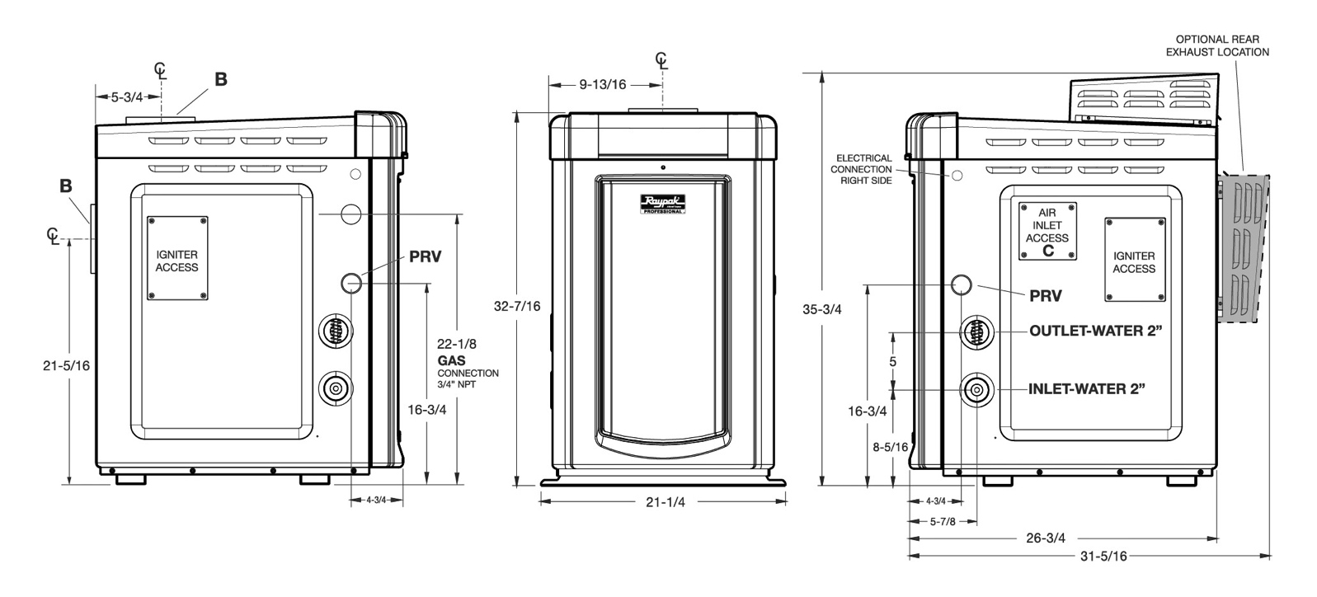

Heater  Model | MTUH  Input | Dimensions (in.) |  |  |  | Shipping Weights (lbs)
 |  | Flue  Diameter  (B) | Air  Inlet  (C) | Minimum Flow  (gpm) | Maximum Flow  (gpm) | With  Stackless Top
BR-259 | 250.0 | 6” | 4” | 25 | 125 | 168
BR-409 | 399.0 | 6” | 4” | 40 | 125 | 180

Notes:
1. The model number prefix indicates: (B=Bronze header), (R=Raypak) Model number suffix indicates: pilot type (E = digital) and fuel type (P = propane, N = natural gas) fin tubing (X=Cupro-Nickel, C= Copper). Example: Model number BR-409-EN-X indicates a unit with digital (IID) ignition using natural gas with bronze headers and cupro-nickel tubes.
2. Ratings are for natural gas and elevations up to 2,000 feet above sea level. For elevations over 2,000 feet, consult the factory.
3. Flue gases must be properly vented with 6” CAT I vertical venting or CAT III horizontal venting. Non-metallic venting not acceptable. Inlet air can be ducted with 4” metal or PVC pipe-See I/O manual for complete venting details.

