Job:

Hi Delta SS®- Type H

Space Heating/Hot Water Boiler Models HD101-HD401

Engineer:

Contractor:
Prepared By: Date:
Model: Indoor/Outdoor: MBTUH Input:

TruSeal® Direct Vent
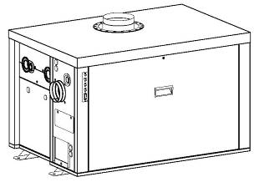
Sealed Combustion Chamber
100% Factory Fire Tested
Efficiency: HD101 – HD 301 85% AFUE
HD401 - 84% Thermal
Maximum Outlet Temperature: 240°F
Minimum Non-condensing Inlet Temperature: 105°F
Thermal Shock Proof Heat Exchanger
Limited Twenty-year Thermal Shock Warranty
Limited Ten-year Closed-System Heat Exchanger Warranty
Status Display LED’s
PolyTuf Powder-Coated Cabinet
No Combustible Floor Shield Required
Proudly Assembled in the USA
Fan-assisted – Ultra Low NOx (<20 ppm Nat.)
Patented Burner Security Blanket

Heat Exchanger
- H Stamp
- Headers
Cast Iron, Glass-lined – Standard
A-1 Bronze
- ASME Inspected and Stamped
160 PSIG Working Pressure
- National Board Approved
- Finned Tubing
Copper – Standard
A-3 Cupro-Nickel
- ASME Steel Tube Sheet
- Silicone High-Temp O-Rings
- Pressure Relief Valve - ASME
45 PSIG - Standard
PSIG - Optional
- Temperature and Pressure Gauge (shipped loose)
- Flow Switch - Mounted
- Left-hand Water (Standard)
- A-6 Right-hand water

Controls
- 120V, 60Hz, 1 Power Supply
- 120/24V 60Hz Transformer
- 100% Shutoff/Lockout
- Hot Surface Ignition
- Remote Flame Sensor
- Fixed High Limit Control, Manual Reset
- On/Off Power Switch
- Blocked Vent Pressure Switch
- Combustion Air Proving Switches (2)
- Economaster Style Pump Relay
- Electronic Outdoor Reset Controller (HD101 – HD301 Only) 2-Stage Controller w/Outdoor Reset, Setpoint 120-200°F

Gas Train
- 4” WC Minimum Pressure
- Combination Valve
- Firing Mode
Two-stage (H3) - Standard
On/Off (H4) - Optional
- Fuel
Natural Gas
Propane Gas
- Design Certified
ANSI Z21.13/CSA 4.9

Burner
- Two-stage
- Ultra-low NOx (<20 ppm Nat.)

Construction
- Indoor/Outdoor Construction
- Slide-out Controls Tray
- Front Controls Enclosed
- PolyTuf Powder Coat Finish
- TruSeal® Direct Vent
- Integral Combustion Air Filter

Venting
- Vent Termination Cap
D-11 Outdoor
D-15 Indoor, Horizontal
D-20 Indoor, Vertical
- Combustion Air - Ducted
D-16 Air Intake Elbow
- Extractor – Optional
By others
Not required

Temperature Controls (HD-401 Only)
B-3 1-Stage Controller, 100-200°F (Loose)
B-6 2-Stage Controller, 130-230°F (Loose)
B-21 TempTracker Digital Controller 4-Stage (loose)
B-26 TempTracker Digital Controller, 2-Stage (Mtd)
B-27 TempTracker Digital Controller, 2-Stage, O/D (Mtd)
B-28 On/Off Digital Controller, (Mtd)
B-42 Electronic Controller, 2-stg, Outdoor Reset, 120° - 200°F (Mtd)
B-32 Remote Controller
By others:

Options
F-10 Low Water Cut-off, Remote Probe
I-1 Adjustable High Limit Control, Auto Reset
P- Pump: HP, 120V, 1 60 Hz
Bronze Mounted
Cast Iron Loose
P- Cold Water Protection (See 1000.19)
S-__ Low and High Gas Pressure Switches, Manual

Hi Delta SS HD101-HD401

Type H - Hydronic Heating Model

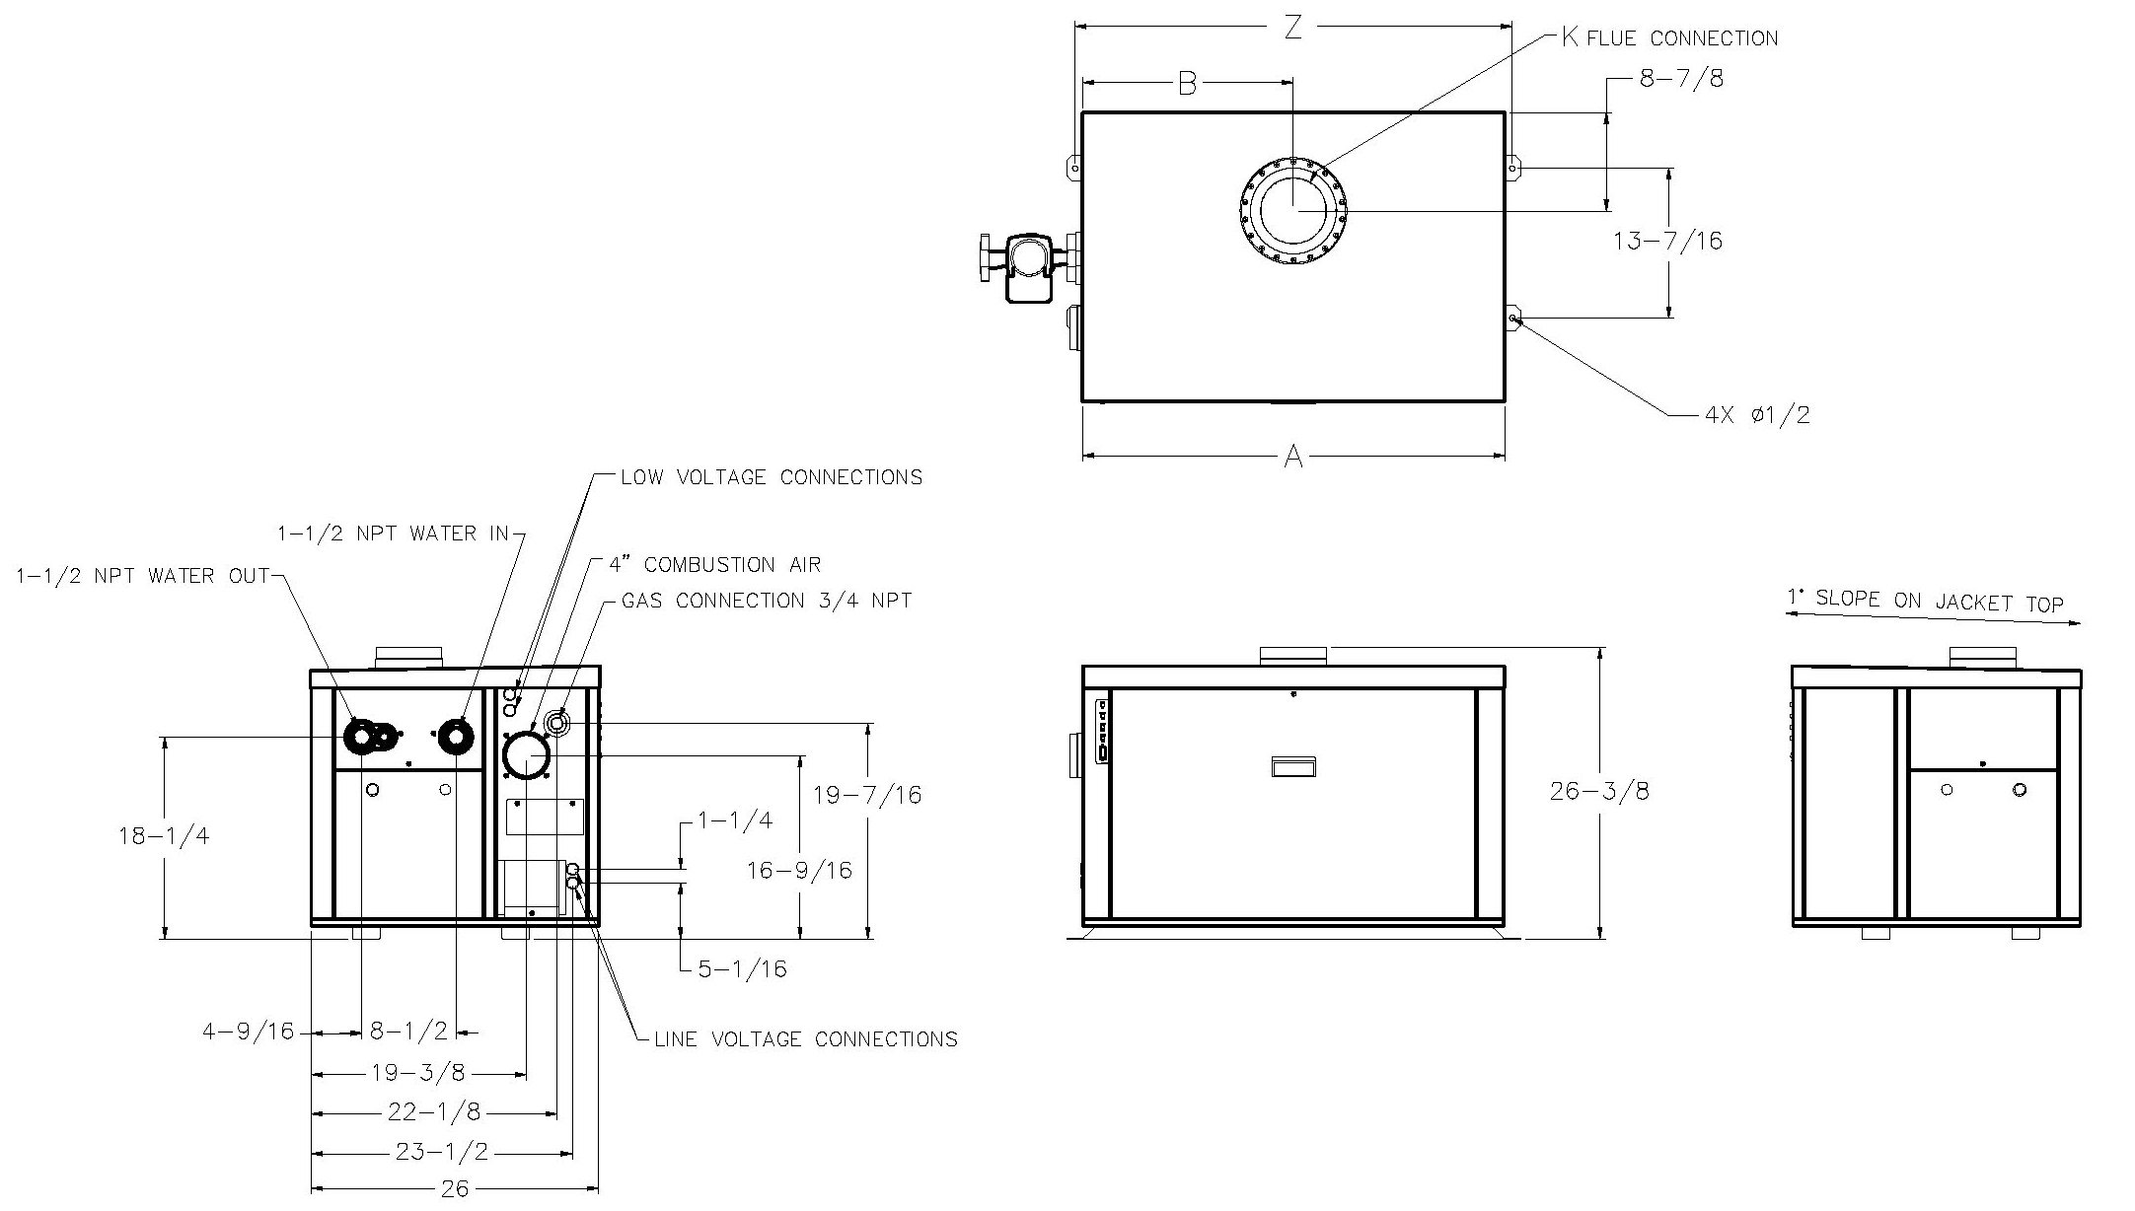
Model
H3-
HD101 | 0010 1/8 – 1.3
HD151
HD201
HD251
HD301
HD401

Primary Pump HP - Amps

APPROX.
SHIP WT.
(LBS.)
MODEL | MBTUH |  | AFUE  (%) | A | B | K | Z | Boiler  Amps‡
 | INPUT | OUTPUT
HD101 | 100 | 84 | 85 | 18-9/16 | 9-1/4 | 4 | 19-15/16 | <5 | 150
HD151 | 150 | 126 |  | 21-7/8 | 10-7/8 | 4 | 23-3/16 | <5 | 175
HD201 | 199 | 167 |  | 25-1/16 | 12-1/2 | 5 | 26-7/16 | <5 | 200
HD251 | 250 | 210 |  | 28-5/16 | 14-1/8 | 5 | 29-11/16 | <5 | 225
HD301 | 299 | 251 |  | 31-9/16 | 15-3/4 | 5 | 32-15/16 | <5 | 250
HD401 | 399 | 335 | 84* | 38-1/16 | 19 | 6 | 39-7/16 | <5 | 300
Dimensions are in inches.
‡ Amp draw does not include pump. * Thermal Efficiency

RATES OF FLOW AND PRESSURE DROPS

MODEL | Input  MBTUH | Output  MBTUH | 10ºF ∆T |  | 20ºF ∆T |  | 30ºF ∆T |  | MIN. FLOW |  |  | MAX. FLOW
 |  |  | GPM | ∆P (ft) | GPM | ∆P (ft) | GPM | ∆P (ft) | GPM | ∆P (ft) | ∆T | GPM | ∆P (ft) | ∆T
HD101 | 100 | 84 | 17 | 1.2 | N/A | N/A | N/A | N/A | 13 | 0.8 | 13 | 44 | 8.8 | 4
HD151 | 150 | 126 | 25 | 2.9 | 13 | 0.8 | N/A | N/A | 13 | 0.8 | 20 | 44 | 8.8 | 6
HD201 | 199 | 167 | 33 | 5.2 | 17 | 1.3 | N/A | N/A | 13 | 3.3 | 27 | 44 | 8.9 | 8
HD251 | 250 | 210 | 44 | 9.2 | 21 | 2.1 | 14 | 0.9 | 13 | 0.7 | 34 | 44 | 9.2 | 10
HD301 | 299 | 251 | N/A | N/A | 25 | 3.1 | 17 | 1.3 | 13 | 0.7 | 40 | 44 | 9.4 | 11
HD401 | 399 | 335 | N/A | N/A | 34 | 5.6 | 22 | 2.5 | 22 | 2.5 | 30 | 44 | 9.8 | 15
NOTE: Basis for minimum flow is 13 GPM or 40°F ∆T.

NOTES: 1. Rates shown are for natural or propane gas, and elevations up to 2,000 feet. For installations above 2,000 feet, please contact manufacturer.
2. Recommended natural gas pressure is 7 – 10.5” WC. Recommended propane gas pressure is 11 - 13” WC.
Raypak, Inc. 2151 Eastman Avenue, Oxnard, CA 93030 (805) 278-5300 Fax (800) 872-9725 www.raypak.com

