­­Job:

# Stainless Steel 110-Gallon Non-ASME Storage Tank

## 

Engineer:

Contractor:

Prepared By:       Date:

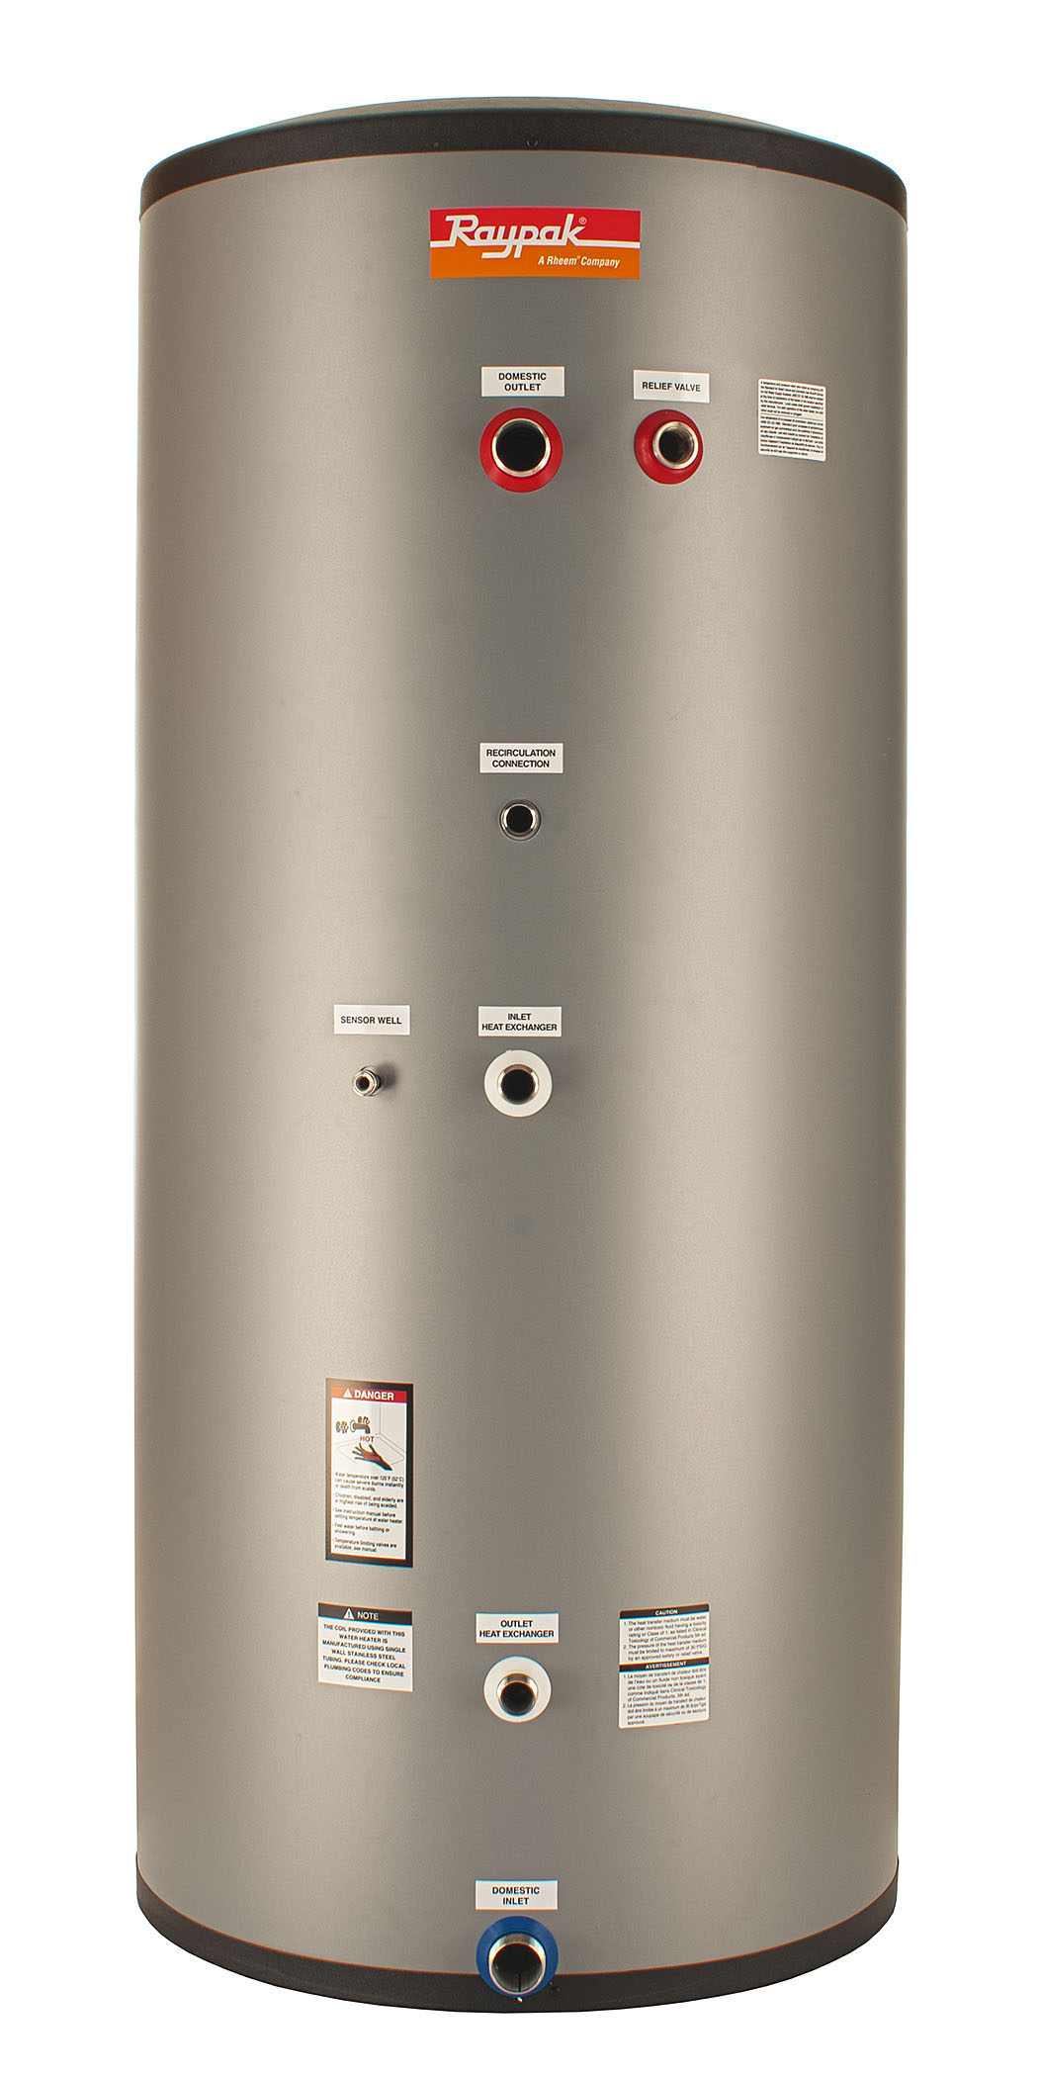Model:

* 444 Stainless Steel Construction
* Fully Seam-Welded Construction
  + No Lining to Fail
* Fully Pickled and Passivated for Maximum Durability
* 100% Pressure Tested Tank and Coil
* R-18 – 3-1/4 Inch Thick High-Density Neopor® GPS Insulation
  + Graphite Impregnated for Superior Performance
* Indoor – Outdoor Installation
* UV Stable Polypropylene Jacket
* UV Stable EPS Caps Top and Bottom
* 150 PSI Max Pressure Rating
* 180 ͦF Maximum Tank Temperature
* 2 Inch NPT Water Connections
* Hand-Hole Inspection and Cleanout Port
* Sensor / Tankstat Drywell Standard
* No Anodes or Dielectric Fittings Required
* All Tank Connections are on the Side for Easy Installation in Low-Clearance Areas
* Commercial 5-Year Warranty

Raypak-Rheem logo, submittalsStainless Steel Indirect Fired Storage Water Heater

Model Number

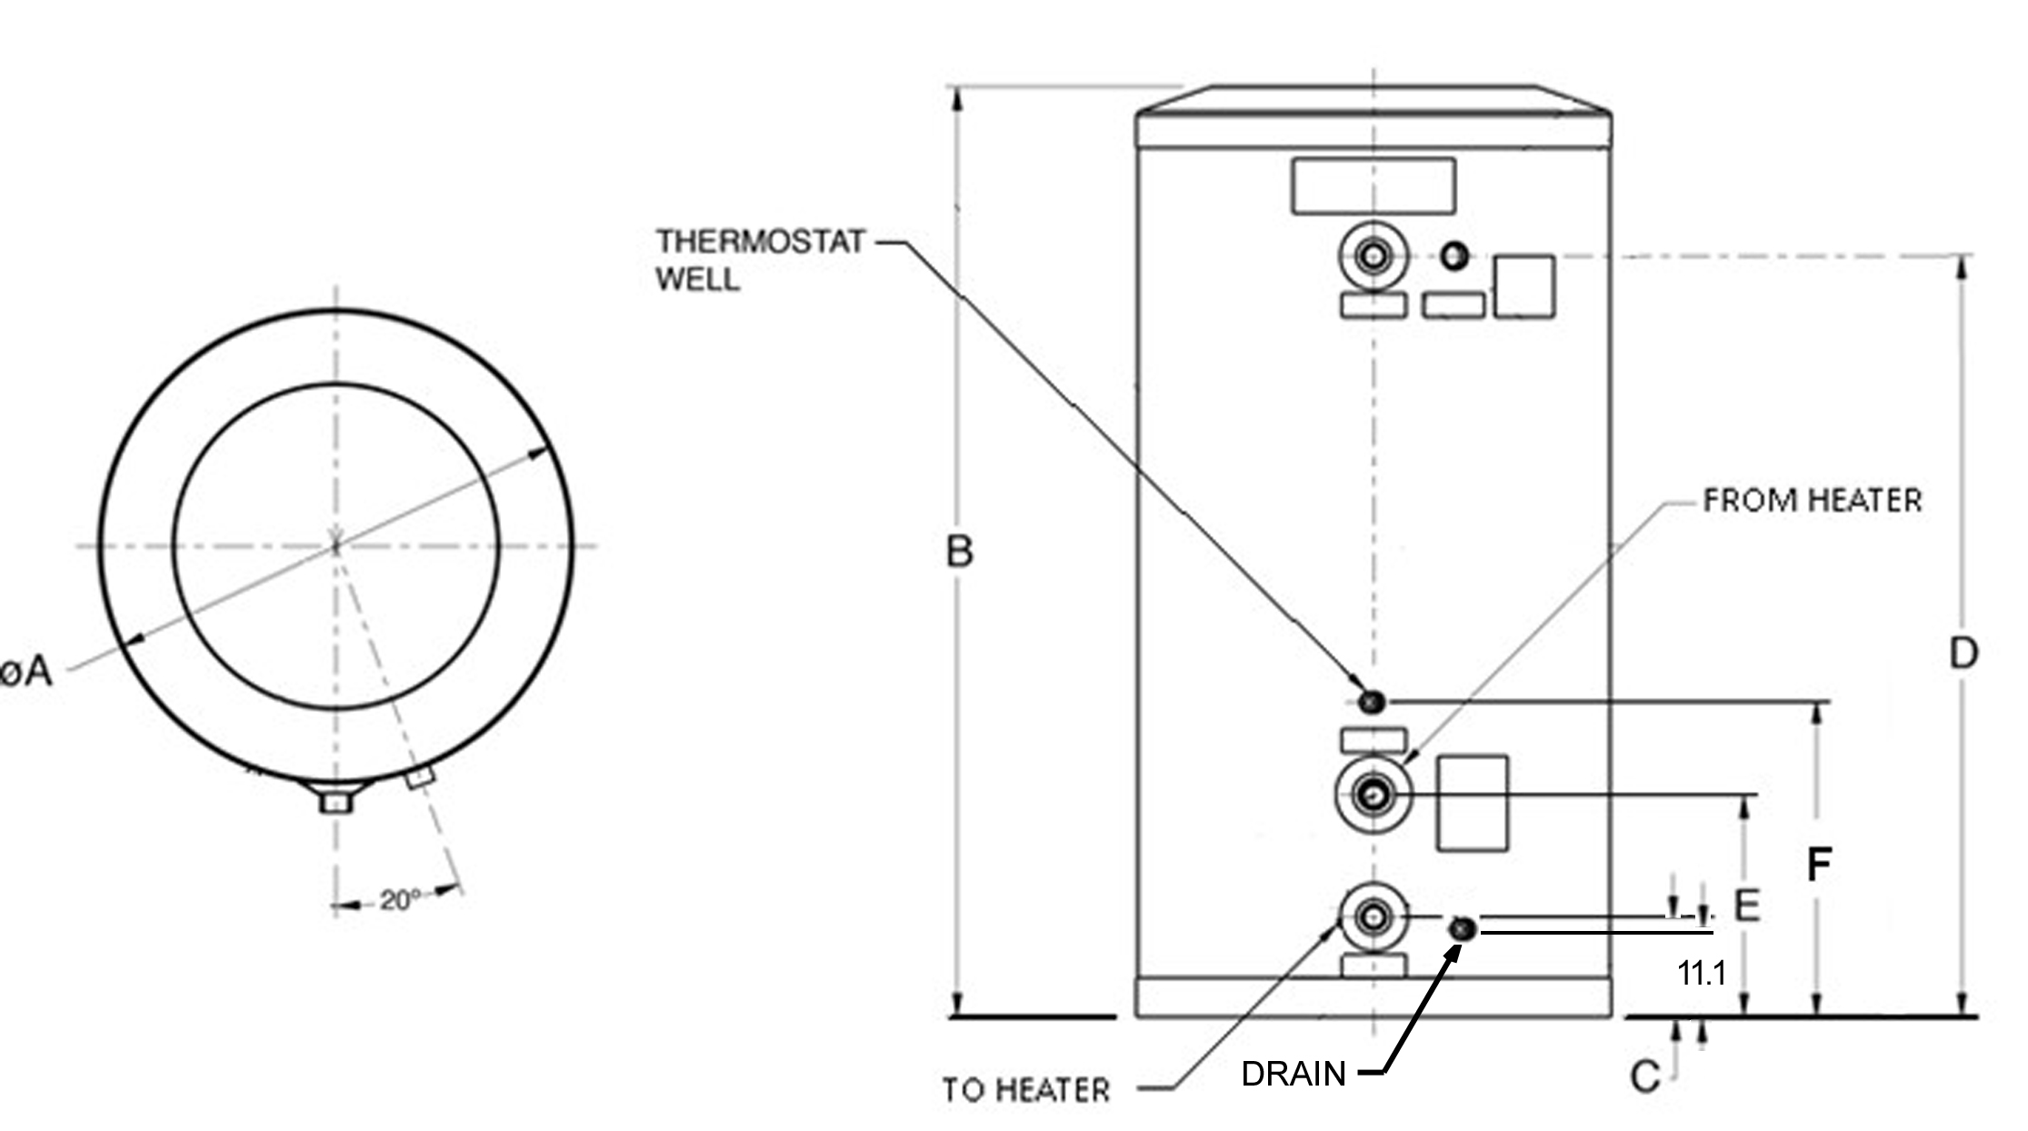

|  |  |  |  |  |  |  |  |  |  |
| --- | --- | --- | --- | --- | --- | --- | --- | --- | --- |
| **Model** | **Shipping**  **Weight**  **Lb. (kg)** | **Operating**  **Weight**  **Lb. (kg)** | **Water**  **Inlet/**  **Outlet** | **Diameter**  **In./(mm)**  **(A)** | **Height**  **In./(mm)**  **(B)** | **To Heater**  **Height**  **In./(mm)**  **(C)** | **Water**  **Outlet/T&P**  **Height**  **In./(mm)**  **(D)** | **From Heater**  **Height**  **In./(mm)**  **(E)** | **Drywell**  **Height**  **In./(mm)**  **(F)** |
| RSST110 | 150  (68) | 1100 (500) | 2 NPT | 31.3 (795) | 67.3 (1710) | 12.2 (310) | 54.8  (1392) | 22  (558) | 27.9 (708) |

Raypak, Inc. ▪ 2151 Eastman Ave., Oxnard, CA 93030 ▪ (805) 278-5300 ▪ Fax (800) 872-9725 ▪ www.raypak.com