Job:

# XTherm®

# Type WH

## Water Heaters

## Models 2505-4005

Engineer:

Contractor:

Prepared By:       Date:

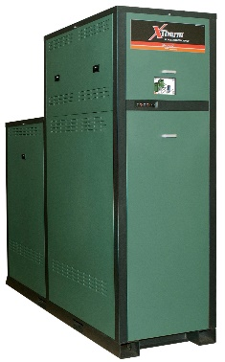Model:       Indoor/Outdoor:

97% Thermal Efficiency at Full Rate

100% Factory Fire-Tested

VERSA IC® Modulating Controller with Color Touch Screen Display

Full Electronic Modulation, 60% Min Fire Under Normal Conditions

Full Safety Diagnostics with History

Status Display Lights

Cascade up to 4 Heaters – No External Sequencer Required

Modbus RTU BMS Port

CSA Low Lead Certified ≤ .25% Lead

Maximum Outlet Water Temperature: 200°F

Maximum Tank Setpoint Temperature: 150°F

Minimum Inlet Water Temp: 50°F

Limited Twenty-Five-Year Thermal Shock Warranty

flag%201Limited Five-Year Copper/Ten-Year Cupro-Nickel Primary Heat Exchanger Warranty

Proudly Assembled in the USA

Limited Ten-Year Stainless Steel Condensing Heat Exchanger Warranty

Low NOx - BAAQMD Certified Per Rule 9-7

#### Heat Exchanger

* Headers - Bronze
* ASME HLW Stamped; 160 PSIG MAWP
* National Board Listed
* Fin Tubing

Copper – Standard

A-3 Cupro-Nickel

* ASME Powder-Coated Tube Sheet
* Silicone High-Temp O-Rings
* ASME Pressure Relief Valve

125 PSIG – Standard

150 PSIG – Optional

* Air Bleed Valve, Manual (2)
* T&P Gauge
* Four Pass Primary Heat Exchanger
* Stainless Steel Evaporator Plate
* 4 Inch Grooved Copper Water Connections

#### Control

* 240V, 60Hz, 1Ø, Power Supply
* 240/120V 60Hz Transformer
* 240/24V 60Hz Transformer
* VERSA IC® Integrated Control
* Cascade up to 4 Heaters
* Hot Surface Ignition (HSI)
* Ignition Module

3-Try – Standard

C-6 Single-Try

* Remote Flame Sensor
* Fixed High Limit, Manual Reset, 200°F
* On/Off Power Switch
* Flow Switch
* Blocked Vent Pressure Switch
* Freeze Protection
* Alarm Dry Contact
* Pump Outputs – Pilot Duty
* Injection Pump
* Recirculation Pump
* High Gas Pressure Switch
* Programmable Pump Time Delays
* Color HD Touch Screen Display
* Modulating Temperature Control, 60% Min Fire Under Normal Conditions
* Water Temperature Sensors (2 MTD, 1 Loose)
* Cold Water Protection Function
* Modbus RTU BMS Port (Up to 115K Baud Rate, see Cat. No. 5000.73)

B-85 BMS Gateway, Modbus RTU to Modbus TCP, N2 Metasys, BACnet IP, or BACnet MS/TP

B-86 BMS Gateway, Modbus RTU to LonWorks

#### Burner

* Radially-Fired Knitted Burner

#### Gas Train

* Fuel

Natural Gas

Propane (Minimum Grade HD5)

* Dual-Seat Combination Valve
* Manual Shut-Off Firing Valve

#### Construction

* Indoor/Outdoor Construction
* Enclosed Front Controls
* PolyTuf Powder Coat Finish
* Rear Connections (Water, Gas, Vent, Electrical, Comb. Air)
* Combustion Air Filter
* Front Connection Low Voltage Wiring
* Design Certified ANSI Z21.10.3/CSA 4.3
* CSA Low Lead Certified ≤.25% Lead

**Venting**

* Vent Termination

D-11 Outdoor or Indoor, Vertical – (Cat IV)

D-15 Indoor, Horizontal – (Cat IV)

D-33 Polypropylene Vent Adaptor

* Extractor – Optional

By others

Not required

#### Options

D-11 Outdoor Vent Cap with Outdoor Filter Cover

D-22 Truseal Air Intake Box, Indoor

F-10 Low Water Cut-Off, Remote Probe

I-6 High Limit, Manual Reset, Adj.,   
100-200°F

I-13 High Limit, Auto Reset, Adj., 100-200°F

S-1 Low Gas Pressure Switch,   
Manual Reset

Z-12 Condensate Treatment Kit

#### Additional Options or Accessories

#### 

Raypak-Rheem logo, submittals

XTherm® - Type WH

Models 2505-4005 Model

**NOTE*:* Use in conjunction with a storage tank for proper operation.**

**Clearances – in**

|  |  |  |  |  |  |  |  |  |
| --- | --- | --- | --- | --- | --- | --- | --- | --- |
|  | Front | Rear | Right | Left | Top | Floor | Vent | Vent Cap (outdoor) |
| Combustible Minimum | 24 | 12 | 1 | 1 | 0 | 0 | 1 | 12 |
| Minimum Service | 30 | 36 | 24 | 1 | 12 | N/A | N/A | 12 |

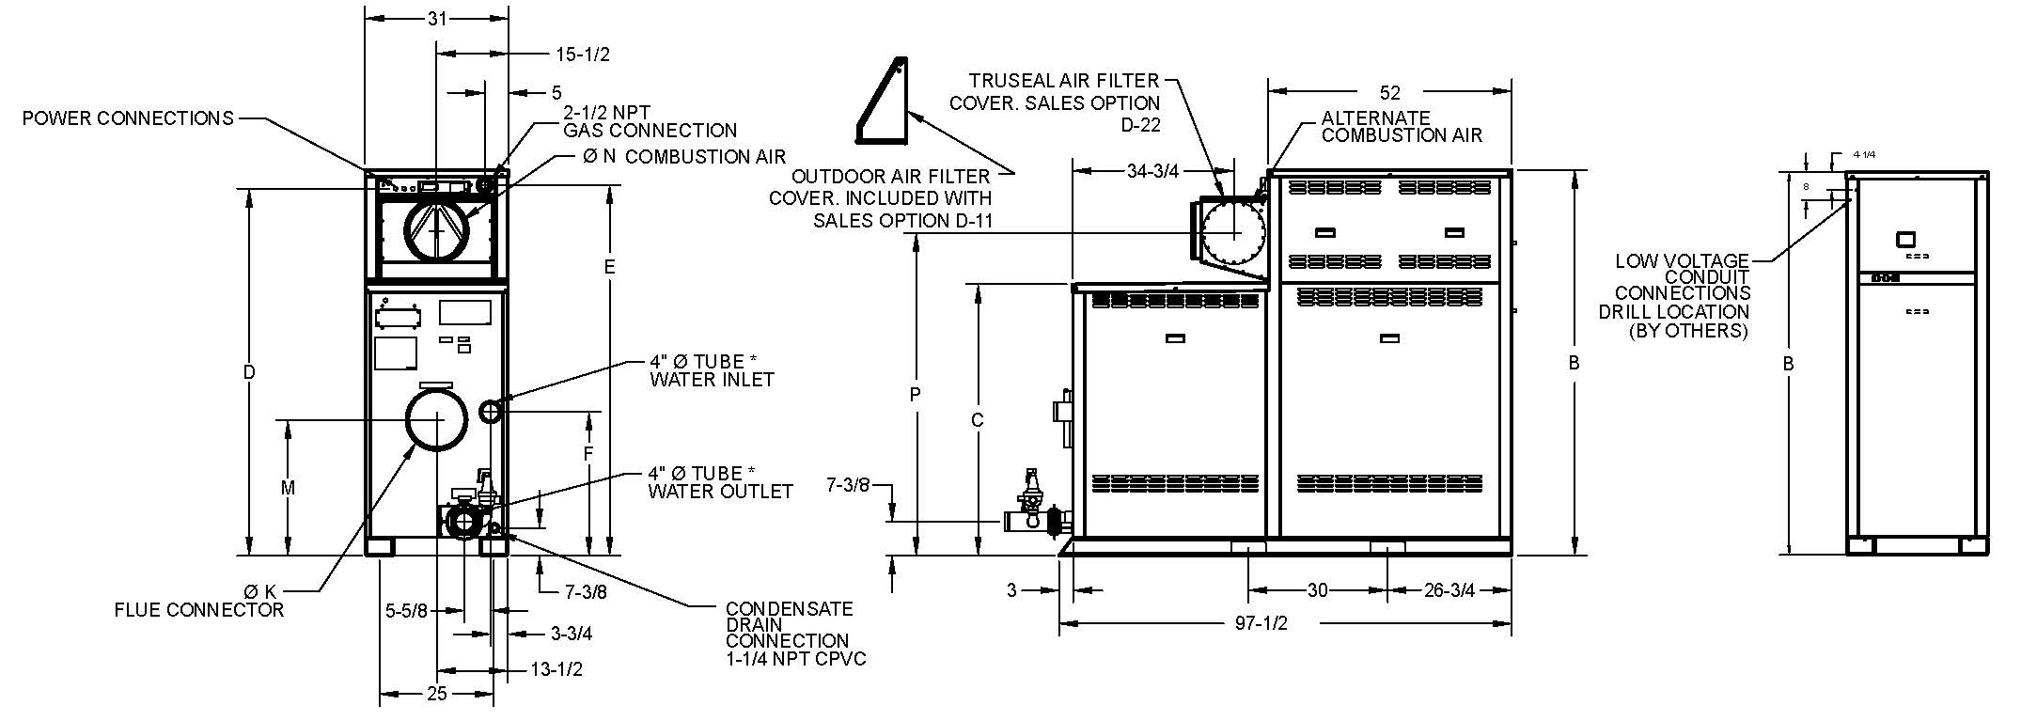

|  |  |  |  |  |  |  |  |  |  |  |  |  |  |  |  |
| --- | --- | --- | --- | --- | --- | --- | --- | --- | --- | --- | --- | --- | --- | --- | --- |
| **Model**  **(WH7 - )** | **MBTUH** | | **Dimensions - inches** | | | | | | | | | **Amp** Draw** | **Thermal Efficiency** | **Turn Down** | **Shipping Weight**  **(Lbs.)** |
| **B** | **C** | **D** | **E** | **F** | **K**  **Flue** | **M** | **N**  **C/A** | **P** |
| **Input** | **Output** |
| 2505 | 2501 | 2426 | 68-1/4 | 43-1/2 | 64 | 79-1/4 | 30-7/8 | 10 | 29-1/4 | 10 | 70 | 12 | 97% | 11:1 | 2656 |
| 3005 | 3000 | 2910 | 73-1/4 | 48-1/2 | 69 | 74-1/4 | 31-1/8 | 10 | 28-1/2 | 10 | 65 | 15 | 10:1 | 2775 |
| 3505 | 3500 | 3395 | 78-1/4 | 53-1/2 | 74 | 69-1/4 | 26-1/8 | 10 | 23-1/2 | 12 | 60 | 17 | 10:1 | 2925 |
| 4005 | 4000 | 3880 | 83-1/4 | 58-1/2 | 79 | 64-1/4 | 21-1/8 | 12 | 18-1/2 | 12 | 55 | 20 | 7:1 | 3058 |

**\*** Water connections are grooved copper tube.

** Amp draw is for heater only and does not include pumps or accessories. Pump amp draw provided in separate table below.

|  |  |  |  |  |  |  |  |  |
| --- | --- | --- | --- | --- | --- | --- | --- | --- |
| **Model**  **(WH7-)** | **Internal Boiler Pump** | | | | | | **External Injection**  **Pump** | |
| **Soft (3-5 GPG)** | | **Medium (6-15 GPG)** | | **Hard (16-25 GPG)** | |
| **HP** | **Amp Draw** | **HP** | **Amp Draw** | **HP** | **Amp Draw** | **HP** | **Amp Draw** |
| 2505 | 1.5 | 8.2 | 1.5 | 8.2 | 1.5 | 8.2 | 1.0 | 7.0 |
| 3005 | 1.5 | 8.2 | 3.0 | 16 | 3.0 | 16 | 1.5 | 8.2 |
| 3505 | 1.5 | 8.2 | 3.0 | 16 | 3.0 | 16 | 1.5 | 8.2 |
| 4005 | 3.0 | 16 | 3.0 | 16 | 3.0 | 16 | 1.5 | 8.2 |

Pumps are 240VAC/1PH.

*External injection pump ships loose for field installation.

|  |  |  |  |  |  |  |  |  |  |  |
| --- | --- | --- | --- | --- | --- | --- | --- | --- | --- | --- |
| **Model**  **(WH7-)** | **RECOVERY RATES** | | | | | | | | | |
| **Temperature Rise (°F)** | | | | | | | | | |
| **20** | **30** | **40** | **50** | **60** | **70** | **80** | **90** | **100** | **110** |
| 2505 | 14703 | 9802 | 7351 | 5881 | 4901 | 4201 | 3676 | 3267 | 2941 | 2673 |
| 3005 | 17636 | 11758 | 8818 | 7055 | 5879 | 5039 | 4409 | 3919 | 3527 | 3207 |
| 3505 | 20576 | 13717 | 10288 | 8230 | 6859 | 5879 | 5144 | 4572 | 4115 | 3741 |
| 4005 | 23515 | 15677 | 11758 | 9406 | 7838 | 6719 | 5879 | 5226 | 4703 | 4275 |

Table data applies at full rate.

XTherm® - Type WH

Models 2505-4005 Model

**NOTE: Use in conjunction with a storage tank for proper operation.**

**Base Anchor Bolt Pattern**

**Models 2005 - 4005**

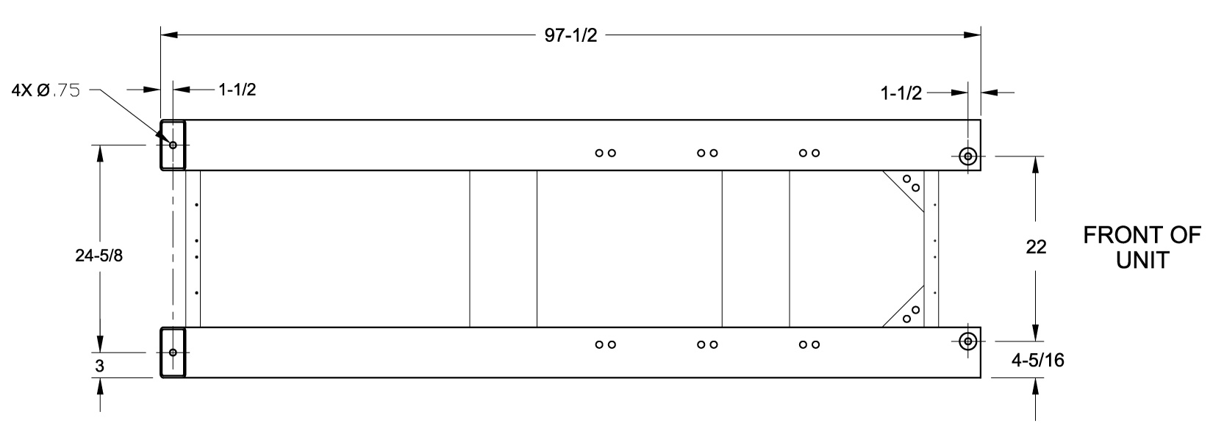

**External Injection Pump – Field Installed**

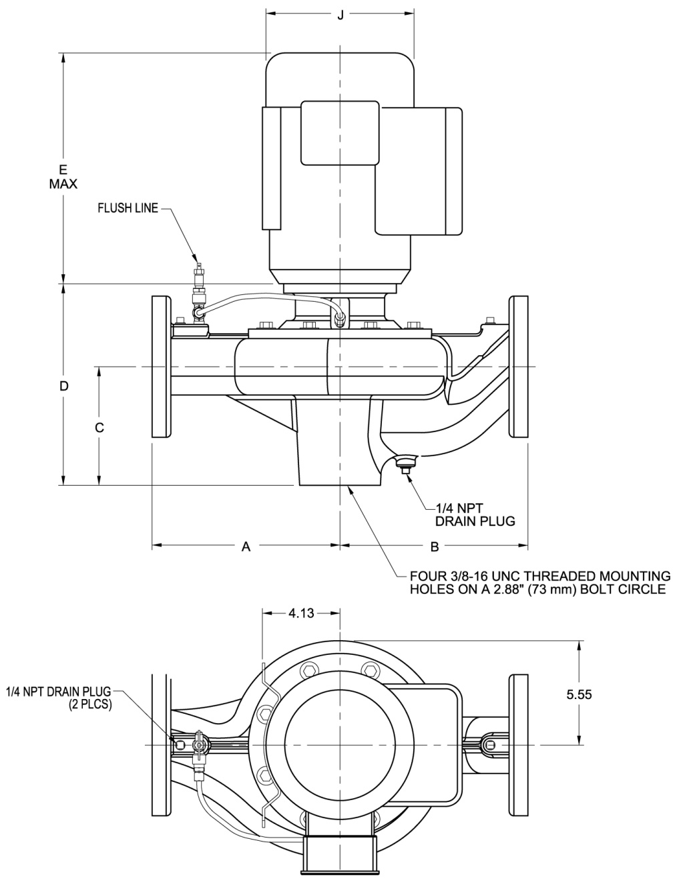

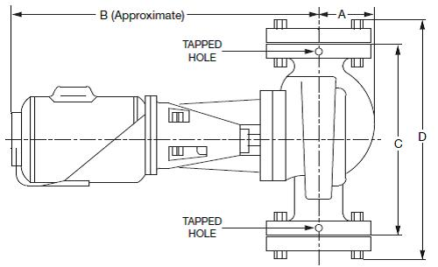

**WH7 – 2505 TO WH7 - 3005**

2-1/2 NPT Flanges Included

|  |  |  |  |  |
| --- | --- | --- | --- | --- |
| **Model**  **(WH7-)** | Dimensions – inches | | | |
| **A** | **B** | **C** | **D** |
| 2505 | 3-1/2 | 19 | 13-1/2 | 16-1/8 |
| 3005 | 3-5/8 | 21 | 16-1/2 | 19-1/2 |

**WH7 – 3505 TO WH7 - 4005**

|  |  |  |  |  |  |  |  |  |  |
| --- | --- | --- | --- | --- | --- | --- | --- | --- | --- |
| **Model**  **(WH7-)** | Dimensions – inches | | | | | | | | |
| **A** | **B** | **C** | **D** | **E** | **F** | **G** | **H** | **J** |
| 3505 | 10 | 10 | 6-5/16 | 10-1/2 | 13-15/16 | 5-5/16 | 6-5/16 | 1/4 | 7-7/8 |
| 4005 |

3” ANSI Flange – By Others

Raypak, Inc. • Eastman Avenue, Oxnard, CA 93030 • (805) 278-5300 • (805) 872-9725 • www.raypak.com

Raypak, Inc. • Eastman Avenue, Oxnard, CA 93030 • (805) 278-5300 • (805) 872-9725 • www.raypak.com