­­Job:

# Storage Water Heater Indirect Fired Stainless Steel

## 6 models from 30-gallon to 115-gallon

## 

Engineer:

Contractor:

Prepared By:       Date:

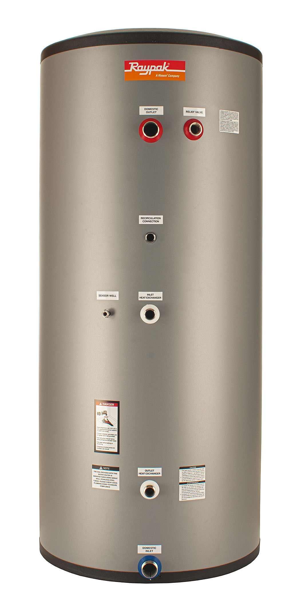Model:

* 444 Stainless Steel Construction
* Fully Seam-Welded Construction
  + No Lining to Fail
* Fully Pickled and Passivated for Maximum Durability
* 100% Pressure Tested Tank and Coil
* 2 Inch Thick Expanded Polystyrene Insulation
* Polypropylene Jacket
* EPS Caps Top and Bottom
* 1 Inch Diameter Single Wall 444 Stainless Steel Coil
* 150 PSI Max Pressure Rating
* 180 ͦF Maximum Tank Temperature
* 210 ͦF Maximum Coil Temperature
* Hand-Hole Inspection and Cleanout Port
* Sensor / Tankstat Drywell Standard
* No Anodes or Dielectric Fittings Required
* All Tank Connections are on the Side for Easy Installation in Low-Clearance Areas
* Residential Limited Lifetime Warranty
* Commercial 5-Year Warranty

Raypak-Rheem logo, submittalsStainless Steel Indirect Fired Storage Water Heater

Model Number

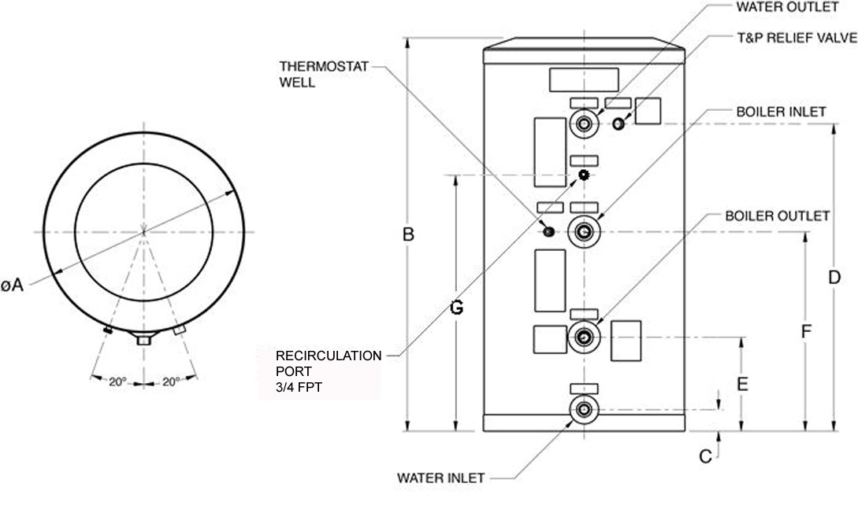

|  |  |  |  |  |  |  |  |  |  |  |  |
| --- | --- | --- | --- | --- | --- | --- | --- | --- | --- | --- | --- |
| **Model** | **Shipping**  **Weight**  **Lb. (kg)** | **Operating**  **Weight**  **Lb. (kg)** | **Water**  **Inlet/**  **Outlet** | **Coil**  **Inlet/**  **Outlet** | **Diameter**  **In./(mm)**  **(A)** | **Height**  **In./(mm)**  **(B)** | **Water**  **Inlet**  **Height**  **In./(mm)**  **(C)** | **Water**  **Outlet/T&P**  **Height**  **In./(mm)**  **(D)** | **Coil**  **Outlet**  **Height**  **In./(mm)**  **(E)** | **Coil Inlet**  **Height**  **In./(mm)**  **(F)** | **Recirc. Port In./(mm) (G)** |
| RSIT30 | 48 (21.8) | 262 (119) | 3/4 | 1 | 20.1 (510) | 39.6 (1006) | 2.2 (56) | 30.9 (785) | 9.4 (239) | 22 (559) | N/A |
| RSIT40 | 60 (27.3) | 328 (173) | 3/4 | 1 | 21.8 (554) | 46.9 (1141) | 2 (51) | 37 (940) | 10.2 (259) | 23.6 (599) | N/A |
| RSIT50 | 76 (34.5) | 535 (243) | 3/4 | 1 | 21.8 (554) | 62.7 (1593) | 2 (51) | 52.8 (1341) | 10.2 (259) | 26.3 (668) | N/A |
| RSIT65 | 85 (38.6) | 610 (277) | 3/4 | 1 | 21.8 (554) | 70.2 (1783) | 2 (51) | 60.3 (1532) | 10.2 (259) | 26.3 (668) | N/A |
| RSIT80 | 106 (48.2) | 744 (337) | 1 | 1 | 23.8 (605) | 69.9 (1775) | 1.9 (48) | 60.5 (1537) | 9.9 (251) | 33.3 (846) | 42 (1066) |
| RSIT115 | 150 (68.2) | 1079 (489) | 1-1/2 | 1 | 28.9 (734) | 65.8 (1671) | 2.4 (61) | 53 (1346) | 11.5 (292) | 31.9 (810) | 41 (1041) |

|  |  |  |  |  |  |  |  |  |  |  |
| --- | --- | --- | --- | --- | --- | --- | --- | --- | --- | --- |
| **Model** | **Potable**  **Water**  **Volume**  **Gal/(L)** | **Heat**  **Source**  **Water**  **Volume**  **Gal/(L)** | **First Hour**  **Rating**  **Gal/hr/(L/hr)** | **Continuous**  **Draw Rating**  **Gal/hr/(L/hr)** | **Standby**  **Loss**  **°F/hr**  **(°C/hr)** | **Minimum**  **Boiler**  **Output**  **MBH/**  **(kw/hr)** | **Coil**  **Length**  **Ft/(m)** | **Heating**  **Surface**  **Area**  **Sq. ft./(m2)** | **Heating**  **Coil**  **Minimum**  **Flow**  **Gpm/**  **(L/min)** | **Coil**  **Pressure**  **Drop at**  **Minimum**  **Flow**  **Ft wc/**  **(M wc)** |
| RSIT30 | 25.7 (97) | 0.8 (3.0) | 172 (651) | 149 (564) | 1.4 (0.8) | 96 (328) | 27 (8.2) | 6.9 (0.64) | 14.0 (53) | 8.4 (2.6) |
| RSIT40 | 38.6 (146) | 1.0 (3.8) | 207 (783) | 172 (651) | 0.9 (0.5) | 108 (369) | 31 (9.4) | 8.0 (0.74) | 14.0 (53) | 9.4 (2.9) |
| RSIT50 | 55.0 (208) | 1.3 (4.9) | 261 (988) | 208 (787) | 0.7 (0.4) | 133 (454) | 39 (11.9) | 10.0 (0.93) | 14.0 (53) | 5.0 (1.5) |
| RSIT65 | 62.9 (238) | 1.3 (4.9) | 270 (1022) | 209 (791) | 0.6 (0.3) | 135 (461) | 39 (11.9) | 10.0 (0.93) | 14.0 (53) | 4.8 (1.4) |
| RSIT80 | 76.5 (290) | 1.6 (6.0) | 348 (1317) | 276 (1045) | 0.6 (0.3) | 177 (604) | 47 (14.3) | 14.6 (1.4) | 14.0 (53) | 4.5 (1.4) |
| RSIT115 | 111.3 (421) | 2.5 (9.5) | 412 (1559) | 309 (1170) | 0.5 (0.3) | 199 (679) | 55 (16.8) | 17.1 (1.6) | 14.0 (53) | 7.0 (2.1) |

Note: Rating data based on 180°F (82°C) boiler water, potable water inlet 58°F (14°C) and outlet 135°F (57°C). Other operating conditions are possible.

Raypak, Inc. ▪ 2151 Eastman Ave., Oxnard, CA 93030 ▪ (805) 278-5300 ▪ Fax (800) 872-9725 ▪ www.raypak.com