Job:

# XTherm®

# Type P

## Pool Heaters

## Models 2505-4005

Engineer:

Contractor:

Prepared By:       Date:

Model:       Indoor/Outdoor:



97% Thermal Efficiency at Full Rate

100% Factory Fire Tested

VERSA IC® Controller with 7” color touchscreen display

Raymote™ remote connectivity provided standard

Maximum Outlet Water Temperature Setpoint: 104°F

Minimum Inlet Water Temperature: 50°F

Full Safety Diagnostics with History

Status Display Lights

Cascade up to 4 Heaters – No External Sequencer Required

Limited Twenty-Five-Year Thermal Shock Warranty

flag%201Limited Five-Year Primary Heat Exchanger Warranty

Proudly Assembled in the USA

Limited Ten-Year Secondary Heat Exchanger Warranty

On/Off Operation

#### Heat Exchanger

* Headers - Bronze
* ASME H Stamped; 160 PSIG MAWP
* National Board Listed
* Fin Tubing

Cupro-Nickel Finned Tubbing

* ASME Powder-Coated Tube Sheet
* Silicone High-Temp O-Rings
* ASME Pressure Relief Valve

125 PSIG – Standard

* Manual Air Bleed (2)
* T&P Gauge
* Stainless Steel Condensing Heat Exchanger – U stamped
* Stainless Steel Evaporator Plate
* 4 Inch Grooved Copper Water Connections

#### Control

* 240V, 60Hz, 1Ø, Power Supply
* 240/120V 60Hz Transformer
* 240/24V 60Hz Transformer
* VERSA IC®
* 7” color HD touchscreen display
* Raymote™ Wi-Fi remote connectivity
* Cascade up to 4 Heaters
* Ignition Module

3-Try – Standard

Single-Try – Option C6

* Remote Flame Sensor
* Fixed High Limit, Manual Reset, 180°F
* On/Off Power Switch
* Flow Switch
* Blocked Vent Pressure Switch
* Freeze Protection
* Alarm Dry Contact
* High Gas Pressure Switch
* Pump outputs – Pilot Duty
* Injection Pump
* System
* Programmable Pump Time Delays
* Water Temperature Sensors (4)
* Sensor Wells (2)
* Cold Water Protection Function
* Modbus RTU BMS Port (Up to 115K Baud Rate, see Cat. No. 5000.73)
* B-85 BMS Gateway, Modbus RTU to Modbus TCP, N2 Metasys, BACnet IP, or BACnet MS/TP
* B-86 BMS Gateway, Modbus RTU to LonWorks

#### Burner

* Hot Surface Ignition (HSI)
* Radially-Fired Knitted Burner
* Low NOx : Less than 30 PPM NOx (Nat)

#### Gas Train

* Fuel

Natural Gas

Propane Gas (Grade HD5)

* Dual-Seat Combination Valve
* Manual Shut Off Firing Valve

#### Construction

* Indoor/Outdoor Construction
* Enclosed Front Controls
* PolyTuf Powder Coat Finish
* Rear Connections (Water, Gas, Vent, Electrical, Comb. Air)
* Combustion Air Filter
* Front Connection Low Voltage Wiring
* Design Certified ANSI Z21.56/CSA 4.3

#### Venting

* Vent Termination

D-11Outdoor or Indoor, Vertical –   
Option (Cat IV)

D-15 Indoor, Horizontal – Option (Cat IV)

* Extractor – Optional

By others

Not required

#### Options

D-32 PVC Vent Connection (Factory Mounted Only)

D-33 Polypropylene Vent Connection

F-10 Low Water Cut-Off, Remote Probe

I-6 High Limit, Auto Reset, Adj.,   
100-240°F

I-12 High Limit, Manual Reset, Adj., 100-240°F

S-1 Low Gas Pressure Switch,   
Manual Reset

Z-12 Condensate Treatment Kit

#### Additional Options or Accessories

#### 



Raypak-Rheem logo, submittals

XTherm® - Type P

Models 2505-4005 Model

**NOTE*:* Primary/Secondary plumbing arrangement is mandatory for proper operation.**

**Clearances (in)**

|  |  |  |  |  |  |  |  |
| --- | --- | --- | --- | --- | --- | --- | --- |
|  | Front | Rear | Right | Left | Top | Floor | Vent |
| Combustible Minimum | 24 | 12 | 1 | 1 | 0 | 0 | 1 |
| Minimum Service | 30 | 36 | 24 | 1 | 12 | N/A | N/A |

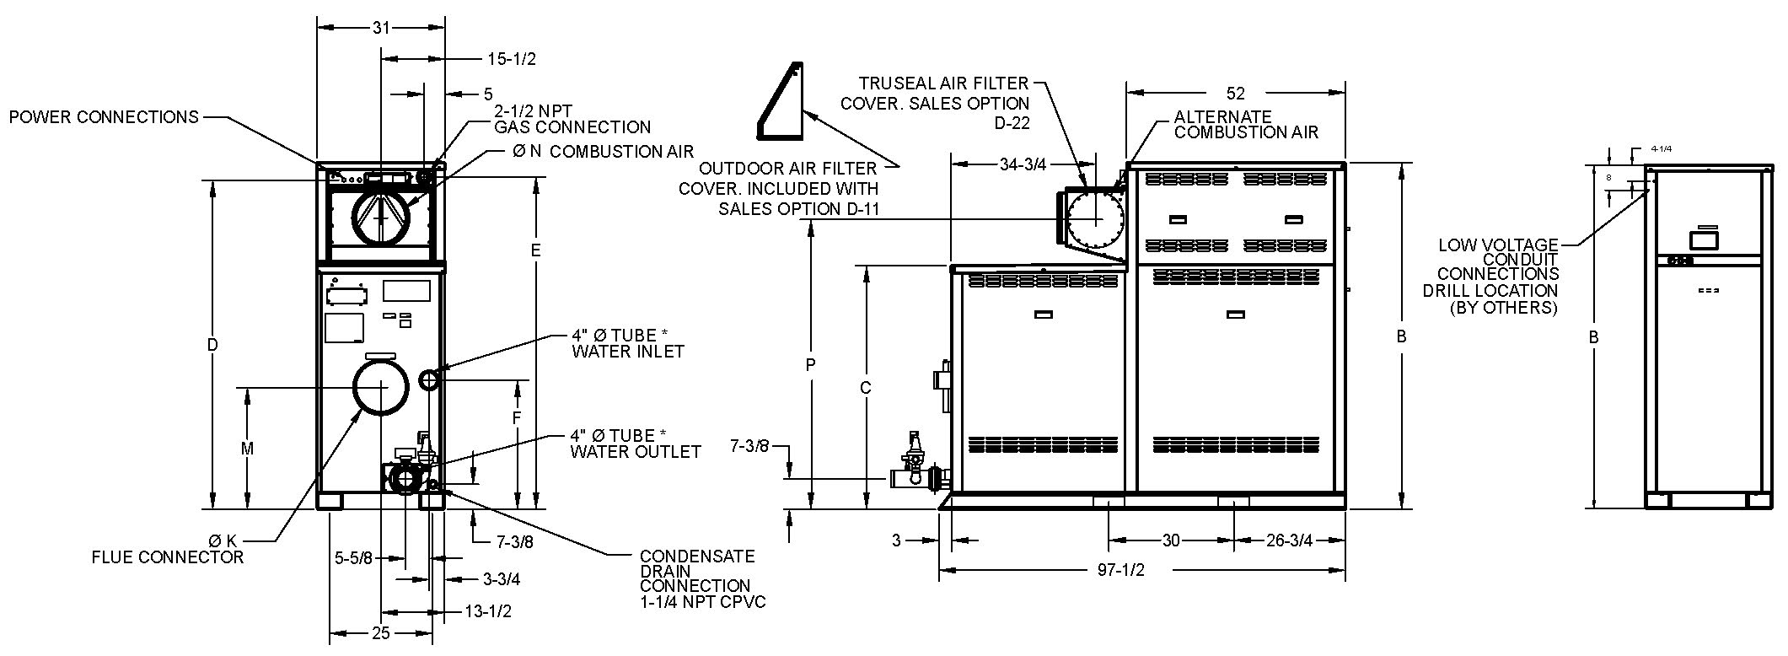

|  |  |  |  |  |  |  |  |  |  |  |  |  |  |
| --- | --- | --- | --- | --- | --- | --- | --- | --- | --- | --- | --- | --- | --- |
| Model  (P - ) | MBTUH | | **Dimensions (in.)** | | | | | | | | | Amp** Draw | Shipping Weight  (Lbs.) |
| B | C | D | E | F | K  Flue | M | N  C/A | P |  |  | |
| Input | Output |  |  |  |  |  |  |  |  |  |  |  | |
| 2505 | 2501 | 2426 | 68-1/4 | 43-1/2 | 64-1/8 | 65 | 21-1/4 | 10 | 18-1/2 | 10 | 54-5/8 | 12 | 2656 | |
| 3005 | 3000 | 2910 | 73-1/4 | 48-1/2 | 69-1/8 | 70 | 26-1/4 | 10 | 23-1/2 | 10 | 59-1/2 | 15 | 2775 | |
| 3505 | 3500 | 3395 | 78-1/4 | 53-1/2 | 74 | 75 | 31-1/4 | 10 | 28-1/2 | 12 | 64-3/4 | 17 | 2925 | |
| 4005 | 4000 | 3880 | 83-1/4 | 58-1/2 | 79 | 80 | 31 | 12 | 29-1/4 | 12 | 69-5/8 | 20 | 3058 | |

**\* Water connections are grooved copper tube.**

**\*\* Amp draw is for heater only and does not include pumps or accessories.**

|  |  |  |  |  |
| --- | --- | --- | --- | --- |
| Model | Internal Heater Pump | | External Injection Pump | |
| HP | Amp Draw | HP | Amp Draw |
| 2505 | 1.5 | 8.2 | 0.5 | 7 |
| 3005 | 1.5 | 8.2 | 0.75 | 11 |
| 3505 | 1.5 | 8.2 | 1.0 | 14  The Chart below represents performance capacity for injection pump as provided with the unit. Pipe size is determined by velocity not to exceed 7.5 ft. per second. |
| 4005 | 3.0 | 16 | 1.0 | 14 |

Pumps are 240VAC/1PH.

External injection pump ships loose for field installation.

|  |  |  |  |  |  |  |  |  |  |  |  |  |  |
| --- | --- | --- | --- | --- | --- | --- | --- | --- | --- | --- | --- | --- | --- |
| Sys Ret Temp (#F) | Model 2505 (30°F Delta T) | | | | Model 3005 (30°F Delta T) | | | Model 3505 (32°F Delta T) | | | Model 4005 (33°F Delta T) | | |
| Supply Temp (#F) | Flow GPM | Pipe Max Eq Ft | | Supply Temp (#F) | Flow GPM | Pipe Max Eq Ft | Supply Temp (#F) | Flow GPM | Pipe Max Eq Ft | Supply Temp (#F) | Flow GPM | Pipe Max Eq Ft |
| 3” | 4” | 4” | 4” | 4” |
| 60 | 144 | 57 | 230 | 450 | 146 | 67 | 110 | 148 | 76 | 100 | 144 | 91 | 100 |
| 80 | 144 | 75 | 230 | 450 | 146 | 87 | 110 | 148 | 99 | 100 | 144 | 120 | 100 |
| 100 | 144 | 109 | 230 | 450 | 146 | 125 | 110 | 148 | 140 | 100 | 144 | 175 | 100 |

**HIGH FIRE CONDITIONS**

XTherm® - Type P

Models 2505-4005 Model

**NOTE: Primary/Secondary plumbing arrangement is mandatory for proper operation.**

Base Anchor Bolt Pattern

Models 2005 - 4005

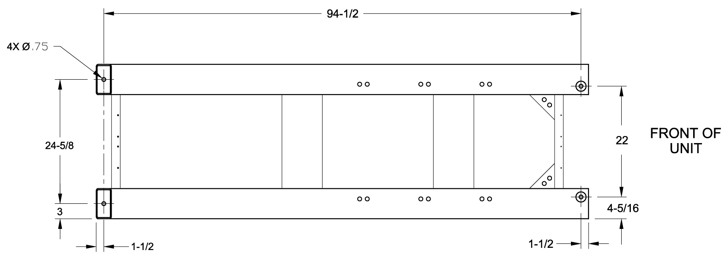

**Injection Pump – Field Installed in Inlet Piping**

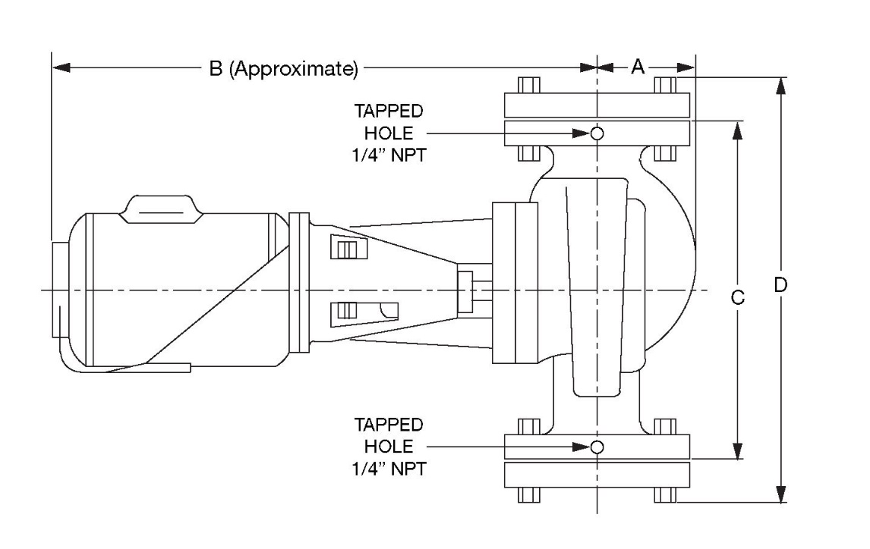

2 1/2” NPT Flanges Included

|  |  |  |  |  |
| --- | --- | --- | --- | --- |
| **Model** | **A** | **B** | **C** | **D** |
| 2505 | 3-1/2 | 18 | 13-1/2 | 16-1/8 |
| 3005 | 18-1/2 |
| 3505 | 19 |
| 4005 |

Raypak, Inc. • Eastman Avenue, Oxnard, CA 93030 • (805) 278-5300 • (805) 872-9725 • www.raypak.com