Job:

# MVB®

# Type H

## Heating Boilers

## Models 2503-4003

Engineer:

Contractor:

Prepared By:       Date:

Model:       Indoor/Outdoor:

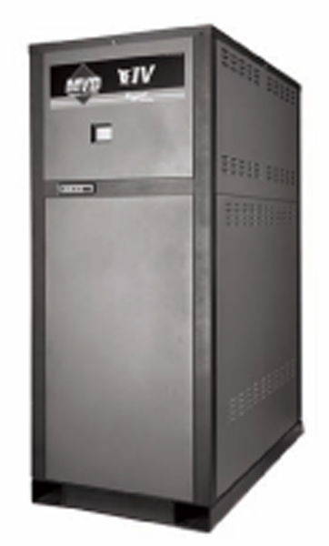

85% Thermal Efficiency at Full Rate; Up to 88.4% at Part Load

100% Factory Fire Tested

VERSA IC® Modulating Controller with LCD Display

Full Electronic Modulation, Constant Ratio 7:1 Turndown

Full Safety Diagnostics with History

Status Display Lights

Cascade up to 4 Heaters – No External Sequencer Required

Modbus RTU BMS Port

Maximum Outlet Water Temperature: 235°F

Minimum Inlet Water Temperature: 120°F

Limited Twenty-Five-Year Thermal Shock Warranty

Limited Ten-Year Heat Exchanger Warranty

Proudly Assembled in the USA



Ultra Low NOx (BAAQMD Reg. 9, Rule 7 Approved)

#### Heat Exchanger

* Headers - Bronze
* ASME H Stamped; 160 PSIG MAWP
* National Board Listed
* Fin Tubing

Copper – Standard

A-3 Cupro-Nickel

* ASME Powder-Coated Tube Sheet
* Silicone High-Temp O-Rings
* ASME Pressure Relief Valve

60 PSIG – Standard

      PSIG – Optional

* 150 PSI Air Vent, Auto (2)
* T&P Gauge
* 4-Pass Heat Exchanger
* Stainless Steel Evaporator Plate
* 4-Inch Grooved Copper Water Connections

#### Control

* 240V, 60Hz, 1Ø, Power Supply
* 240/120V 60Hz Transformer
* 240/24V 60Hz Transformer
* VERSA IC® Integrated Control
* Cascade up to 4 Heaters
* Hot Surface Ignition (HSI)
* Ignition Module

3-Try – Standard

C-6 Single-Try

* Remote Flame Sensor
* Fixed High Limit, Manual Reset, 240°F
* On/Off Power Switch
* Flow Switch
* Blocked Vent Pressure Switch
* Freeze Protection
* Alarm Dry Contact
* High Gas Pressure Switch
* Pump outputs – Pilot Duty
* Boiler
* DHW Indirect
* System
* Programmable Pump Time Delays
* LCD Display; Status, Fault and Diagnostics
* Modulating Temperature Control, 7:1 turndown
* Water Temperature Sensors (5)
* Cold Water Protection Function

Optional Variable Speed Pump

Optional Proportional Valve

* Modbus RTU BMS Port (Up to 115K Baud Rate, see Cat. No. 5000.73)

#### Burner

* Radially-Fired Knitted Burner

#### Gas Train

* Fuel

Natural Gas

Propane

* Dual-Seat Combination Valve
* Manual Shut Off Firing Valve

#### Construction

* Indoor/Outdoor Construction
* Enclosed Front Controls
* PolyTuf Powder Coat Finish
* Rear Connections (Water, Gas, Vent, Electrical, Comb. Air)
* Combustion Air Filter
* Front Connection Low Voltage Wiring
* Design Certified ANSI Z21.13/CSA 4.9
* CSA Low Lead Certified ≤.25% Lead

#### Venting

* Vent Termination

D-11 Outdoor or Indoor, Vertical (Cat IV)

D-15 Indoor, Horizontal (Cat IV)

* Extractor – Optional

By others

Not required

#### Options

B-31 Well Assembly - System

B-32 Outdoor Air Sensor

B-85 BMS Gateway, Modbus RTU to Modbus TCP, N2 Metasys, BACnet IP, or BACnet MS/TP

B-86 BMS Gateway, Modbus RTU to LonWorks

D-22 Truseal Air Intake Box, Indoor

F-10 Low Water Cut-Off, Remote Probe

I-1 High Limit, Auto Reset, Adj.,   
100-240°F

I-2 High Limit, Manual Reset, Adj., 100-240°F

S-1 Low Gas Pressure Switch,   
Manual Reset

Z-12 Condensate Treatment Kit

#### Regulatory Agency Requirements

#### 

#### Multi-Boiler Digital Temp Controllers

B-36 TempTracker Mod+ Hybrid,   
2-4 Boilers

B-37 TempTracker Mod+ Hybrid,   
5-10 Boilers

B-38 TempTracker Mod+ Hybrid,   
11-16 Boilers

B-39 EMS 4-20 mA Remote Setpoint Interface Module (may only be used with B-36 to B-38)

B-62 BACnet MS/TP Interface Module (may only be used with B-36 to B-38)



Raypak-Rheem logo, submittals

MVB® - Type H

Models 2503-4003 Model

**Clearances (in)**

|  |  |  |  |  |  |  |  |
| --- | --- | --- | --- | --- | --- | --- | --- |
|  | Front | Rear | Access  Side | Other Side | Top | Floor | Vent |
| Combustible Minimum | 24 | 12 | 1 | 1 | 0 | 0 | 1 |
| Minimum Service | 30 | 36 | 24* | 1 | 12 | N/A | N/A |

*Service Clearance can be right side or left side.

**NOTE*:* Primary/Secondary plumbing arrangement is mandatory for proper operation.**

**SIDE**

**VIEW**

**FRONT**

**VIEW**

**REAR**

**VIEW**

REAR

VIEW

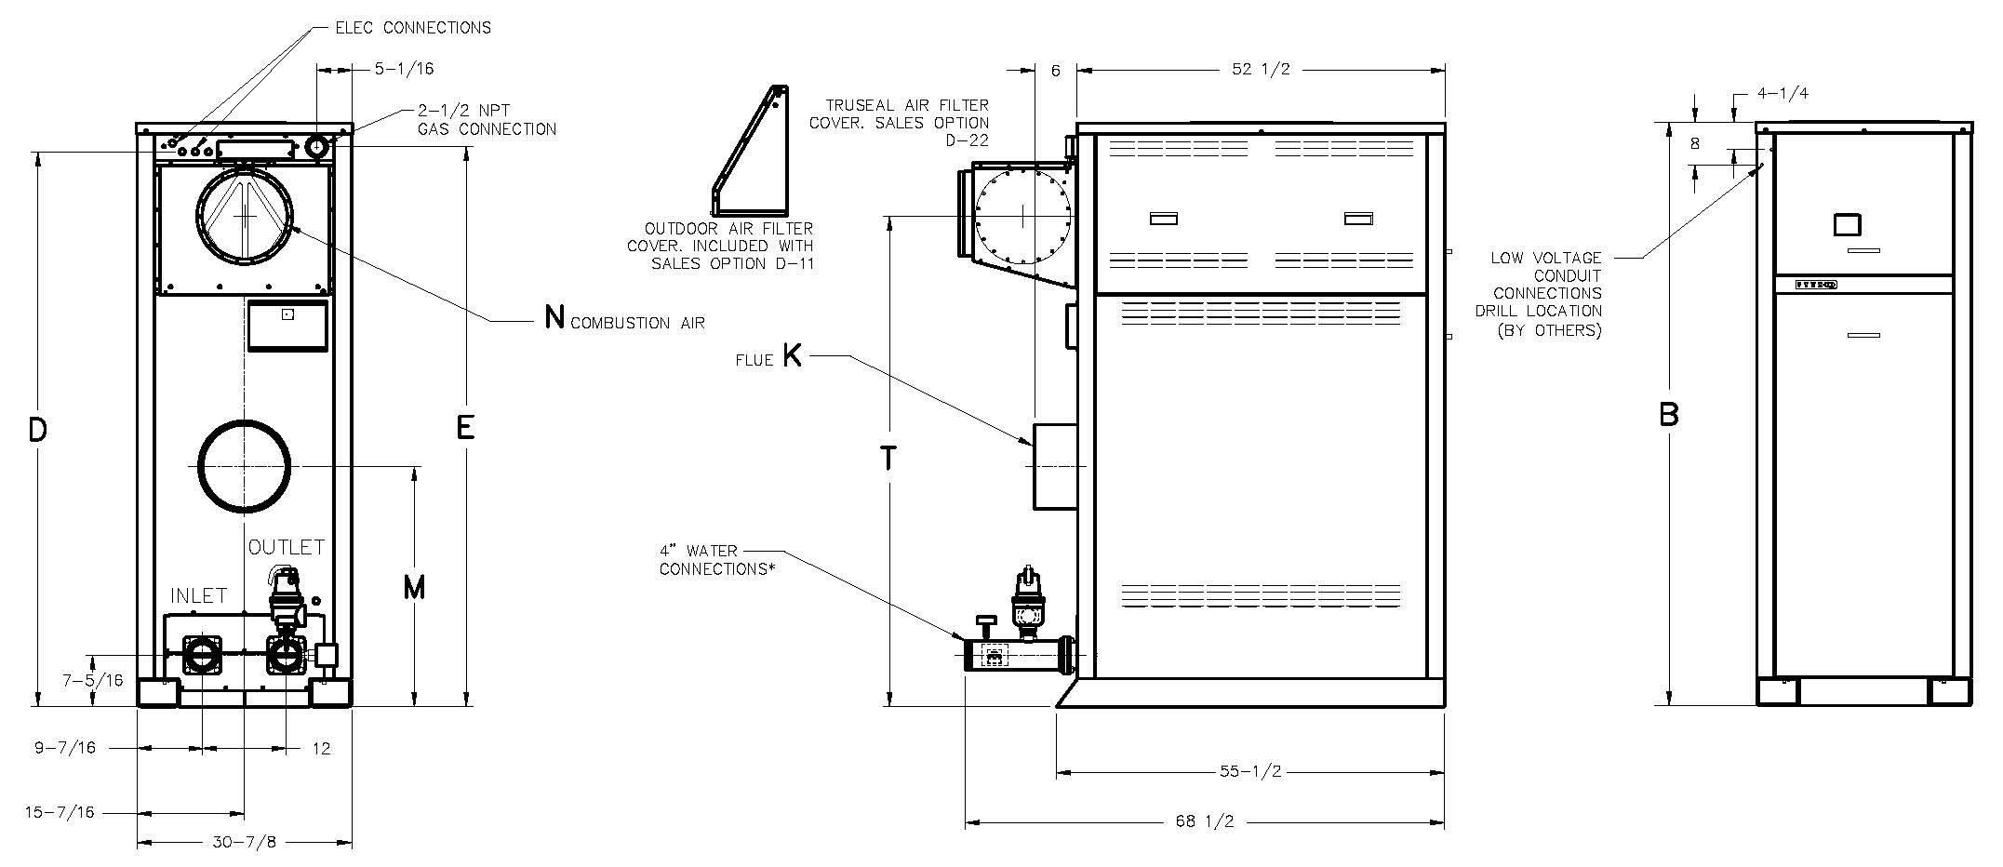

|  |  |  |  |  |  |  |  |  |  |  |  |
| --- | --- | --- | --- | --- | --- | --- | --- | --- | --- | --- | --- |
| **Model (H7)** | **MBTUH Input** | **MBTUH Output** | **Dimensions (in)** | | | | | | | **Amp Draw** | **Shipping Weight (Lbs.)** |
| **B Height** | **D** | **E** | **K Flue Ø** | **M** | **N C/A Ø** | **T** |
| 2503 | 2501 | 2126 | 68-1/4 | 62 | 64-3/4 | 10 | 26-3/4 | 10 | 53-1/4 | 12 | 1150 |
| 3003 | 3000 | 2550 | 73-1/4 | 67 | 69-3/4 | 10 | 29-1/4 | 10 | 58-1/4 | 15 | 1250 |
| 3503 | 3500 | 2975 | 78-1/4 | 71 | 74-3/4 | 12 | 31-3/4 | 12 | 63-1/4 | 17 | 1375 |
| 4003 | 4000 | 3400 | 83-1/4 | 76 | 79-3/4 | 12 | 34-1/4 | 12 | 68-1/4 | 20 | 1450 |

**\*Water connections are grooved copper tube.**

**Amp draw is for boiler only and does not include pumps or accessories.**

MVB® - Type H

Models 2503-4003 Model

**NOTE: Primary/Secondary plumbing arrangement is mandatory for proper operation.**

|  |  |  |  |  |  |  |  |  |  |  |  |  |  |  |  |  |  |  |  |
| --- | --- | --- | --- | --- | --- | --- | --- | --- | --- | --- | --- | --- | --- | --- | --- | --- | --- | --- | --- |
| Model (H7) | Input MBTUH | 20°ΔT | | SHL | | 30°ΔT | | SHL | | Minimum Flow | | | SHL | | Maximum Flow | | | SHL | |
| GPM | ΔP | 3” | 4” | GPM | ΔP | 3” | 4” | GPM | ΔP | ΔT | 3” | 4” | GPM | ΔP | ΔT | 3” | 4” |
| 2503 | 2501 | 213 | 11.7 | N/A | 14.3 | 142 | 6.2 | 10.7 | 7.4 | 120 | 4.7 | 35 | 8.0 | 5.6 | 264 | 15.7 | 16 | N/A | 19.6 |
| 3003 | 3000 | 255 | 21.7 | N/A | 25.3 | 170 | 10.3 | 16.6 | 12.0 | 131 | 6.3 | 39 | 10.2 | 7.4 | 264 | 23.1 | 19 | N/A | 27.0 |
| 3503 | 3500 | N/A | N/A | N/A | N/A | 198 | 15.2 | N/A | 17.5 | 153 | 9.1 | 39 | 14.3 | 10.5 | 264 | 26.8 | 23 | N/A | 30.6 |
| 4003 | 4000 | N/A | N/A | N/A | N/A | 227 | 23.7 | N/A | 26.6 | 174 | 13.5 | 39 | 20.1 | 15.3 | 264 | 33.5 | 26 | N/A | 37.4 |

**ΔP & SHL are in feet of head based upon 100 equivalent feet of type “L” copper tubing

Base Anchor Bolt Pattern

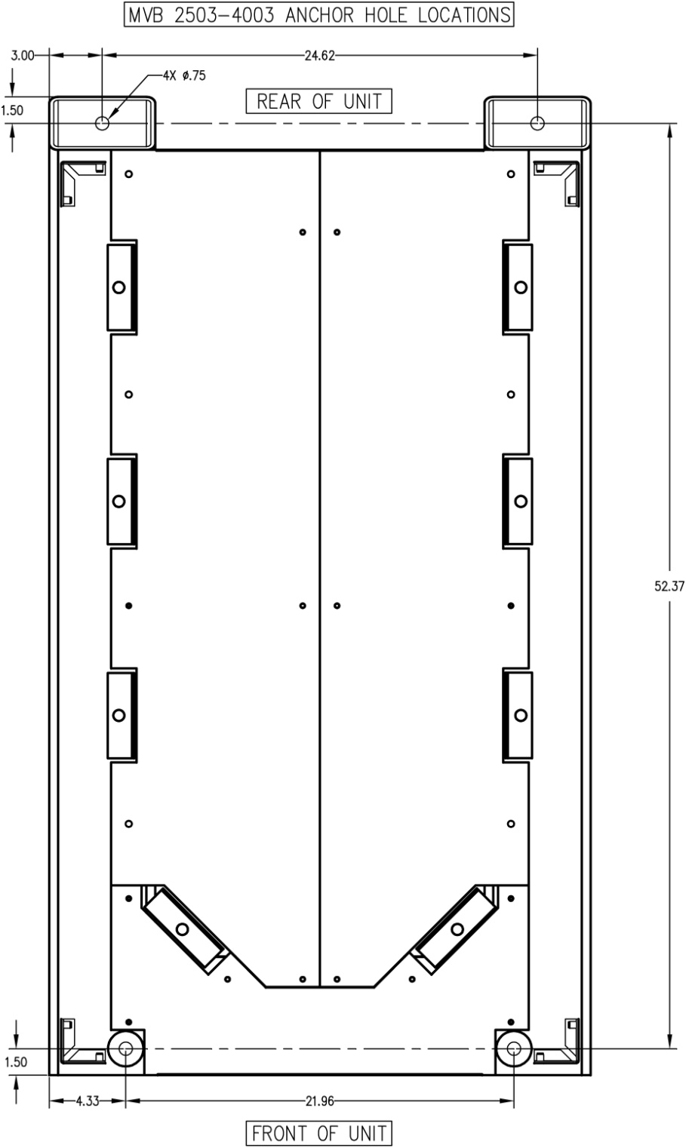

Raypak, Inc. • Eastman Avenue, Oxnard, CA 93030 • (805) 278-5300 • (805) 872-9725 • www.raypak.com