Job:

MVB® - Type H

Heating Boilers
Models 503A-2003A

Engineer:

Contractor:
Prepared By: Date:
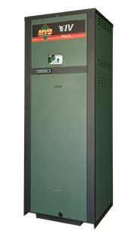
Model: Indoor/Outdoor:
86.2% Thermal Efficiency at Full Rate
100% Factory Fire-Tested
VERSA IC® Integrated Controller with 7” Color Touchscreen Display
Raymote™ remote connectivity provided standard
Electronic Modulation, Constant Ratio 7:1 Turndown
Full Safety Diagnostics with History
Status Display Lights
Modbus RTU BMS Port
Maximum Outlet Water Temperature: 235°F
Minimum Acceptable Inlet Water Temperature: 120°F
Limited Twenty-Five-Year Thermal Shock Warranty
Limited Ten-Year Heat Exchanger Warranty
Proudly Assembled in the USA
Ultra Low NOx – Less than 20PPM

Heat Exchanger
- Headers
Cast Iron – Standard
A-1 Bronze
- ASME H Stamped
160 PSIG MAWP
- National Board Approved
- Fin Tubing
Copper – Standard
A-3 Cupronickel
- ASME Powder-Coated Tube Sheet
- Silicone High-Temp O-Rings
- ASME Pressure Relief Valve
60 PSIG – Standard
PSIG – Optional
- Temperature and Pressure Gauge,
Shipped Loose
- Stainless Steel Evaporator Plate
- Four-pass heat exchanger

Control
- 120V, 60Hz, 1Ø, Power Supply
- 120/24V 60Hz Transformer
- VERSA IC® built-in controller
- 7” color HD touchscreen display
- Raymote™ Wi-Fi remote connectivity
- Cascade up to 4 Boilers
- Ignition Module
3-Try – Standard
C-6 Single-Try
- Remote Flame Sensor
- Freeze Protection
- High Limit, Manual Reset, Fixed, 240ºF
- On/Off Power Switch
- Flow Switch
- Blocked Vent Pressure Switch
- Pump Outputs
- Boiler pump
- DHW Indirect – Pilot Duty
- System – Pilot Duty
- Programmable Pump Time Delays
- Water Temperature Sensors (7)
- Cold Water Protection Function
Optional Variable Speed Pump
Optional Proportional Valve
- Modbus RTU BMS Port
B-85 Gateway – BACnet MS/TP, BACnet IP, N2 Metasys or Modbus TCP
B-86 Gateway - LonWorks

Burner
- Hot Surface Ignition (HSI)
- Radially-Fired Knitted Burner

Gas Train
- Fuel
Natural Gas
Propane (Minimum Grade HD-5)
- Dual-Seat Combination Firing Valve
- Manual Shut-Off Valve

Construction
- Design Certified ANSI Z21.13/CSA 4.9
- CSA Low Lead Certified ≤.25% Lead
- Indoor/Outdoor Construction
- Front Controls Enclosed
- PolyTuf Powder Coat Finish
- Rear Connections (Water, Electrical, Gas, Vent, Combustion Air)
- Combustion Air Filter – Inline

Venting
- Vent Termination
D-11 Outdoor
D-15 Indoor, Horizontal
Indoor, Vertical (by others)
- Combustion Air
D-16 Air Intake Elbow
- Extractor – Optional
By others

Not required

Options
A-30 Air Vent, Auto, 150 PSI (loose)
B-31 Dry-Well Assembly
B-32 Outdoor Air Sensor
F-10 Low Water Cut-Off, Remote Probe
I-1 High Limit, Auto Reset, Adj.,
100-240°F
I-2 High Limit, Manual Reset, Adj., 100-240°F (additional)
P- Pump: HP, 120V, 1∅, 60Hz
Cast Iron Bronze
Loose Mounted
P- Cold Water Start
P- Cold Water Run
S-1 Low Gas Pressure Switch,
Manual Reset
S-2 High Gas Pressure Switch, Manual Reset
Z-12 Condensate Treatment Kit

Additional Options or Accessories

Multi-Boiler Temperature Controllers
TempTracker Mod+ Hybrid
B-36 2-4 Heaters
B-37 5-10 Heaters
B-38 11-16 Heaters
B-39 EMS 4-20mA Remote Setpoint Interface Module
B-62 BACnet MS/TP Interface

MVB® – Type H

Models 503A-2003A Model

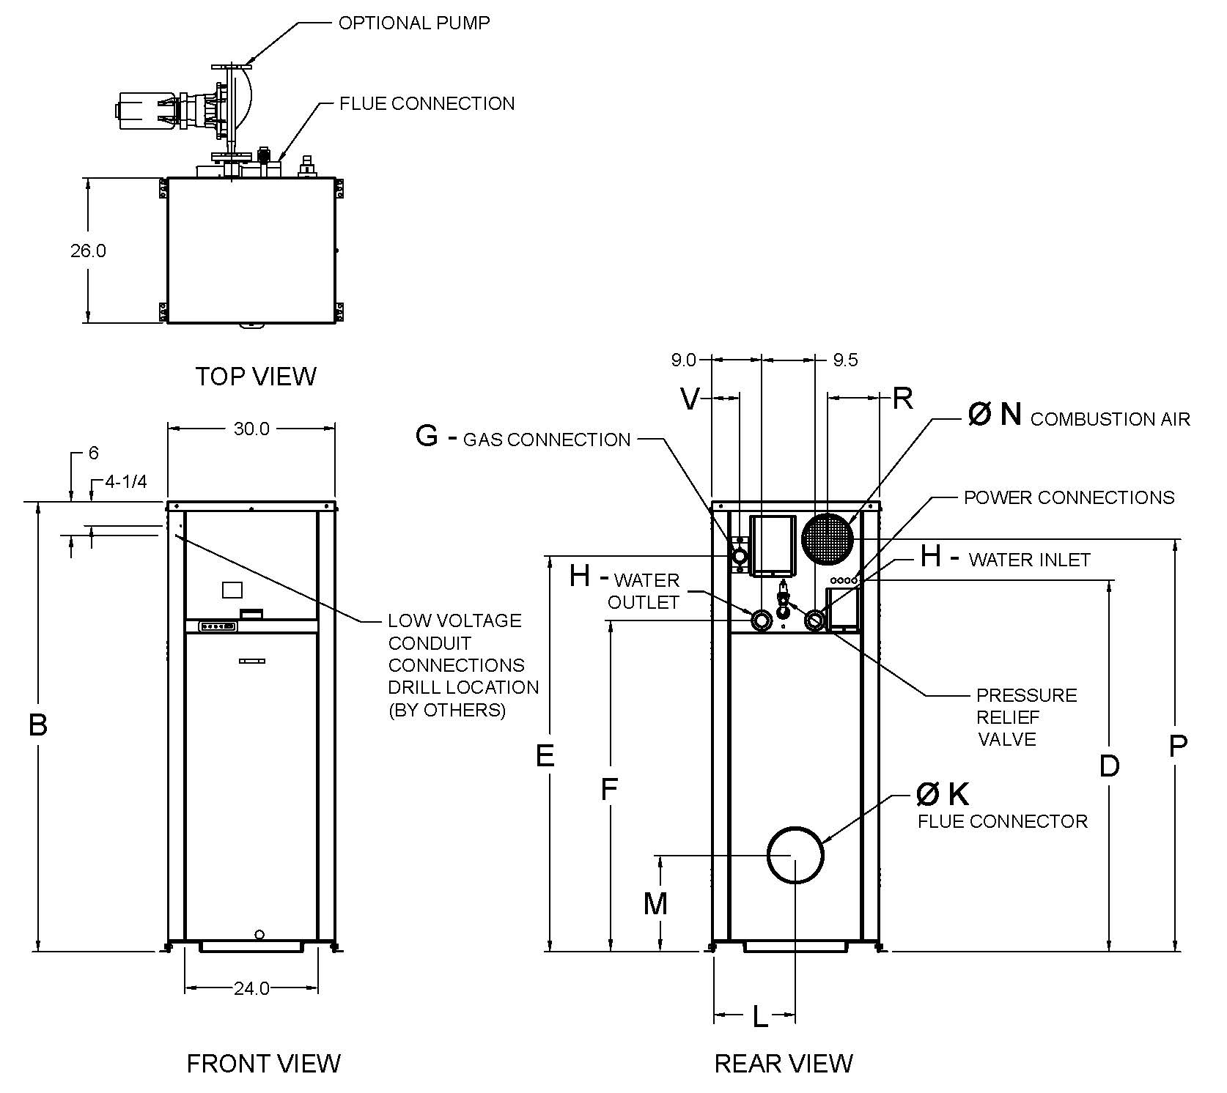
 | Certified Minimum | Recomm. Service
Front | 24” | 24”
Rear | 12” | 24”
Right | 1’ | 1”
Left | 1” | 1”
Top | 0” | 10”
Floor | 0” | 0”
Vent | 1” | 1”

CLEARANCES

Model  (H7-) | MBTUH |  | Dimensions (in.)
 |  |  | B  Height | D | E | F | G*  NPT | H  NPT | K  Flue  Ø | L | M | N  C/A  Ø | P | R | V
 | Input | Output
503A | 500 | 431 | 43 | 30-3/4 | 35 | 23-3/4 | 1 | 2 | 6 | 13-3/4 | 14-1/4 | 6 | 36-3/4 | 8-1/4 | 1-3/4
753A | 750 | 647 | 49 | 36-3/4 | 40-3/4 | 29-1/2 | 1 | 2 | 6 | 13-1/2 | 14-1/4 | 6 | 42-1/2 | 8-1/4 | 1-3/4
1003A | 999 | 861 | 55 | 42-3/4 | 46-3/4 | 35-1/2 | 1-1/4 | 2-1/2 | 6 | 13-1/2 | 14-1/4 | 6 | 48-1/2 | 8-1/4 | 1-3/4
1253A | 1250 | 1078 | 61 | 48-3/4 | 53 | 41-3/4 | 1-1/4 | 2-1/2 | 8 | 13-3/4 | 17-1/4 | 8 | 54-3/4 | 8-1/4 | 1-3/4
1503A | 1500 | 1293 | 67 | 54-3/4 | 58-3/4 | 47-1/2 | 1-1/4 | 2-1/2 | 8 | 13-3/4 | 17-1/4 | 8 | 60-1/2 | 8-1/4 | 1-3/4
1753A | 1750 | 1508 | 75 | 61 | 65-1/4 | 53-3/4 | 2 | 2-1/2 | 8 | 13-1/2 | 17-1/4 | 8 | 68-1/2 | 9-1/2 | 5
2003A | 1999 | 1723 | 81 | 66-3/4 | 71-1/4 | 59-1/2 | 2 | 2-1/2 | 8 | 13-3/4 | 17-1/4 | 8 | 74 | 9-1/2 | 5

* For natural gas. For propane, 1” NPT for all sizes.
- Ratings shown are for elevations up to 4,500 feet. For installations at elevations above 4,500 feet, please consult the factory for additional instructions.
- For direct vent applications, please contact the factory about relocating the pump.

PUMP HP (Amps*)
Model  (H7-) | Water Hardness
 | Soft | Medium | Hard
503A | 1/4 - 6 | 1/4 - 6 | 3/4 – 11
753A | 1/4 - 6 | 1/2 – 7 | 3/4 – 11
1003A | 1/4 - 6 | 1/2 – 7 | 1 – 14
1253A | 1/2 – 7 | 1 – 14 | 1 – 14
1503A | 3/4 – 11 | 1 – 14 | 1 – 14
1753A | 1 – 14 | 1-1/2 – 16 | 1-1/2 – 16
2003A | 1 – 14 | 1-1/2 – 16 | 1-1/2 – 16

*Current Draw is for Pump Only

MVB® – Type H

Models 503A-2003A Model

Model  (H7-) | Shipping Weight  (Lbs.) | Footprint  (Ft²) | Amps*
503A | 600 | 5.4 | 12
753A | 670 | 5.4 | 12
1003A | 720 | 5.4 | 12
1253A | 780 | 5.4 | 12
1503A | 840 | 5.4 | 12
1753A | 940 | 5.4 | 18
2003A | 1000 | 5.4 | 18

*Current draw is for heater only.
(Supply breaker must have delayed trip.)

RATES OF FLOW AND PRESSURE DROPS

Model  (H7-) | 20°F ΔT |  | 30°F ΔT |  | 39°F ΔT* |  | Maximum Flow |  |  | Minimum Flow*
 | GPM | ΔP (ft.) | GPM | ΔP (ft.) | GPM | ΔP (ft.) | GPM | ΔP (ft.) | ΔT (°F) | GPM | ΔP (ft.) | ΔT (°F)
503A | 43 | 2.8 | 29 | 1.4 | N/A | N/A | 100 | 11.3 | 8.6 | 25 | 1.1 | 35
753A | 65 | 6.4 | 43 | 3.1 | 33 | 1.9 | 100 | 13.8 | 13 | 33 | 1.9 | 39
1003A | 86 | 12.0 | 57 | 6.0 | 44 | 3.7 | 113 | 18.6 | 15 | 44 | 3.7 | 39
1253A | 108 | 20.9 | 72 | 10.2 | 55 | 6.2 | 113 | 22.2 | 19 | 55 | 6.2 | 39
1503A | N/A | N/A | 86 | 16.0 | 66 | 9.5 | 113 | 25.5 | 23 | 66 | 9.5 | 39
1753A | N/A | N/A | 101 | 22.5 | 77 | 13.4 | 113 | 27.2 | 27 | 77 | 13.4 | 39
2003A | N/A | N/A | 115 | 31.9 | 88 | 18.9 | 115 | 30.2 | 31 | 88 | 18.9 | 39
* Closed systems only

Raypak, Inc. • Eastman Avenue, Oxnard, CA 93030 • (805) 278-5300 • (805) 872-9725 • www.raypak.com

