Job:

XTherm® - Type H

Heating Boilers

Models 1005A-2005A

Engineer:

Contractor:
Prepared By: Date:
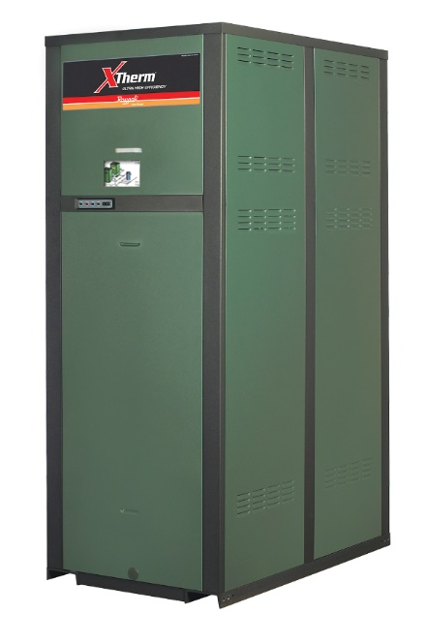
Model: Indoor/Outdoor:

96% Thermal Efficiency at Full Rate
100% Factory Fire Tested
VERSA IC® Modulating Controller with 7” color touchscreen display
Raymote™ remote connectivity provided standard
Full Electronic Modulation, Constant Ratio 7:1 Turndown
Full Safety Diagnostics with History
Status Display Lights
Cascade up to 4 Heaters – No External Sequencer Required
Modbus RTU BMS Port
Maximum Outlet Water Temperature: 235°F
Minimum Inlet Water Temperature: 50°F
Limited Twenty-Five-Year Thermal Shock Warranty
Limited Ten-Year Primary Heat Exchanger Warranty
Proudly Assembled in the USA
Limited Ten-Year Secondary Heat Exchanger Warranty

Heat Exchanger
- Headers
Cast Iron – Standard
Bronze – Option A-1
- ASME H Stamped; 160 PSIG MAWP
- National Board Listed
- Fin Tubing
Copper – Standard
Cupro Nickel – Option A-3
- ASME Powder-Coated Tube Sheet
- Silicone High Temp O-Rings
- ASME Pressure Relief Valve
60 PSIG – Standard
PSIG – Optional
- Manual Air Bleed
- T&P Gauge
- Secondary Stainless Steel Condensing Heat Exchanger – U stamped
- Stainless Steel Evaporator Plate
- Boiler Pump: 120V, 1∅, 60Hz;
Cast Iron – Standard
Bronze – Option

Control
- 120V, 60Hz, 1Ø, Power Supply
- 120/24V 60Hz Transformer
- VERSA IC®
- 7” color HD touchscreen display
- Raymote™ Wi-Fi remote connectivity
- Ignition Module
3-Try – Standard
C-6 Single-Try – Optional
- Remote Flame Sensor
- Fixed High Limit, Manual Reset, 240°F
- On/Off Power Switch
- Flow Switch
- Blocked Vent Pressure Switch
- Freeze Protection
- Alarm Dry Contact
* Requires 200ºF Manual Reset High Limit & 180ºF Max Setpoint
- Pump Outputs – Pilot Duty
- DHW Indirect
- System
- Programmable Pump Time Delays
- Modulating Temperature Control; 7:1 turndown
- Water Temperature Sensors (7)
- Cold Water Protection – Built In
- Blocked Condensate Switch
- Modbus RTU BMS Port (Up to 115K Baud Rate, see Cat. No. 5000.73)
B-85 BMS Gateway, Modbus RTU to Modbus TCP, N2 Metasys, BACnet IP, or BACnet MS/TP
B-86 BMS Gateway, Modbus RTU to LonWorks

Burner
- Hot Surface Ignition (HSI)
- Radially Fired Knitted Burner

Gas Train
- Fuel
Natural Gas
Propane (Grade HD-5)
- Dual-Seat Combination Valve
- Manual Shut Off Firing Valve

Construction
- Indoor/Outdoor Construction
- Enclosed Front Controls
- PolyTuf Powder Coat Finish
- Rear Connections (Water, Gas, Vent, Electrical, Comb. Air, Cond. Drain)
- Combustion Air Filter
- Design Certified ANSI Z21.13/CSA 4.9
- Front Connection Low Voltage Wiring

Venting
- Vent Termination, Cat IV
D-11 Outdoor or Indoor, Vertical
D-15 Indoor, Horizontal
- Extractor – Optional, Cat II
By others
Not required

Options
D-32* PVC Vent Adapter
(Includes 162ºF Manual Vent Limit) (Factory installed only)
D-33 Centrotherm™ Polypropylene Vent Adapter (Includes 180ºF
Manual Vent Limit) (shipped loose)
F-10 Low Water Cut-Off, Remote Probe
I-1 High Limit, Auto Reset, Adj.,
100-240°F
I-2 High Limit, Manual Reset, Adj., 100-240°F
S-1 Low Gas Pressure Switch,
Manual Reset
S-2 High Gas Pressure Switch, Manual Reset
Z-12 Condensate Treatment Kit

Additional Options or Accessories

Multi-Boiler Digital Temp Controllers
B-36 TempTracker Mod+ Hybrid,
2-4 Boilers, OA Reset
B-37 TempTracker Mod+ Hybrid,
5-10 Boilers, OA Reset
B-38 TempTracker Mod+ Hybrid,
11-16 Boilers, OA Reset
B-39* EMS 4-20 mA Remote Setpoint Interface Module
B-62* BACnet MS/TP Interface Module (*only used with B-36 to B-38)

XTherm – Type H

Models 1005A-2005A Model
NOTE: Primary/Secondary plumbing is mandatory for proper operation.
CLEARANCES (in.)
 | Front | Rear | Right | Left | Top | Floor | Vent
Certified Minimum | 24 | 12 | 1 | 1 | 0 | 0 | 1
Minimum Service | 24 | 36 | 24 | 1 | 10 | N/A | N/A

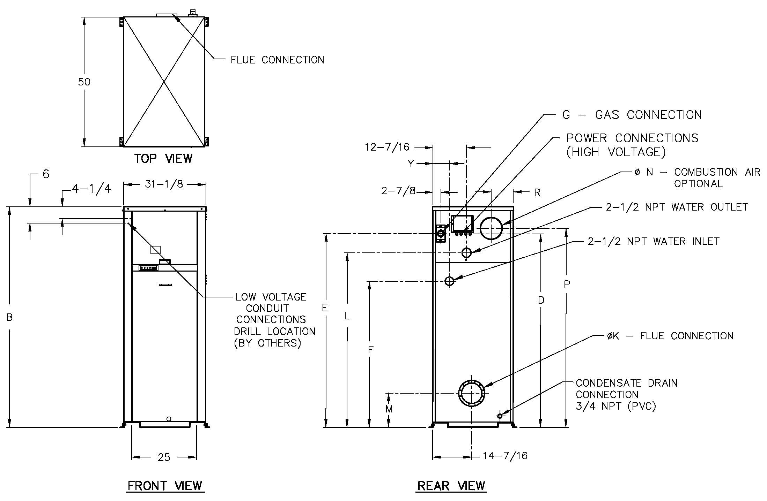
Model | Amp Draw**
 | Boiler † | Pump †
1005A | 12** | 10
1505A | 12** | 14
2005A | 18** | 17
† Separate power connections are factory supplied and separate supply breakers must be field supplied.
** Current draw is for boiler only (Supply breaker must have delayed trip).

Model (H7-) | MBTUH |  | Dimensions (in) |  |  |  |  |  |  |  |  |  |  |  | Ship Weight (Lbs.)
 |  |  | B Height | D | E | F | G* NPT | K  Flue Ø | L | M | N C/A Ø | P | R | Y
 | Input | Output
1005A | 999 | 959 | 55-1/8 | 45 | 47-1/8 | 36-1/2 | 1-1/4 | 6 | 40-1/16 | 11-1/2 | 6 | 47-1/8 | 8-1/16 | 6-1/16 | 1065
1505A | 1500 | 1440 | 67-1/8 | 57 | 59-1/16 | 38-1/2 | 1-1/4 | 8 | 52-1/16 | 12-5/8 | 8 | 59-1/8 | 8-3/16 | 6-1/16 | 1234
2005A | 1999 | 1919 | 81-1/8 | 71 | 71-3/16 | 38-1/2 | 2 | 8 | 64-1/16 | 12-5/8 | 8 | 73-1/8 | 8-3/16 | 6-1/4 | 1461

Note: Ratings shown are for elevations up to 4,500 feet. For installations at elevations  above 4,500 feet, please consult the factory for additional instructions. | * For Propane Gas, all models are 1” NPT

System Return Temp (ºF) | Model 1005A |  |  | Model 1505A |  |  | Model 2005A
 | Supply Temp¹ (ºF) | Minimum Pipe Size² |  | Supply Temp¹ (ºF) | Minimum Pipe Size² |  | Supply Temp¹ (ºF) | Minimum Pipe Size²
 |  | <80’ eq | 80-200’ eq |  | <80’ eq | 80-200’ eq |  | <80’ eq | 80-200’ eq
60 | 138 | 2” NPT | 2-1/2” NPT | 147 | 2” NPT | 2-1/2” NPT | 154 | 2” NPT | 2-1/2” NPT
80 | 138 | 2” NPT | 2-1/2” NPT | 147 | 2” NPT | 2-1/2” NPT | 154 | 2-1/2” NPT | 3” NPT
100 | 138 | 2-1/2” NPT | 3” NPT | 147 | 2-1/2” NPT | 3” NPT | 154 | 2-1/2” NPT | 3” NPT
120 | 145 | 2-1/2” NPT | 3” NPT | 158 | 2-1/2” NPT | 3” NPT | 170 | 2-1/2” NPT | 3” NPT
140 | 165 | 2-1/2” NPT | 3” NPT | 178 | 2-1/2” NPT | 3” NPT | 190 | 2-1/2” NPT | 3” NPT
160 | 185 | 2-1/2” NPT | 3” NPT | 198 | 2-1/2” NPT | 3” NPT | 210 | 2-1/2” NPT | 3” NPT
¹ – Approximate high fire heater outlet temperature based on the standard heater pump and recommended connecting pipe size.
² – Minimum pipe size based on total equivalent feet of supply and return piping between the system loop and heater.

