Job:      

# Hi Delta® FlexGas® - Type H

## Dual-Fuel Hot Water Boilers Models 992CD-2342CD

Engineer:

Contractor:

Prepared By:       Date:

Model:       Indoor/Outdoor:       MBTUH Input:

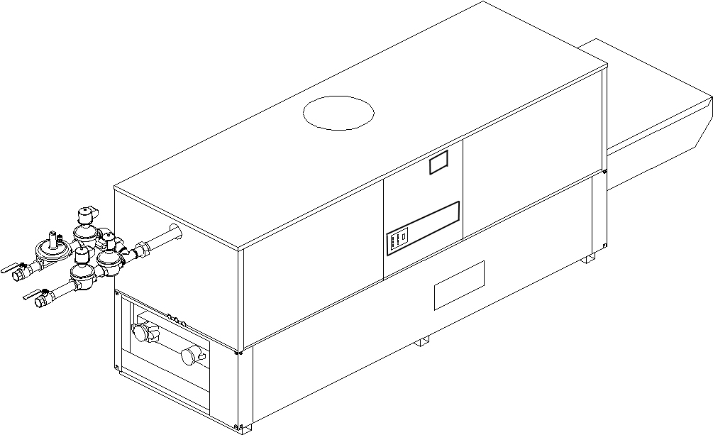

* 100% Factory Fire Tested
* Thermal Efficiency: 84%
* Versa IC® Controller with LCD Display
* Maximum Setpoint: 220°F
* Maximum Outlet Temperature: 240°F
* Minimum Non-Condensing Inlet Temperature: 105°F
* Thermal Shock Proof Heat Exchanger
* Limited Twenty-Year Thermal Shock Warranty
* Limited Ten-Year Closed Loop Heat Exchanger Warranty
* Full Safety Diagnostics with Fault History
* PolyTuf Powder Coated Cabinet
* No Combustible Floor Shield Required

Patent Nos. 6,904,873 & 7,044,124; other patents pending

* Fan-Assisted
* Patented Burner Security Blanket

Proudly Assembled in the USA



* Ultra-Low NOx – SCAQMD 1146.2 Certified
* Cascade up to 4 Heaters – No External Sequencer Required

#### Heat Exchanger

* Headers

Glass-Lined Cast Iron – Standard

A-1 Bronze

* ASME Inspected and H-Stamped  
  160 PSIG Working Pressure
* National Board Approved
* Fin Tubing

Copper – Standard

A-3 Cupro-Nickel

* ASME Steel Tube Sheet
* Silicone High Temp. O-Rings
* ASME Pressure Relief Valve

60 PSIG – Standard

      PSIG – Optional

* Temperature and Pressure Gauge
* Water Connections

Left – Standard

A-6 Right

#### Controls

* 120V, 60Hz, 1∅ Power Supply
* 120/24V 60Hz Transformer
* Versa IC® Integrated Control
* 100% Shut-Off/Lockout
* Hot Surface Ignition
* Ignition Module

3-Try – Standard

C-6 Single Try

* Remote Flame Sensor
* Fixed High Limit, Manual Reset 240°F
* On/Off Power Switch
* Flow Switch
* Blocked Vent Pressure Switch
* Combustion Air Proving Switch
* Programmable Pump Time Delays
* Heater
* Recirculation

Enable/Disable

* LCD Display; Status, Fault and Diagnostics



* Cold Water Protection Function

CWR Variable-Speed Pump

(See Cat. 5000.73)

* Modbus RTU BMS Port (Up to 115K Baud,

B-85 – BMS Gateway – BACnet MS/TP, BACnet IP, N2 Metasys or Modbus TCP

* B-86 – BMS Gateway – LonWorks

#### Gas Train

* Manual Gas Shut-Off Valve(s)
* Gas Pressure Regulator
* Safety Shut-Off Valve
* Firing Control Valve
* Firing Mode

3-Stage: Model 992CD (H8)

4-Stage: Model 1262CD-2342CD (H9)

* Fuel

Natural Gas

Propane Gas (HD-5) (Excludes 2002CD)

G – 20 4” WC Nat Supply

* Design Certified - ANSI Z21.13/CSA 4.9

#### Construction

* Indoor/Outdoor Construction
* Front Controls Enclosed
* PolyTuf Powder Coat Finish
* CSA Low Lead Certified ≤ .25% Lead

#### Venting

* Vent Location

Top – Standard

D-14 Rear

* Vent Termination Cap

D-11 Outdoor

D-15 Indoor, Horizontal

Indoor, Vertical (by others)

* Combustion Air

D-17 In-Line Filter Kit (TruSeal   
only)

D-16 Air Intake Elbow



* Extractor – Optional

By others

#### Not required

#### Burner

* Ultra-Low NOx: Less than 20 PPM (NAT)

#### Options

C-6 Ignition Module, Manual Reset

D-21 TruSeal® Direct Vent

F-10 Low Water Cut-Off, Remote Probe

I-1 High Limit Control, Auto Reset

P-   Pump:       HP, 120V, 1∅, 60Hz

Cast Iron  Bronze  
 Mounted  Loose

Front  Rear

P-   Cold Water Start (See 2000.48)

P-   Cold Water Run (See 2000.48)

S-1 Low Gas Pressure Switch, Manual

S-2 High Gas Pressure Switch, Manual

X-1 SureRack® Kit

X-2 SureRack Add-on

    



*For Metric information, see Catalog*

#### Additional Options or Accessories



*For Metric information, see Catalog*

#### Multi-Boiler Temperature Controllers

TempTracker Mod+ Hybrid

B-36, 2-4 Heaters

B-37, 5-10 Heaters

B-38, 11-16 Heaters

B-39 EMS 4-20mA Remote Setpoint Interface Module

B-62 BACnet MS/TP Interface

#### Hi Delta FlexGas – Type H

**Models 992CD-2342CD Model**

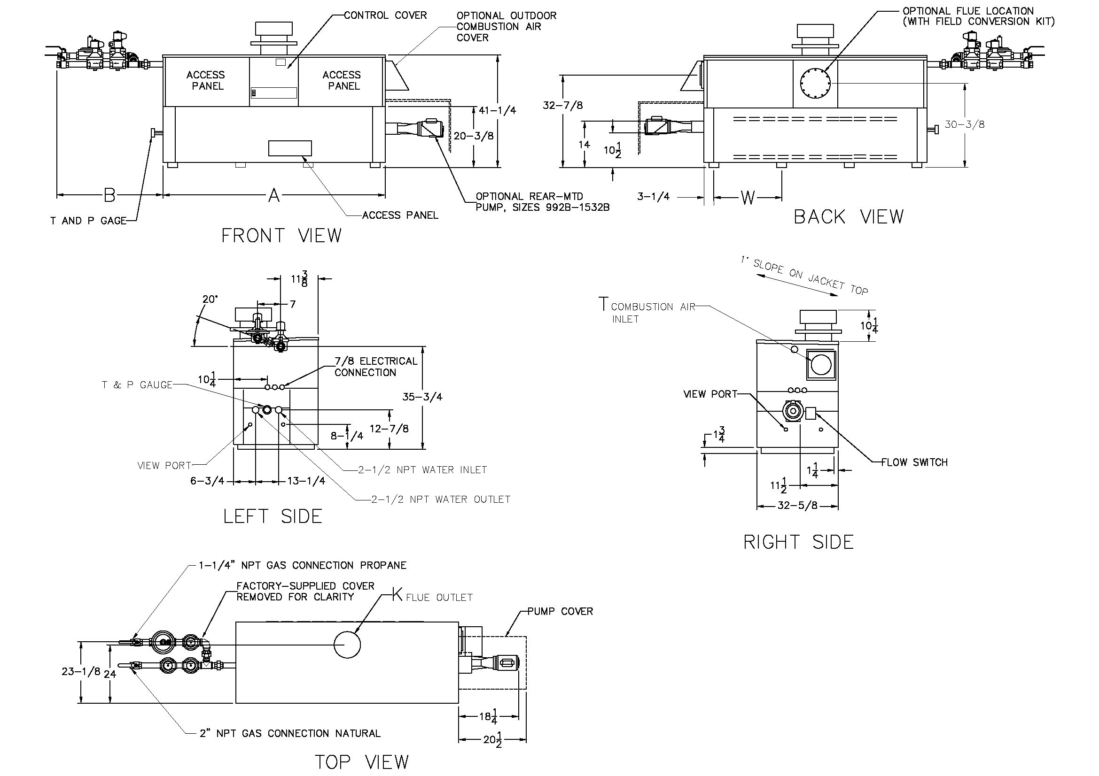

**RATES OF FLOW AND PRESSURE DROPS**

NOTE: Pump location varies based on model and application

Raypak, Inc. ▪ 2151 Eastman Avenue, Oxnard, CA 93030 ▪ (805) 278-5300 ▪ Fax (800) 872-9725 ▪ www.raypak.com

|  |  |  |  |  |  |  |  |  |  |  |
| --- | --- | --- | --- | --- | --- | --- | --- | --- | --- | --- |
| Model | 20ºF ΔT | | 30ºF ΔT | | Min. Flow | | | Max. Flow | | |
| GPM | ΔP (FT) | GPM | ΔP (FT) | GPM | ΔP (FT) | ΔT | GPM | ΔP (FT) | ΔT |
| 992CD | 84 | 5.6 | 56 | 2.5 | 42 | 1.5 | 40 | 132 | 14.0 | 13 |
| 1532CD | 107 | 10.0 | 71 | 4.5 | 53 | 2.6 | 40 | 132 | 15.5 | 16 |
| 1802CD | 130 | 16.0 | 86 | 7.1 | 65 | 4.1 | 40 | 132 | 16.5 | 20 |
| 2072CD | N/A | N/A | 117 | 15.0 | 88 | 8.7 | 40 | 132 | 19.5 | 27 |
| 2342CD | N/A | N/A | 132 | 21.0 | 99 | 12.0 | 40 | 132 | 21.0 | 30 |

Basis is 30 GPM or 40ºF ΔT for minimum flow, 132 GPM for maximum flow.

NOTES:

1. Dimensions are in inches.

2. Rates shown are for natural or propane gas, and elevations up to 4,500 feet. For installation above 4,500 feet, please contact manufacturer.

3. Required natural gas supply pressure is   
7 - 10.5” WC. Required propane gas supply pressure is 11 - 13” WC.

|  |  |  |  |  |  |  |  |  |  |  |
| --- | --- | --- | --- | --- | --- | --- | --- | --- | --- | --- |
| Model | MBTUH | | Firing  Stages | A  Width | B | K | T | W | Amp  Draw* | Approx.  Shipping  Wt. (Lbs.) |
| Input | Output |
| 992CD | 990 | 832 | 3 | 57-1/8 | 41-3/8 | 10 | 10 | 16-3/16 | <12 | 930 |
| 1262CD | 1260 | 1058 | 4 | 68-1/2 | 41-1/2 | 12 | 10 | 20-9/16 | <12 | 1040 |
| 1532CD | 1530 | 1285 | 4 | 79-7/8 | 36 | 12 | 10 | 24-3/8 | <12 | 1255 |
| 1802CD | 1800 | 1512 | 4 | 91-1/8 | 33-1/2 | 14 | 10 | 28-1/8 | <12 | 1380 |
| 2072CD | 2070 | 1739 | 4 | 102-1/2 | 39 | 14 | 10 | 31-15/16 | <12 | 1480 |
| 2342CD | 2340 | 1966 | 4 | 113-7/8 | 34 | 16 | 10 | 35-11/16 | <12 | 1550 |

*Without Pump