Job:

# MVB®

# Type WH

## Water Heaters

## Models 2503-4003

Engineer:

Contractor:

Prepared By:       Date:

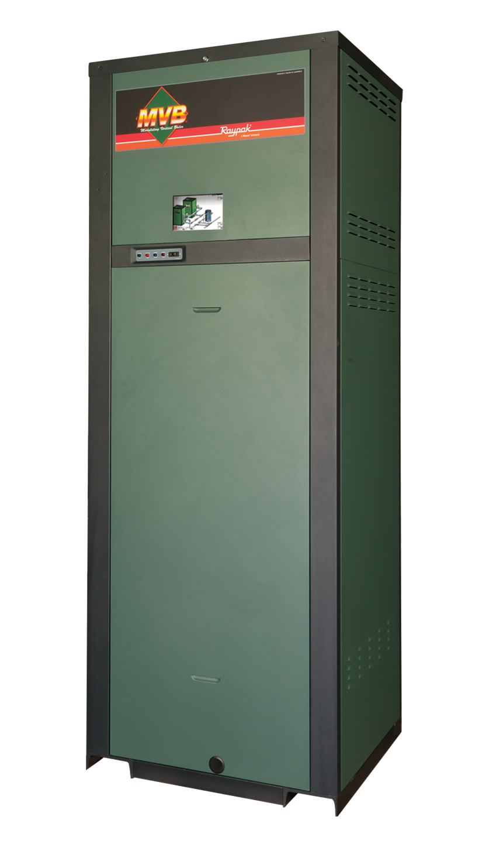Model:       Indoor/Outdoor:

85% Thermal Efficiency at Full Rate

100% Factory Fire-Tested

VERSA IC® Integrated Controller with 7” Color Touch Screen Display

Full Electronic Modulation, 60% Minimum Fire under Normal Conditions

Full Safety Diagnostics with History

Status Display LED Lights

Ultra Low NOx (BAAQMD Reg. 9, Rule 7 Approved)

Cascade up to 4 Heaters – No External Sequencer Required

Modbus RTU BMS Port

Maximum Outlet Water Temperature: 200°F

Maximum Tank Setpoint: 150°F

Minimum Inlet Water Temperature: 120°F

Proudly Assembled in the USA

Limited Five-Year Copper/Ten-Year Cupro-Nickel Heat Exchanger Warranty

#### Heat Exchanger

* Bronze Headers
* ASME HLW Stamped; 160 PSIG MAWP
* National Board Approved
* Fin Tubing

Copper – Standard

A-3 Cupro-Nickel

* ASME Powder-Coated Tube Sheet
* Silicone High-Temp O-Rings
* ASME Pressure Relief Valve

125 PSIG – Standard

      PSIG – Optional

* 150 PSI Air Vent, Auto (2)
* T&P Gauge
* 4-Pass Heat Exchanger
* Stainless Steel Evaporator Plate
* 4-Inch Grooved Copper Water Connections

#### Control

* 240V, 60Hz, 1Ø, Power Supply
* 240/120V 60Hz Transformer
* 240/24V 60Hz Transformer
* VERSA IC® Integrated Control
* Hot Surface Ignition (HSI)
* Ignition Module

3-Try – Standard

C-6 - Single-Try

* Remote Flame Sensor
* Fixed High Limit, Manual Reset, 200°F
* On/Off Power Switch
* Flow Switch
* Blocked Vent Pressure Switch
* Freeze Protection
* Alarm Dry Contact
* High Gas Pressure Switch
* Pump outputs – Pilot Duty
* Water Heater
* System
* Programmable Pump Time Delays
* 7” Color HD Touch Screen Display
* Modulating Temperature Control, 60% minimum fire
* Water Temperature Sensors (3)
* Cold Water Protection Function

CWR Variable-Speed Pump

* Modbus RTU BMS Port (Up to 115K Baud, See Cat. 5000.73)

B-85 – BMS Gateway – BACnet MS/TP, BACnet IP, N2 Metasys or Modbus TCP

B-86 – BMS Gateway - LonWorks

#### Burner

* Radially-Fired Knitted Burner

#### Gas Train

* Fuel

Natural Gas

Propane (HD-5)

* Dual-Seat Combination Valve
* Manual Shut Off Firing Valve

#### Construction

* Indoor/Outdoor Construction
* Enclosed Front Controls
* PolyTuf Powder Coat Finish
* Rear Connections (Water, Gas, Vent, Electrical, Comb. Air)
* Combustion Air Filter
* Front Connection Low Voltage Wiring
* Design Certified ANSI Z21.10.3/CSA 4.3
* CSA Low Lead Certified ≤.25% Lead

#### Venting

* Vent Termination

D-11 Outdoor or Indoor, Vertical – (Cat IV)  D-15 Indoor, Horizontal – (Cat IV)

* Extractor – Optional

By others

Not Required

#### Options

D-11 Outdoor Vent Cap with Outdoor Filter Cover

D-22 Truseal Air Intake Box, Indoor

F-10 Low Water Cut-Off, Remote Probe

I-6 High Limit, Auto Reset, Adj.,   
100-200°F

I-12 High Limit, Manual Reset, Adj., 100-200°F

S-1 Low Gas Pressure Switch,   
Manual Reset

Z-12 Condensate Treatment Kit

#### Additional Options or Accessories

#### 



Description: Raypak-Rheem logo, submittals

MVB® - Type WH

Models 2503-4003 Model

**Clearances (in)**

|  |  |  |  |  |  |  |  |
| --- | --- | --- | --- | --- | --- | --- | --- |
|  | Front | Rear | Side | Other Side | Top | Floor | Vent |
| Combustible Minimum | 24 | 12 | 1 | 1 | 0 | 0 | 1 |
| Minimum Service | 30 | 36 | 24* | 1 | 12 | N/A | N/A |

*Service Clearance can be right side or left side.

**NOTE: Must be used with properly sized storage tank for proper operation.**

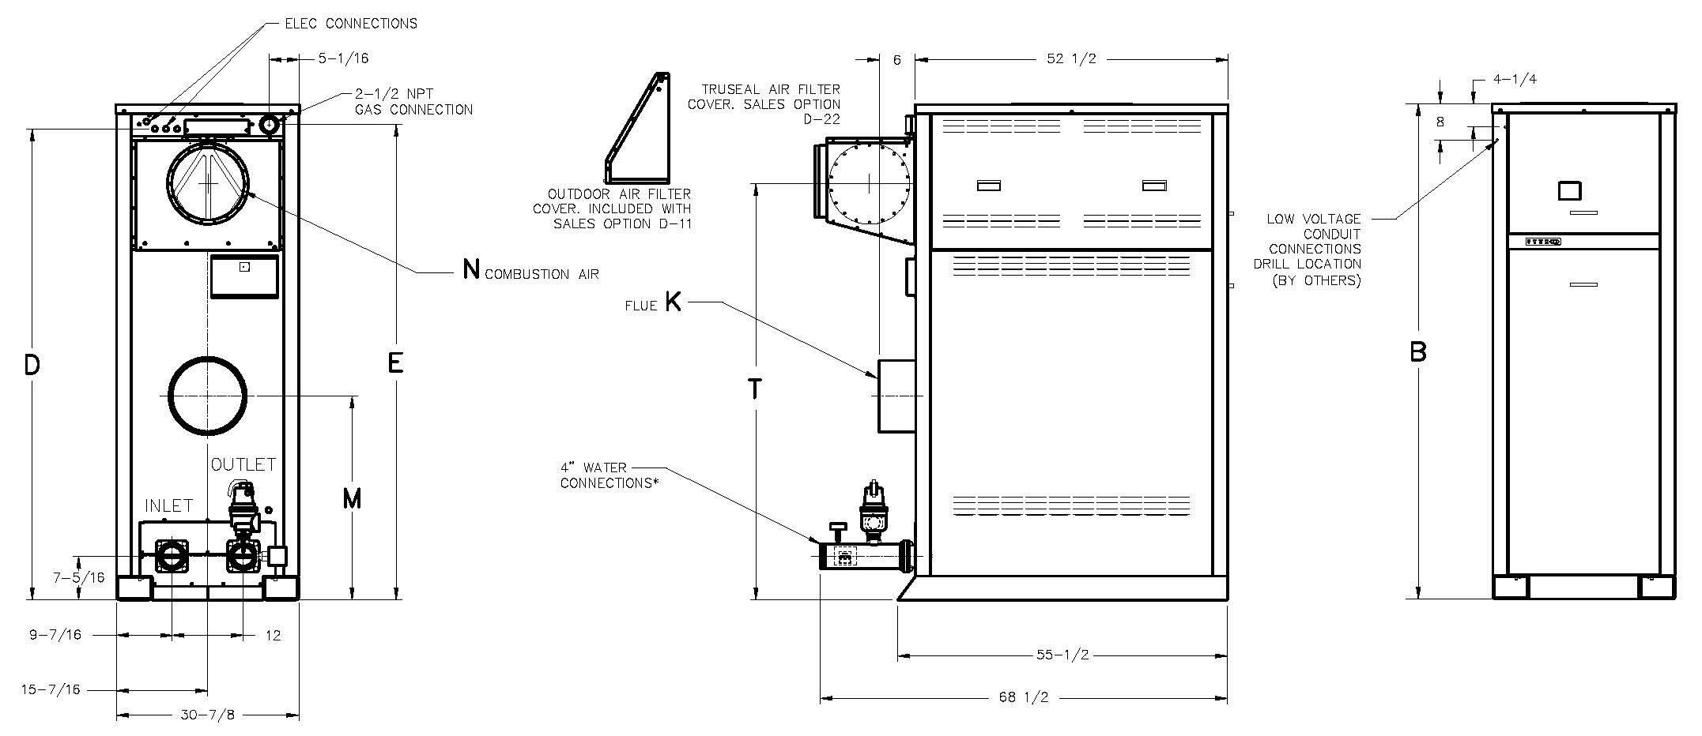

|  |  |  |  |  |  |  |  |  |  |  |  |
| --- | --- | --- | --- | --- | --- | --- | --- | --- | --- | --- | --- |
| **Model (WH7-)** | **MBTUH** | | **Dimensions (in)** | | | | | | | **Amp Draw** | **Shipping Weight (Lbs.)** |
| **Input** | **Output** | B Height | D | E | K Flue Ø | M | N C/A Ø | T |
| 2503 | 2501 | 2126 | 68-1/8 | 64-1/16 | 64-7/8 | 10 | 26-3/4 | 10 | 53-1/4 | 12 | 1410 |
| 3003 | 3000 | 2550 | 73-1/8 | 69-1/16 | 69-7/8 | 10 | 29-1/4 | 10 | 58-1/4 | 15 | 1450 |
| 3503 | 3500 | 2975 | 78-1/8 | 74-1/16 | 74-7/8 | 12 | 31-3/4 | 12 | 63-1/4 | 17 | 1550 |
| 4003 | 4000 | 3400 | 83-1/8 | 79-1/16 | 79-7/8 | 12 | 34-1/4 | 12 | 68-1/4 | 20 | 1660 |

**\*Water connections are grooved copper tube.**

**Amp draw is for heater only and does not include pumps or accessories.**

MVB® - Type WH

Models 2503-4003 Model

**NOTE: Must be used with properly sized storage tank for proper operation.**

|  |  |  |  |  |  |  |  |  |  |  |  |  |  |  |  |  |
| --- | --- | --- | --- | --- | --- | --- | --- | --- | --- | --- | --- | --- | --- | --- | --- | --- |
|  |  | **WATER HARDNESS** | | | | | | | | | | | | | | |
|  |  | **SOFT \*** | | | | | **MEDIUM** | | | | | **HARD\*** | | | | |
| **Model**  **(WH7-)** |  | **3-4 Grains Per Gallon‡** | | | | | **5-15 Grains Per Gallon** | | | | | **16-25** Grains Per Gallon** | | | | |
| **MBTUH Input** | ΔT (°F) | GPM | ΔP† (ft wc) | MTS (in) | SHL (ft wc) | ΔT (°F) | GPM | ΔP† (ft wc) | MTS (in) | SHL (ft wc) | ΔT (°F) | GPM | ΔP† (ft wc) | MTS (in) | SHL (ft wc) |
| 2503 | 2501 | 29 | 147 | 6.6 | 4 | 7.9 | 20 | 213 | 11.7 | 4 | 14.4 | 16 | 264 | 15.7 | 4 | 20.0 |
| 3003 | 3000 | 29 | 176 | 11.0 | 4 | 12.8 | 20 | 255 | 21.7 | 4 | 25.6 | 19 | 264 | 23.1 | 4 | 27.3 |
| 3503 | 3500 | 29 | 205 | 16.3 | 4 | 18.8 | 23 | 264 | 26.8 | 4 | 31.0 | 23 | 264 | 26.8 | 4 | 31.0 |
| 4003 | 4000 | 29 | 234 | 25.6 | 4 | 28.9 | 26 | 264 | 33.5 | 4 | 37.7 | 26 | 264 | 33.5 | 4 | 37.7 |

**\* Cupro-Nickel tubes are required for hard water applications and water softened below 3 GPG.**

**\*\* Water treatment is required when hardness exceeds 25 GPG.**

**‡ Water softened below 3 GPG has been known to be aggressive and may damage the appliance.**

**†ΔP is based upon type “L” copper tubing.**

**264 GPM is maximum allowable flow.**

**Do not exceed ΔT of 29 ºF.**

|  |  |  |  |  |  |  |  |  |  |
| --- | --- | --- | --- | --- | --- | --- | --- | --- | --- |
| **Model (WH7)** | **RECOVERY RATES (GPH)** | | | | | | | | |
| **Temperature Rise (°F)** | | | | | | | | |
| **20** | **30** | **40** | **50** | **60** | **70** | **80** | **90** | **100** |
| **2503** | 12884 | 8589 | 6442 | 5154 | 4295 | 3681 | 3221 | 2863 | 2577 |
| **3003** | 15455 | 10303 | 7727 | 6182 | 5152 | 4416 | 3864 | 3434 | 3091 |
| **3503** | 18030 | 12020 | 9015 | 7212 | 6010 | 5152 | 4508 | 4007 | 3606 |
| **4003** | 20606 | 13737 | 10303 | 8242 | 6869 | 5887 | 5152 | 4579 | 4121 |

Base Anchor Bolt Pattern

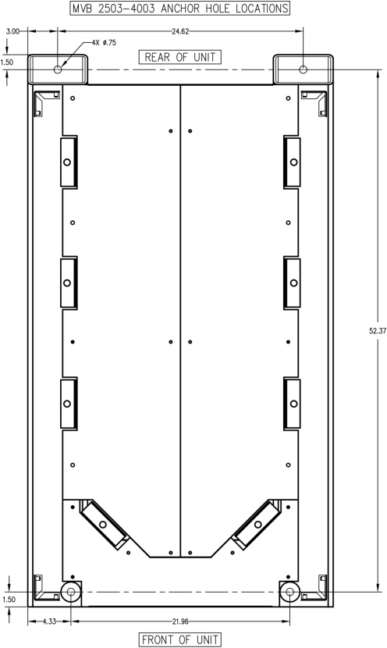

Raypak, Inc. • Eastman Avenue, Oxnard, CA 93030 • (805) 278-5300 • (805) 872-9725 • www.raypak.com